How Many Is Too Many? Line Master 1
(Assessment Master)
Name: _____________________________

Estimate and Group to Skip-count  to 50 | Not observed | Sometimes | Consistently
Estimates sets to 50
Groups sets of up to 50
Recognizes the number of items in a set does not change with counting method or order (conservation of number)
Says counting sequence correctly
Uses counting on strategy
Counts sets to 50
Uses grouping strategies (2s, 5s, 10s) to determine how many
Describes sets to 50
Compare Quantities to 50
Compares sets of objects to identify more/less/equal
Creates set that has more, less, or as many as a given number
Compares a set to a referent using comparative words, such as “more,” “less,” “the same,” or “equal”
Strengths:

Next Steps:

Connecting Home and School Line Master 2–1

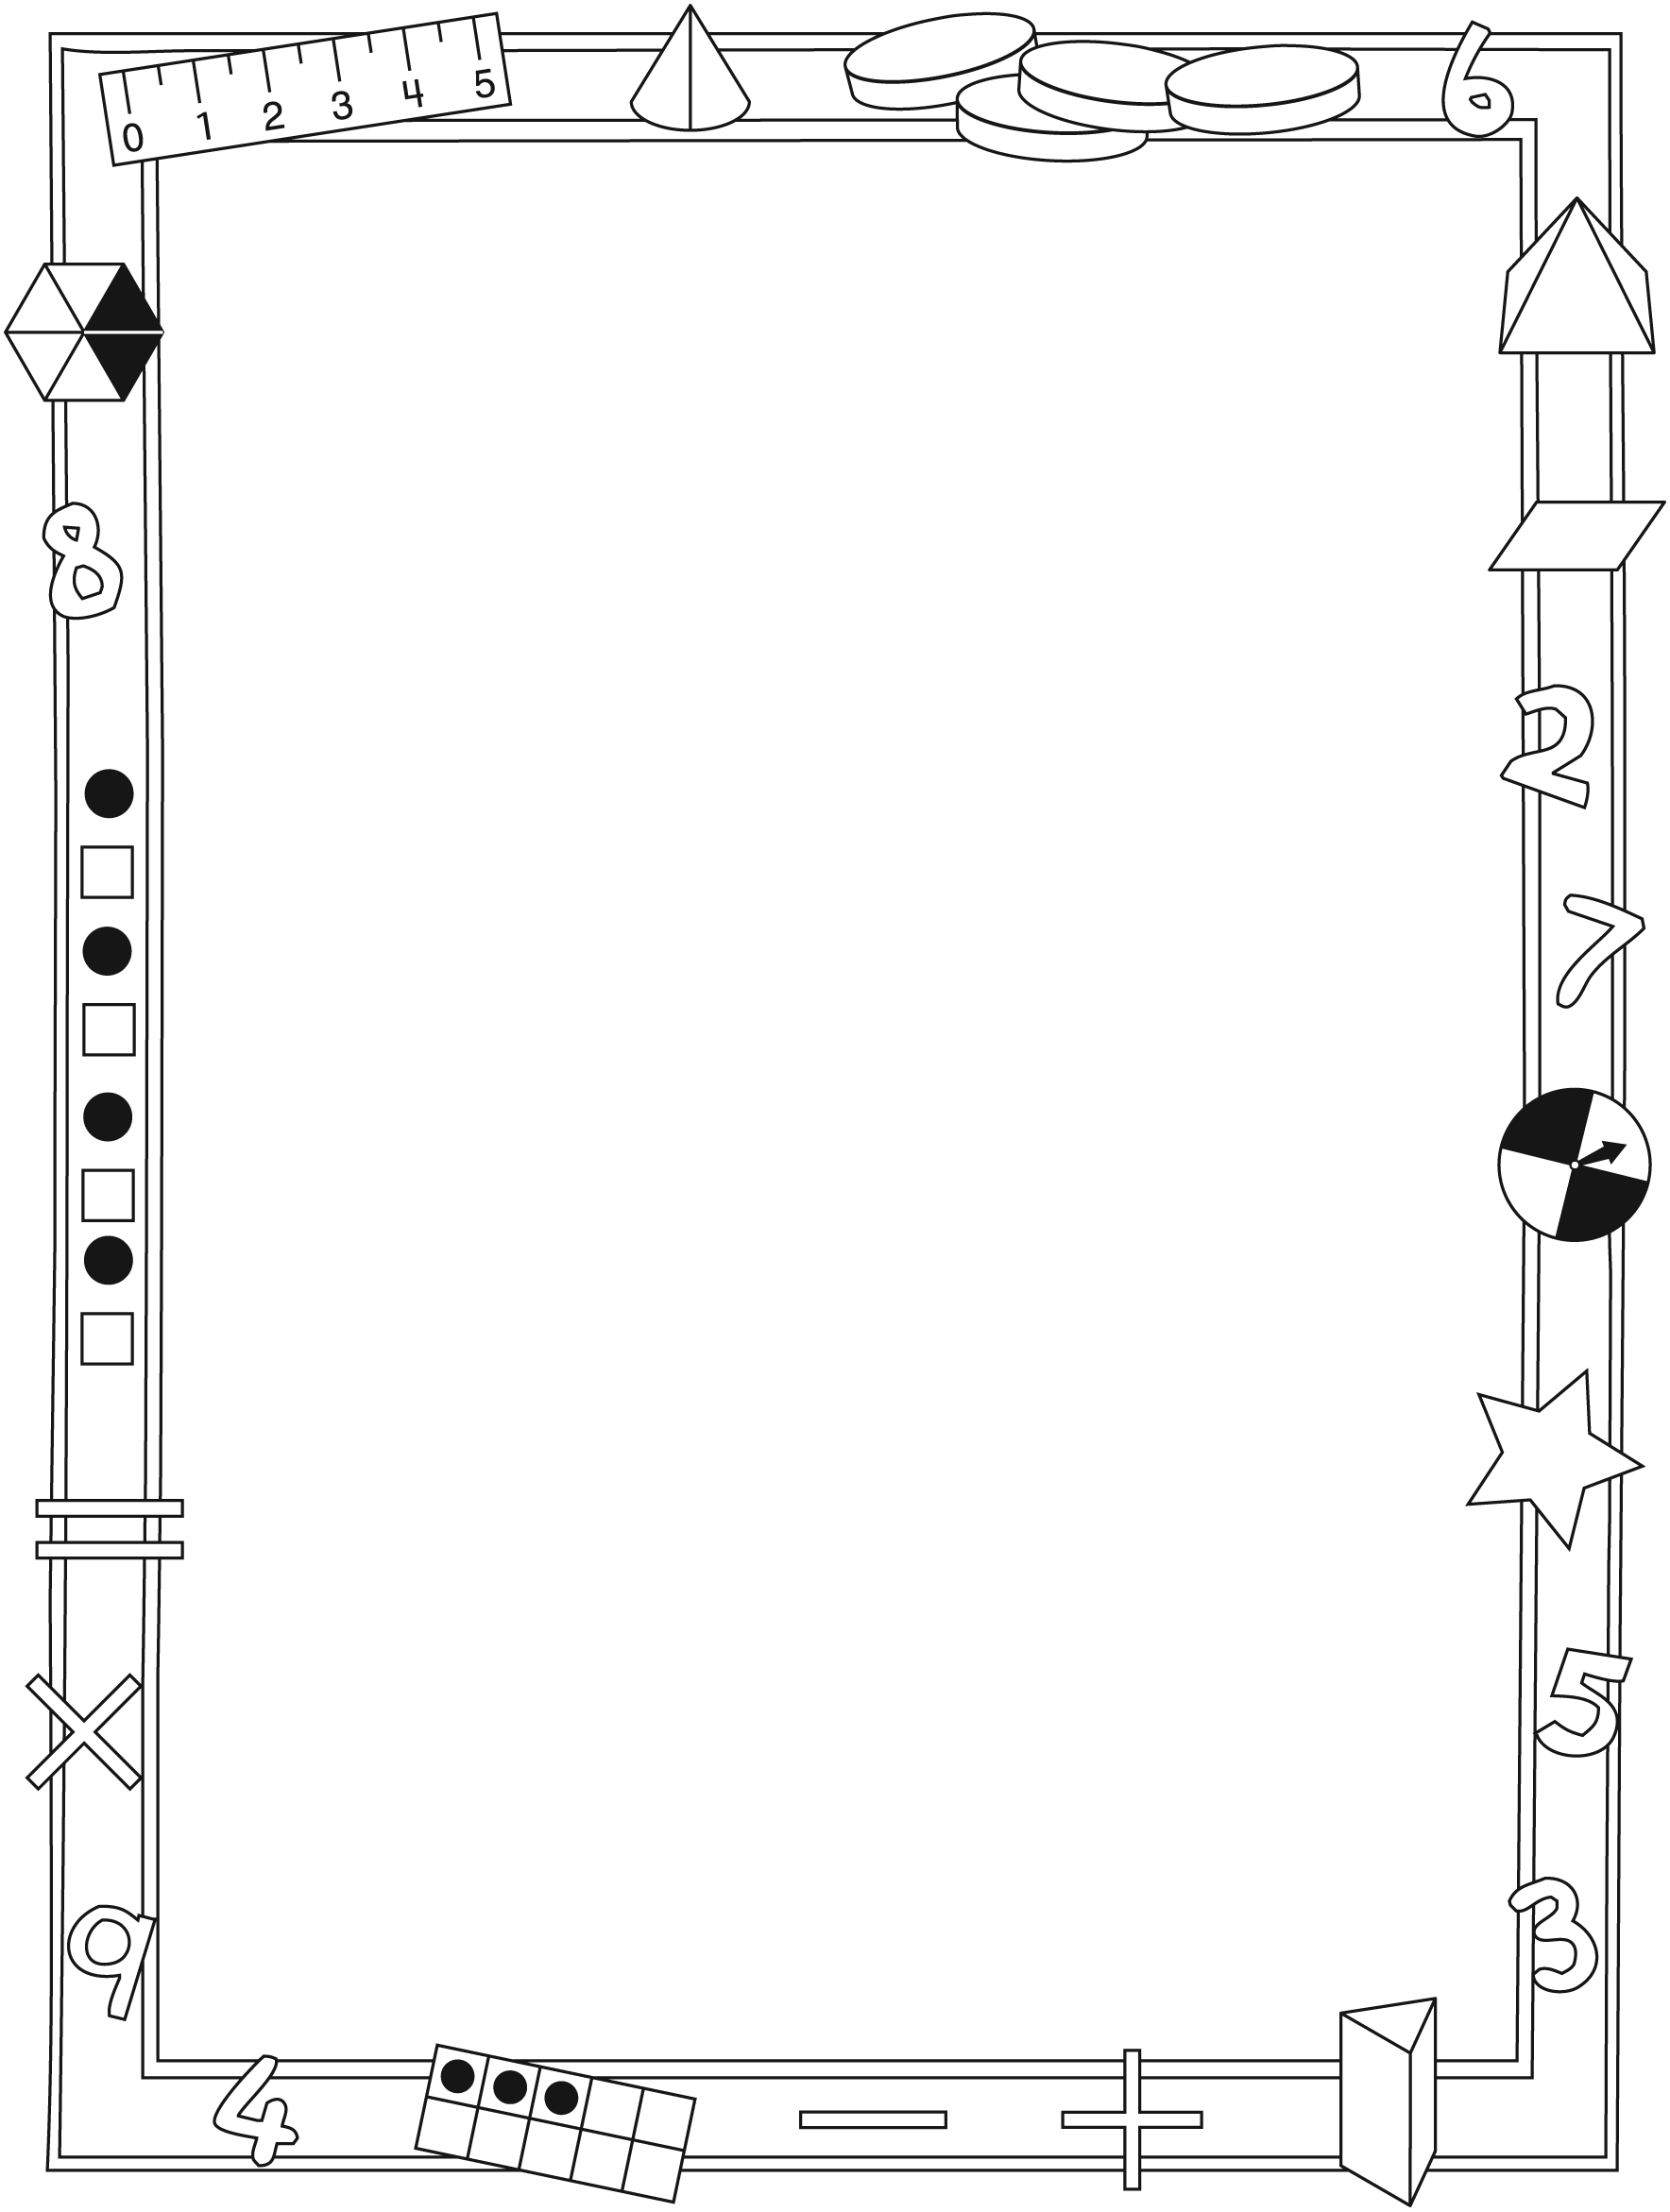

NOTE TO THE TEACHER

You may wish to send families a How Many Is Too Many? letter outlining a familiar activity or two they can do at home with their children.

Create a letter using this template and select one or two activities from the suggestions on the next page. Simply delete these instructions and cut and paste the activities you have selected, adapting them to fit your needs.

Connecting Home and School Line Master 2–2

Dear Family:

We have been working on How Many is Too Many?, which focuses on Estimating, and Grouping to Skip Count to 50 and Comparing Quantities to 50. Try this activity at home with your child.

– – – – – – – – – – – – – – – – – – – – – – – – – – – – – – – – – – – – – – – – – –

Reading the Story: As you read the story, enjoy estimating (your best guess as to how many there are) and counting the collections. Encourage your child to chant the counting sequences. You might find your child keeps the chanting and pattern going by naming the next numbers in the sequence.

– – – – – – – – – – – – – – – – – – – – – – – – – – – – – – – – – – – – – – – – – –

Counting in Different Ways: Invite your child to count by 2s, 5s, and 10s. Find collections of items in your home to count. Ask your child to estimate how many he/she thinks there are; group them (by 2s, 5s, 10s) and then count and recount to find out how many. You might look for and count items that come in pairs (socks, shoes, mittens, eyes in your family); or fives (fingers, toes); or tens (fingers, toes).

– – – – – – – – – – – – – – – – – – – – – – – – – – – – – – – – – – – – – – – – – –

Handfuls: Grab a handful of small objects (buttons, cotton swabs, paper clips, etc.) along with your child and spill them onto a work area. You both look at your objects, announce how many you think you have, and whether you think you have more than, fewer than, or the same number as the other. Group your items (by 2s, 5s, or 10s), count to determine how many there are, then talk and decide who has more.

– – – – – – – – – – – – – – – – – – – – – – – – – – – – – – – – – – – – – – – – – –

Sincerely,

___________________________

Ten-Frames Line Master 3

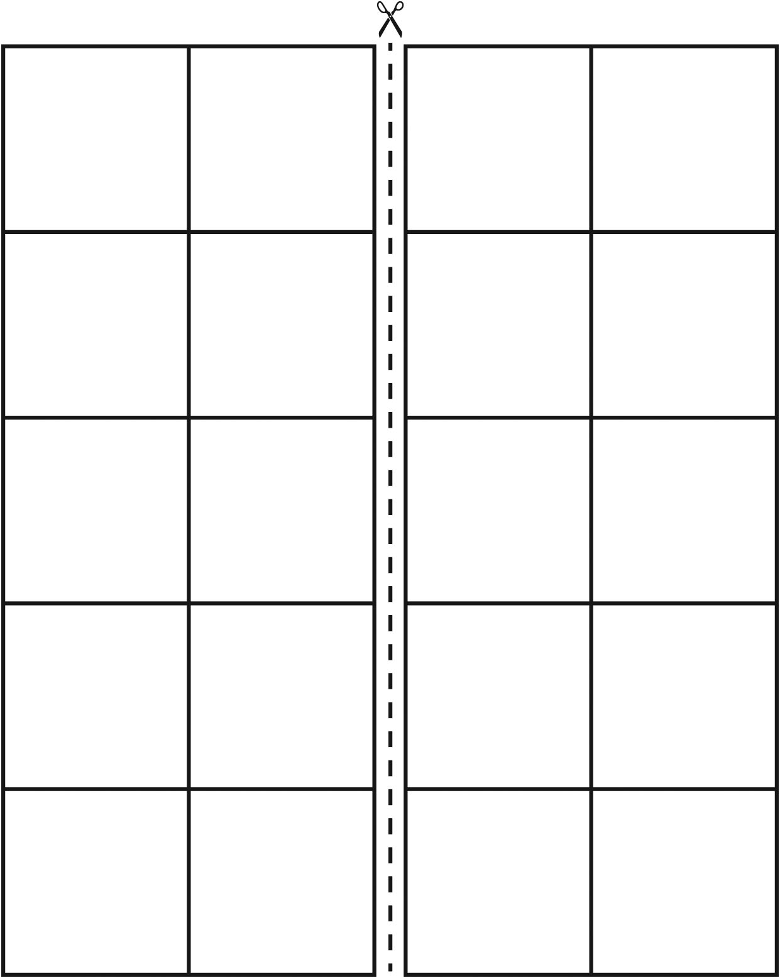

Counting Recording Sheet Line Master 4
Name: _________________________________________

I estimated… | I counted… | I counted again…

Hundred Chart Line Master 5

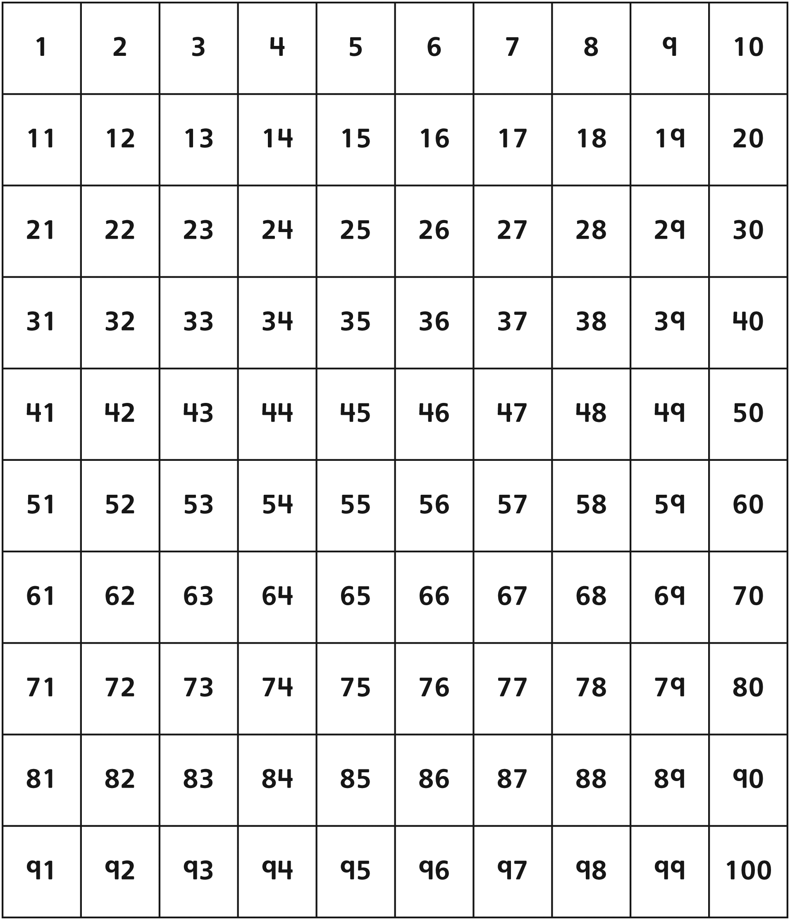

Fifty Chart Line Master 6

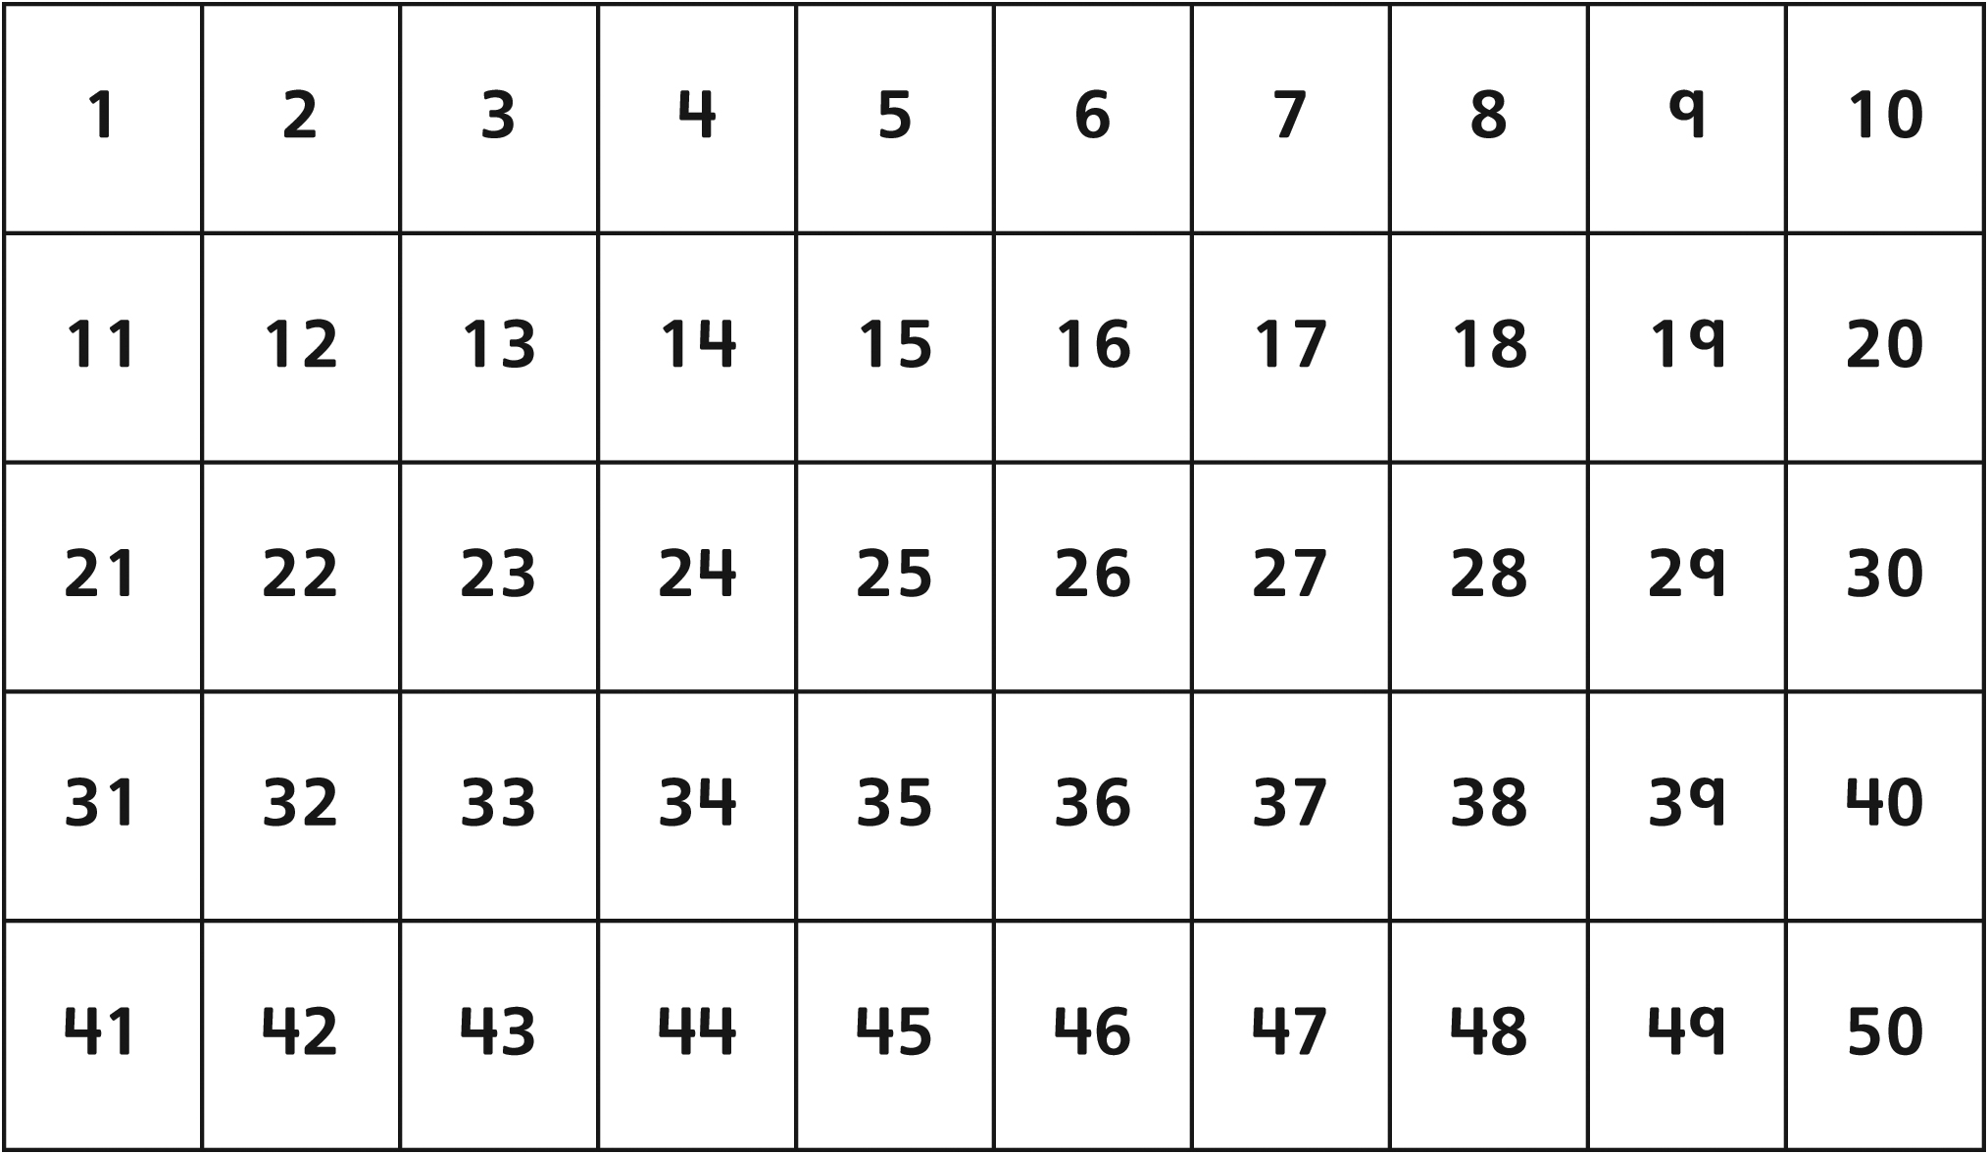

– – – – – – – – – – – – – – – – – – – – – – – – – – – – – – – – – – – – – – – – – –

Double Ten-Frame Line Master 7

Do I Have Too Many? Line Master 8
Recording Sheet

What You Need
• counters
• counter with sides labeled “More” and “Fewer”
• ten-frames or double ten-frames
• number cards with 20, 30, 40

How to Play
Taking turns:
• Turn over a number card.
• Grab counters. Try to get the same number of counters as the number on the card.
• Count the counters you grabbed.
• Score 2 points if you grabbed the same number of counters as the number on the card
• If you don’t score 2 points, flip the labeled counter.
• Score 1 point if you grabbed an amount that matches how the counter landed.

Turn | Player 1 | Player 2
1
2
3
4
5
 | Total: | Total:

How Many? Problems Line Master 9–1
– – – – – – – – – – – – – – – – – – – – – – – – – – – – – – – – – – – – – – – – – –

How many lines? ___________________

How did you count? _______________________________________________________

– – – – – – – – – – – – – – – – – – – – – – – – – – – – – – – – – – – – – – – – – –
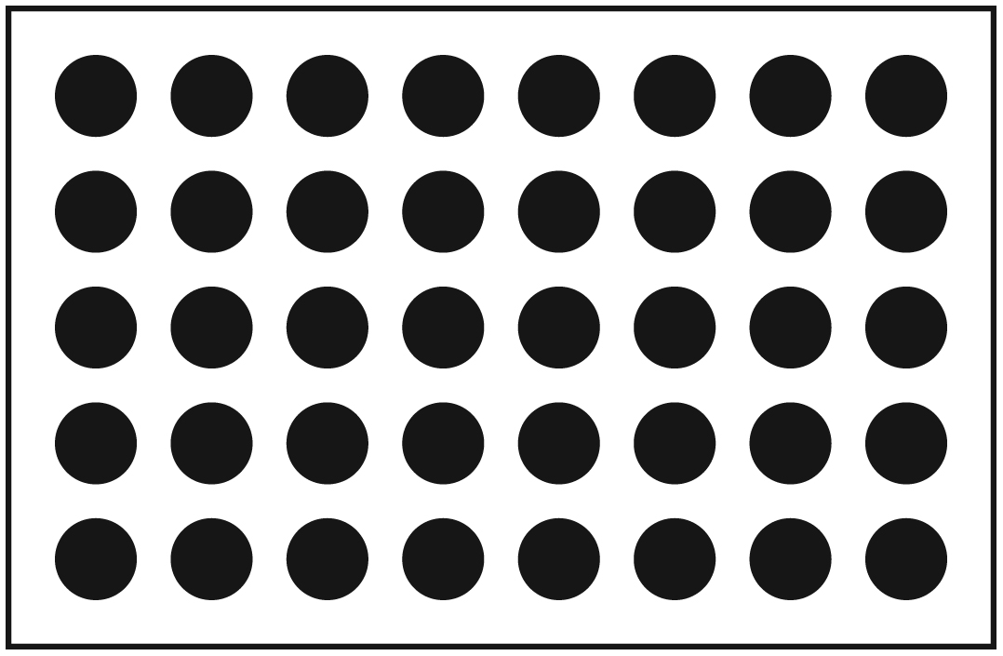

How many dots? __________________

How did you count? _______________________________________________________

How Many? Problems Line Master 9–2
– – – – – – – – – – – – – – – – – – – – – – – – – – – – – – – – – – – – – – – – – –

How many dots? __________________

How did you count? _______________________________________________________
– – – – – – – – – – – – – – – – – – – – – – – – – – – – – – – – – – – – – – – – – –
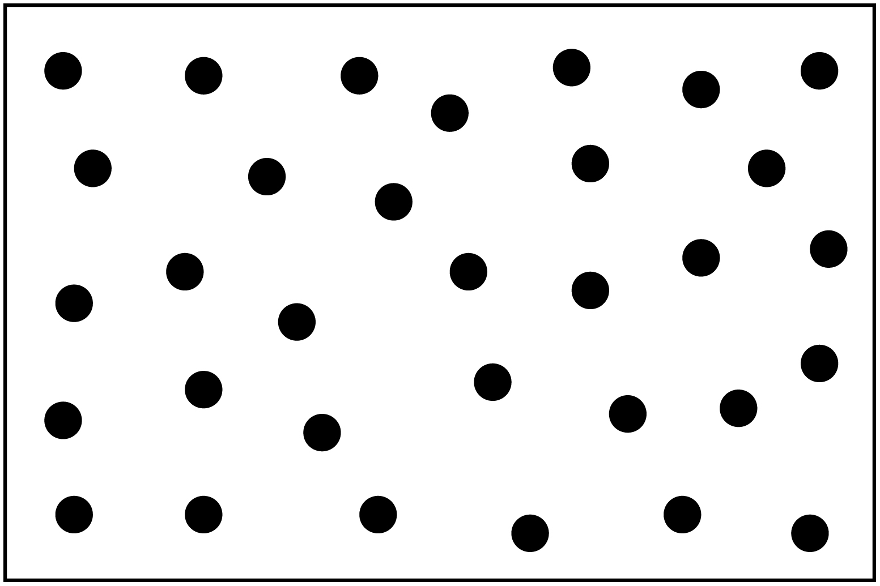

How many dots? __________________

How did you count? _______________________________________________________

