The Tailor Shop Line Master 1
(Assessment Master)
Name: _____________________________

Transform and Describe Shapes | Not observed | Sometimes | Consistently
Identifies congruent shapes (i.e., same size and shape)
Moves and manipulates shapes to check for congruency (slide, flip, turn)
Describes how to make shapes congruent
Identifies symmetrical shapes and designs
Constructs and/or completes symmetrical shapes and designs
Describe and Compare Shapes
Recognizes and describes shapes
Identifies and describes similarities and differences among shapes
Describes location, position, and/or orientation of shapes
Gives clear and accurate directions
Composes and completes composite shapes (shapes made from other shapes)
Strengths:

Next Steps:

Connecting Home and School Line Master 2–1

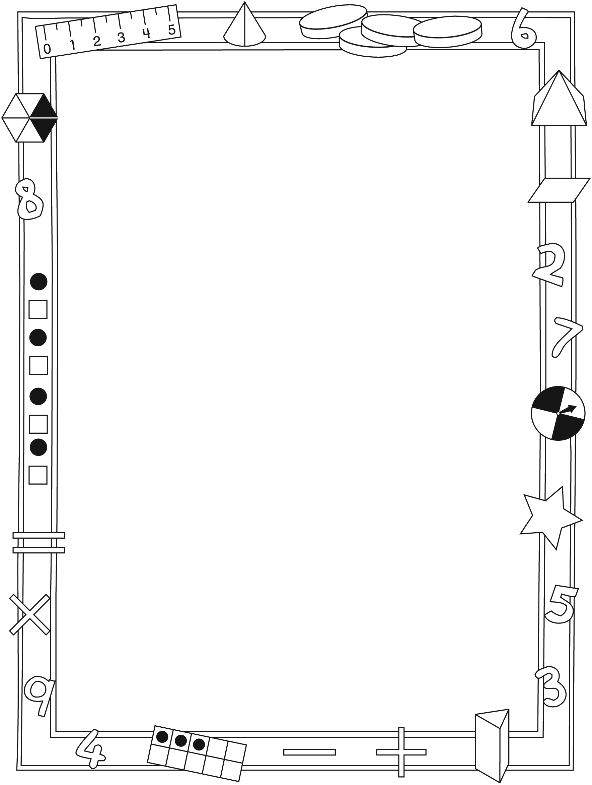

NOTE TO THE TEACHER

You may wish to send families a The Tailor Shop letter outlining a familiar activity or two they can do at home with their children.

Create a letter using this template and select one or two activities from the suggestions on the next page. Simply delete these instructions and cut and paste the activities you have selected, adapting them to fit your needs.

Connecting Home and School Line Master 2–2

Dear Family:

We have been working on The Tailor Shop, which engages children in conversations, investigations, and activities that help to develop their understanding of the big math idea that “Shapes and solids can be transformed in many ways.” Particular focus is placed on transforming, describing, and comparing shapes, and using them to make pictures and designs. Try this activity at home with your child.
– – – – – – – – – – – – – – – – – – – – – – – – – – – – – – – – – – – – – – – – – –
Reading the Story: As you read the story, enjoy predicting what Thomas might make with the shapes he selects from the sack. Talk about the different shapes he chooses and others within the illustrations. Consider tracing some of the shapes with your finger and making them in the air. Look for shapes that might be exactly the same size and shape. We call these congruent shapes. You might play I Spy (e.g., I spy a large, red circle above the table.). Encourage your child to take on the I Spy role.
– – – – – – – – – – – – – – – – – – – – – – – – – – – – – – – – – – – – – – – – – –
Make My Shape Picture: Your child has brought home some paper shapes.
Take turns making a picture or design by combining and arranging different shapes, and then challenging each other to re-create the picture using the same or different shapes. Compare the two pictures and identify the shapes used and where they are positioned.
– – – – – – – – – – – – – – – – – – – – – – – – – – – – – – – – – – – – – – – – – –
Paint Blobs: We are exploring symmetry. To create symmetrical designs, we have been putting identical shapes of the same size on both sides of a line called the line of symmetry. Fold a sheet of paper in half and then unfold it. On one half, place small drops or blobs of paint. Refold the paper and gently press down on it while the paint is still wet. Unfold the paper and ask your child what he/she notices when looking at both sides of the fold (symmetry) line. Have fun exploring and creating interesting symmetrical designs!
– – – – – – – – – – – – – – – – – – – – – – – – – – – – – – – – – – – – – – – – – –
Puzzles and More Puzzles! Working on and completing puzzles offers your child a wonderful opportunity to develop his/her spatial thinking and reasoning. Pieces are often moved around to visualize where and how they will fit.
– – – – – – – – – – – – – – – – – – – – – – – – – – – – – – – – – – – – – – – – – –
Sincerely,

___________________________

The Tailor Shop Line Master 3
Math Mat

Shape Cut-Outs Line Master 4–1

Shape Cut-Outs Line Master 4–2

Shape Cut-Outs Line Master 4–3

Shape Cut-Outs Line Master 4–4

Shape Cut-Outs Line Master 4–5

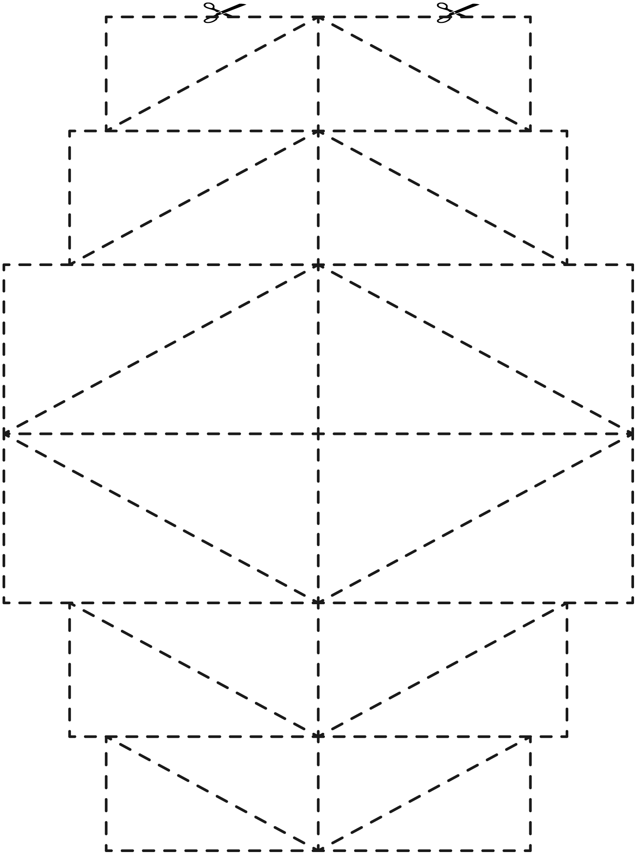

Shape Cut-Outs Line Master 4–6

Shape Cut-Outs Line Master 4–7

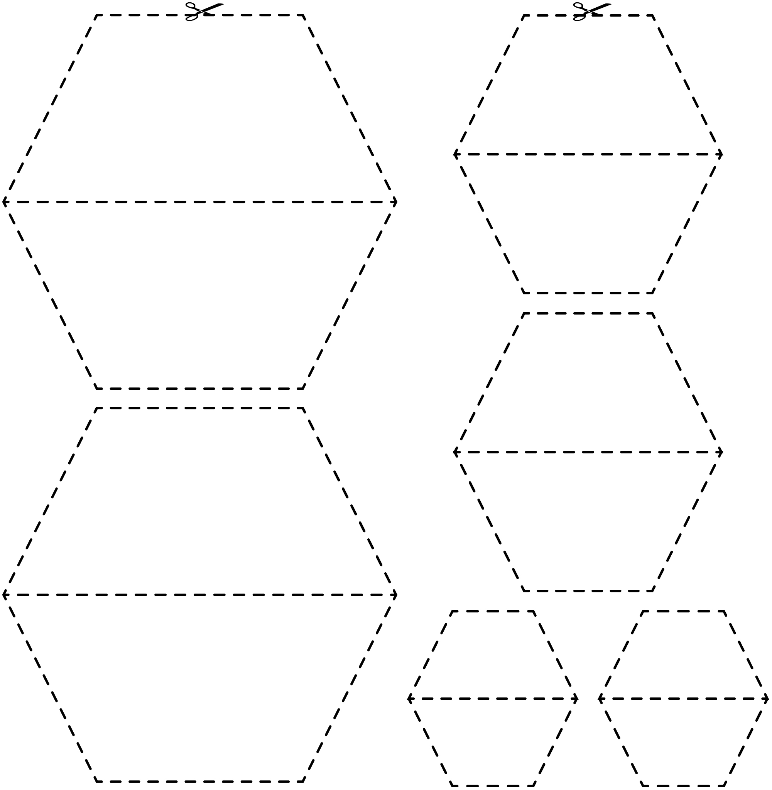

Shape Cut-Outs Line Master 4–8

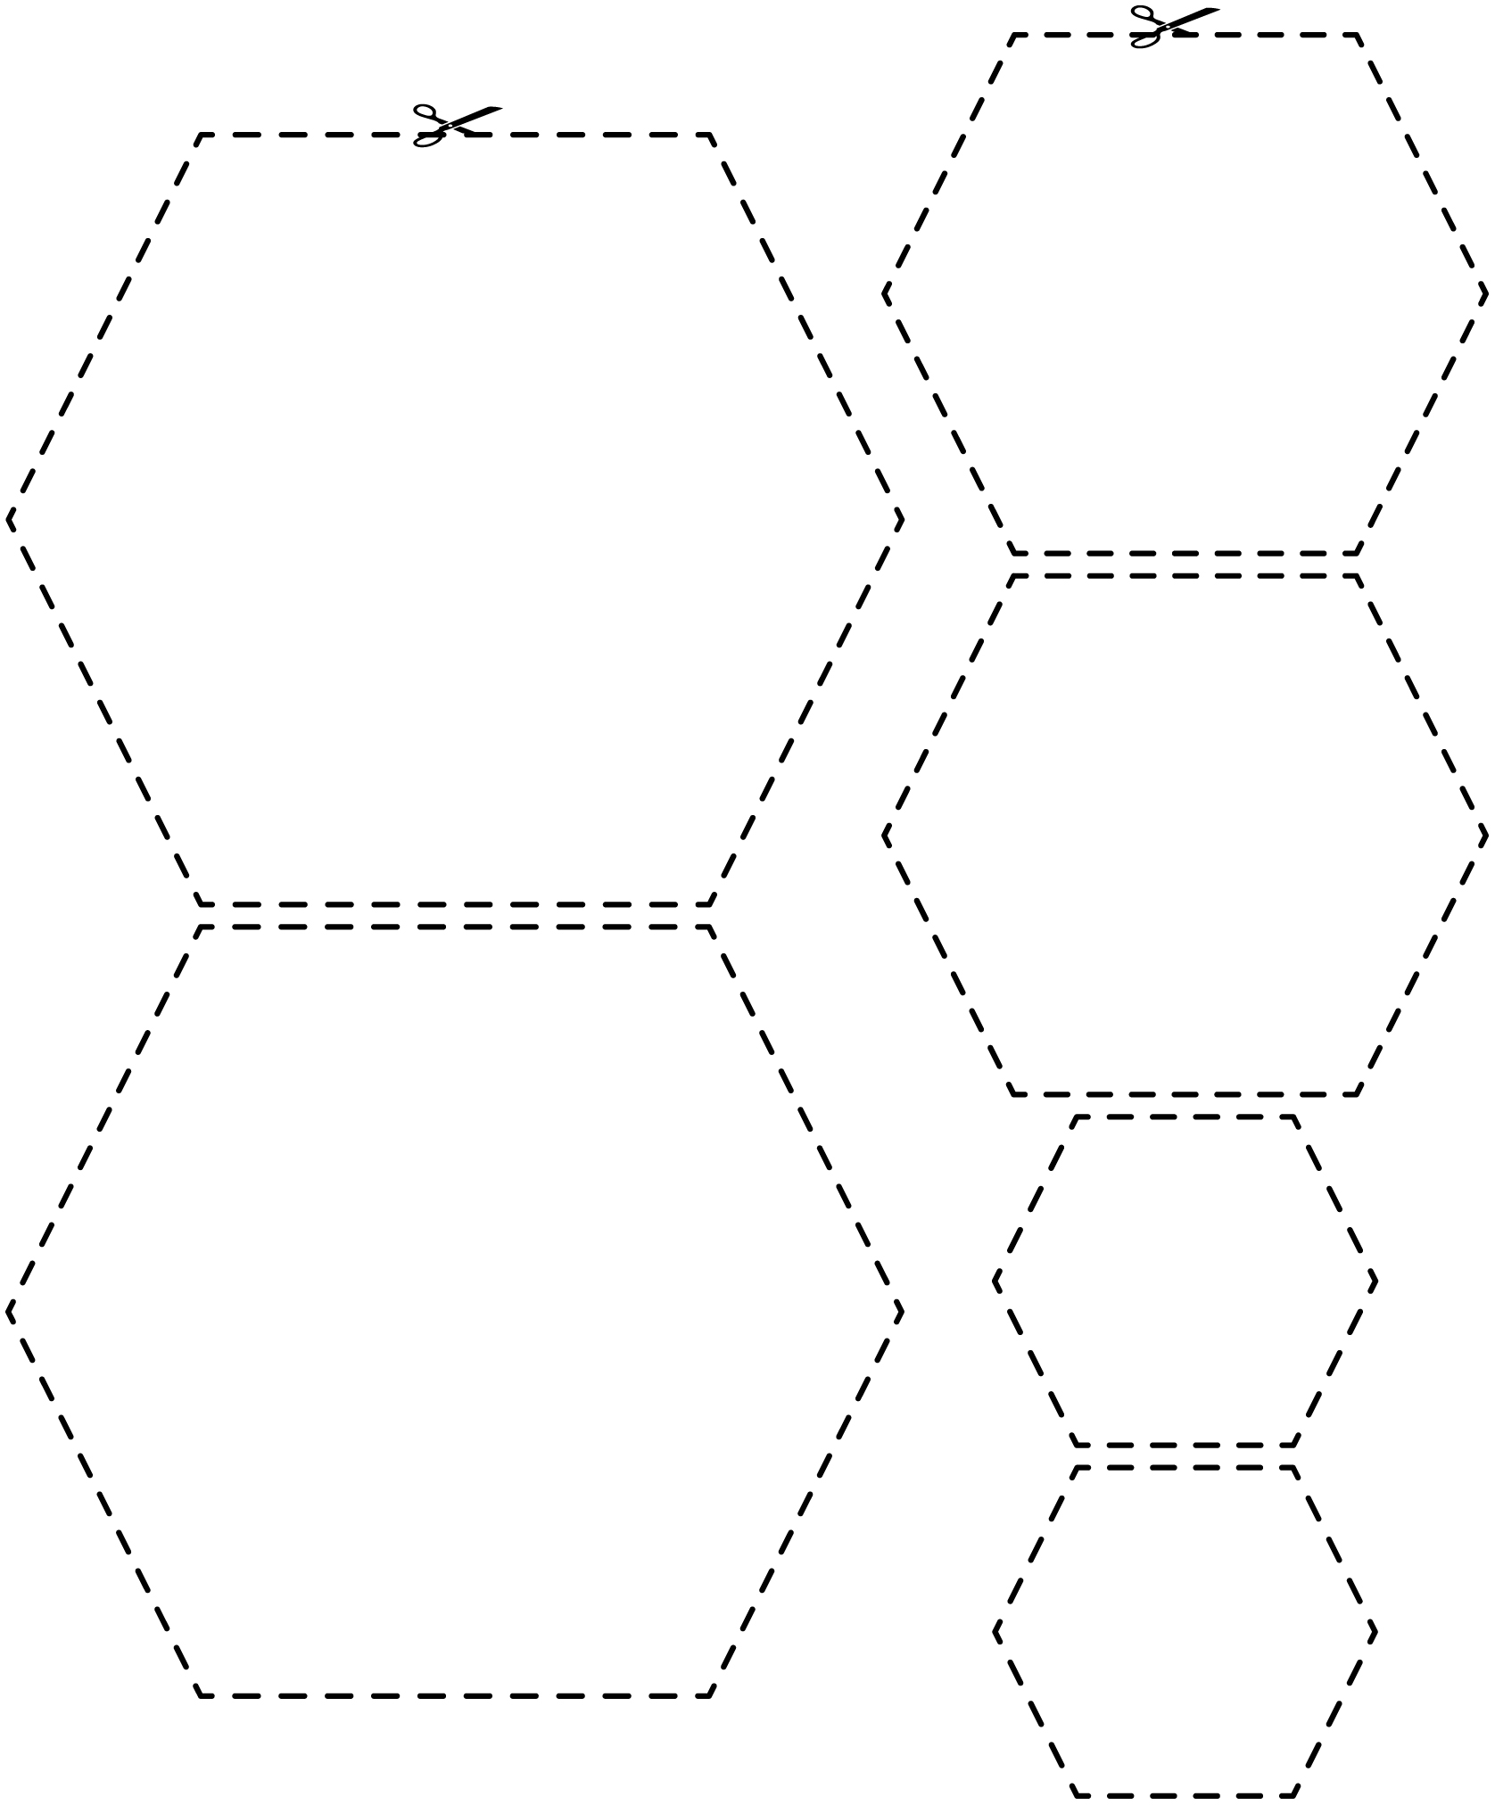

Shape Cut-Outs Line Master 4–9

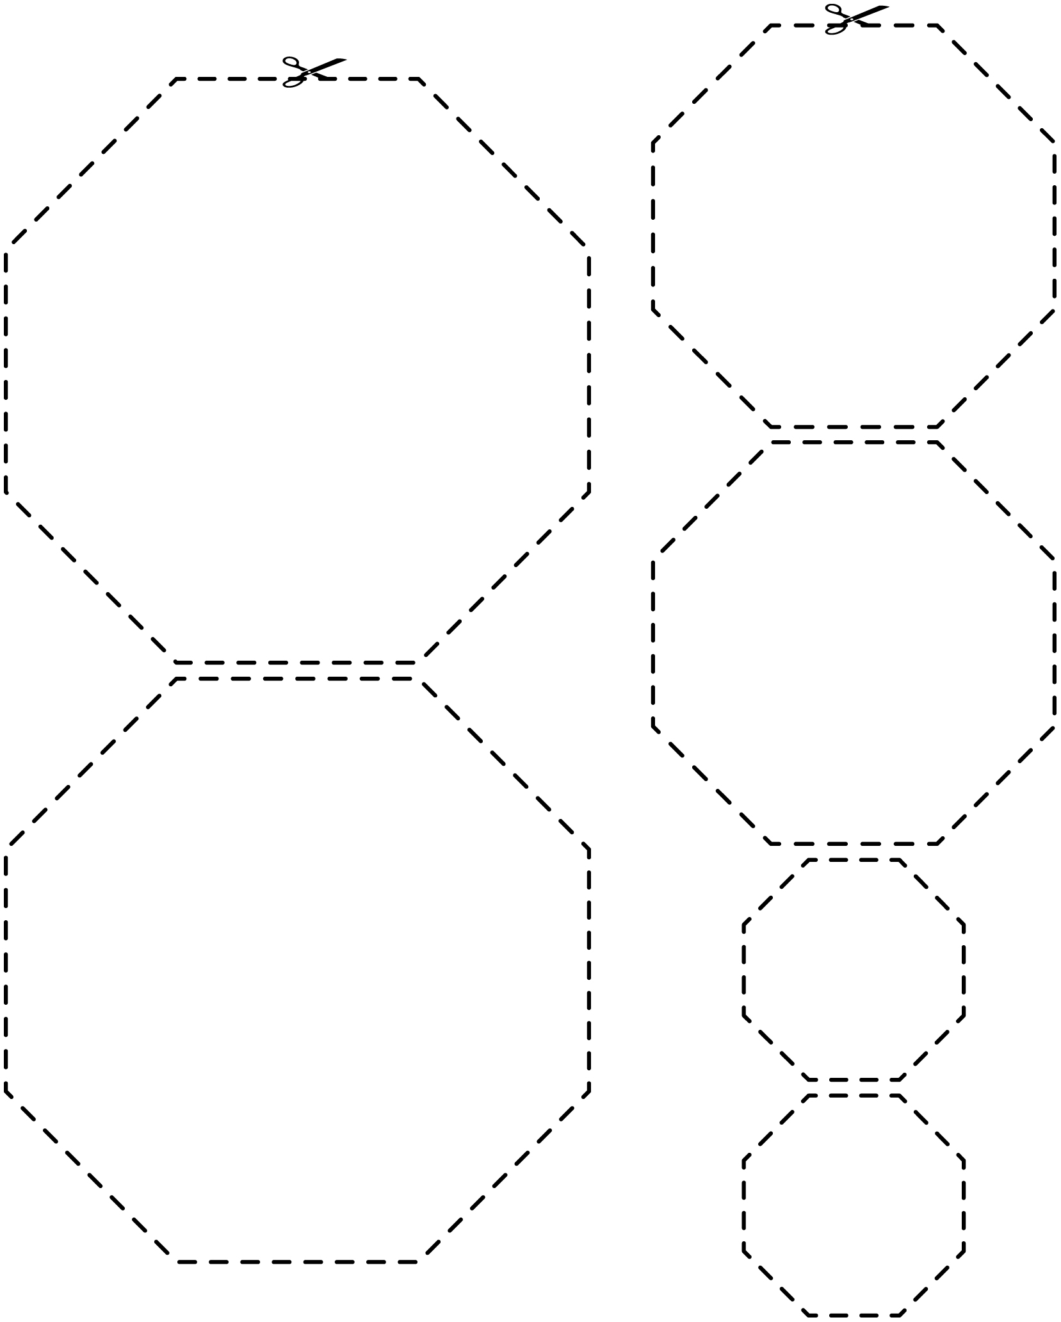

Shape Cut-Outs Line Master 4–10

Shape Cut-Outs Line Master 4–11

Pattern Block Cut-Outs Line Master 5–1

Note: You may wish to print on orange paper.

Pattern Block Cut-Outs Line Master 5–2

Note: You may wish to print on green paper.

Pattern Block Cut-Outs Line Master 5–3

Note: You may wish to print on tan paper.

Pattern Block Cut-Outs Line Master 5–4

Note: You may wish to print on blue paper.

Pattern Block Cut-Outs Line Master 5–5

Note: You may wish to print on red paper.

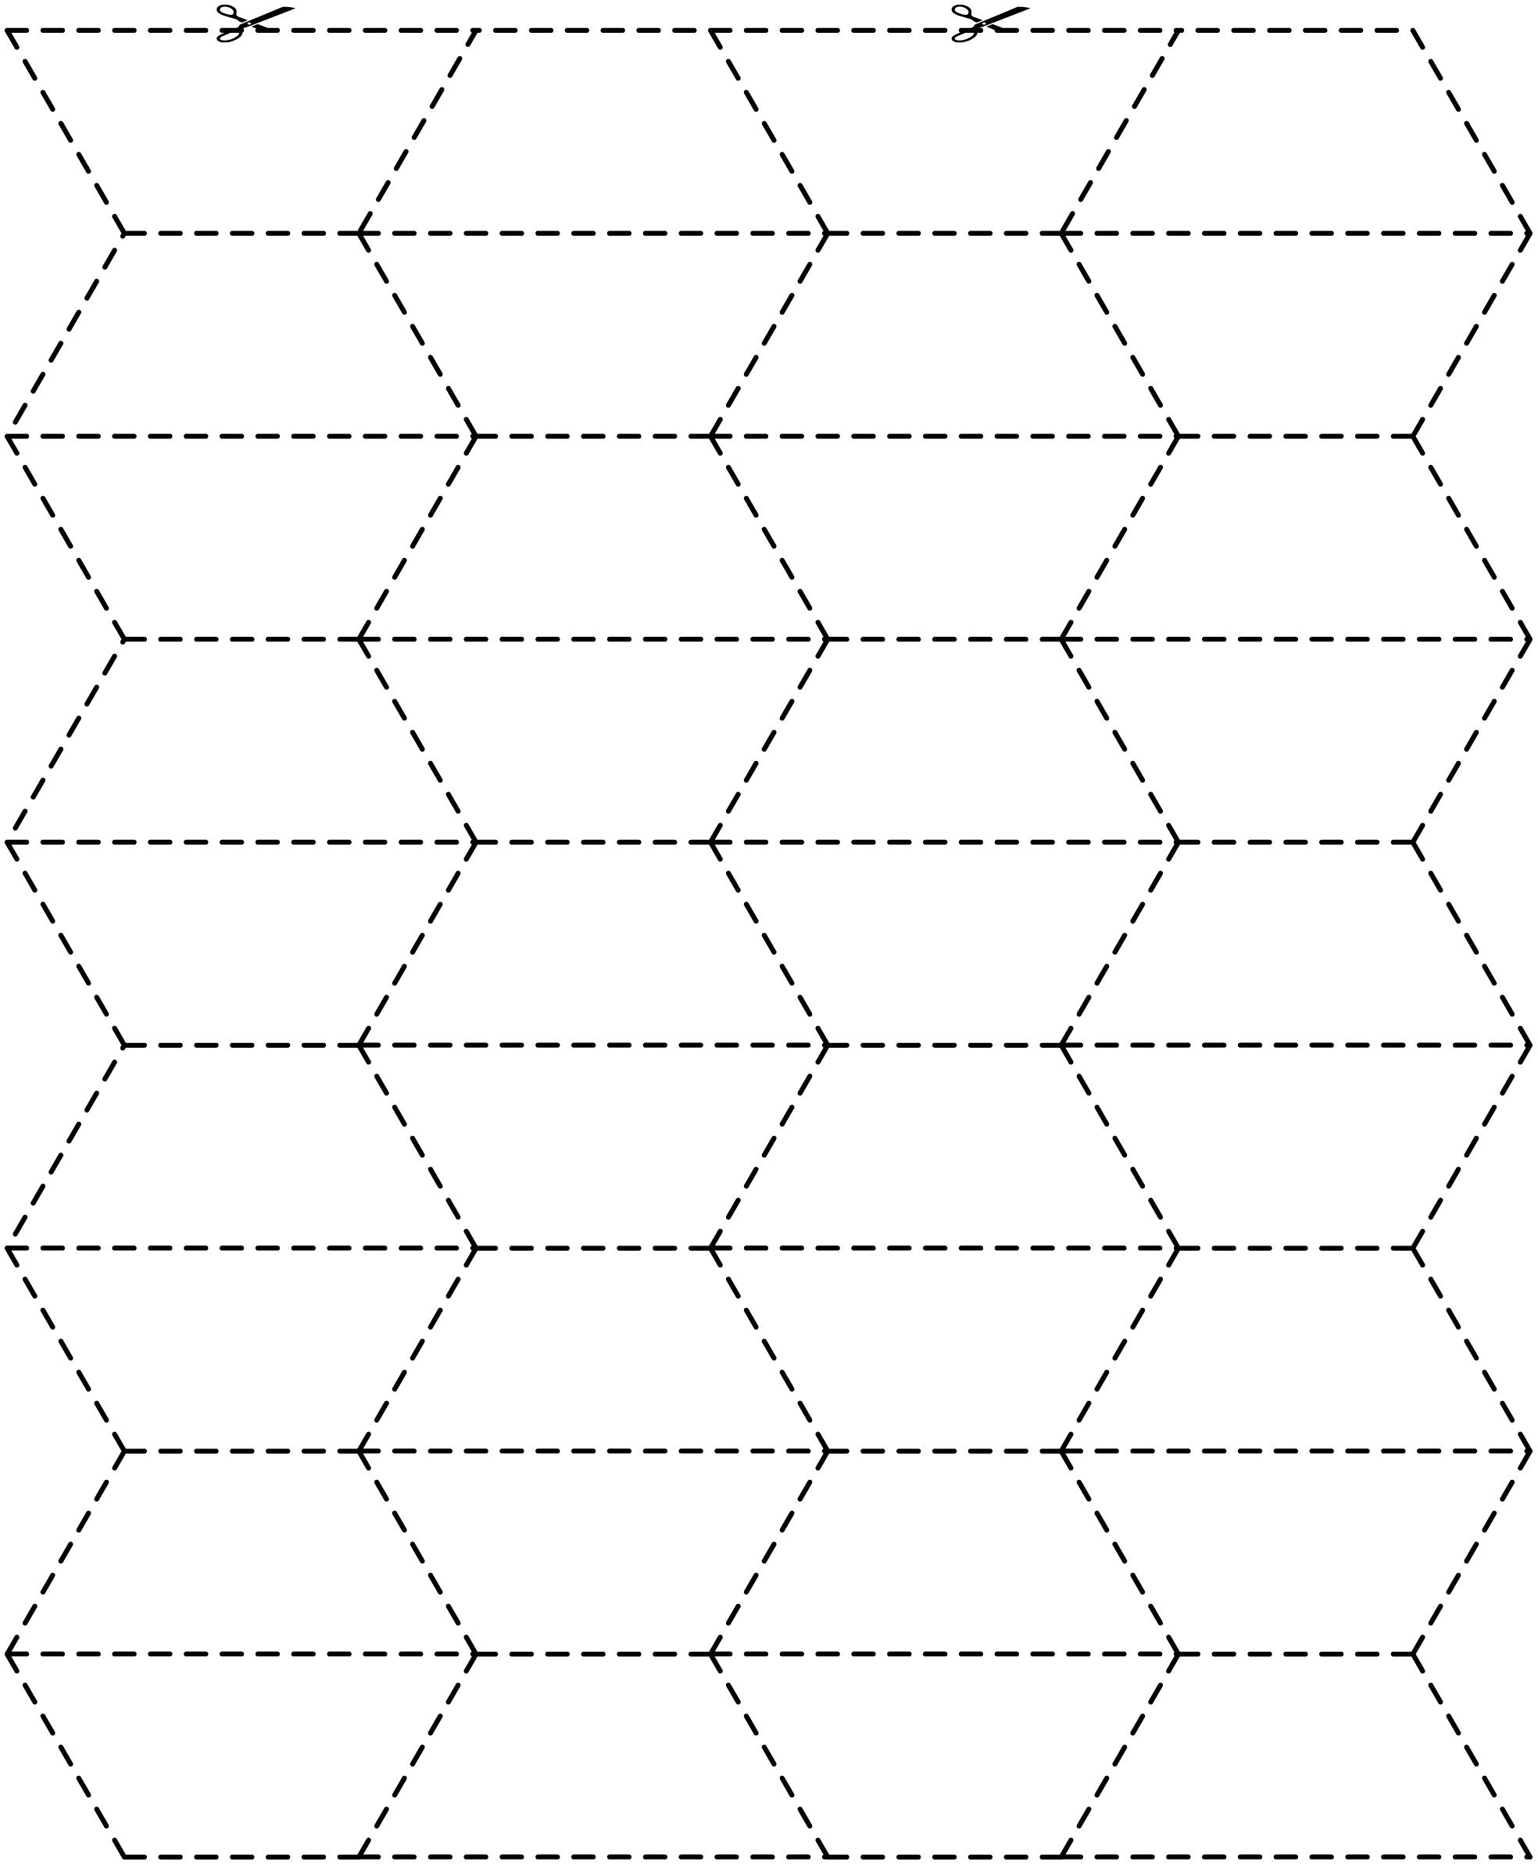

Pattern Block Cut-Outs Line Master 5–6

Note: You may wish to print on yellow paper.

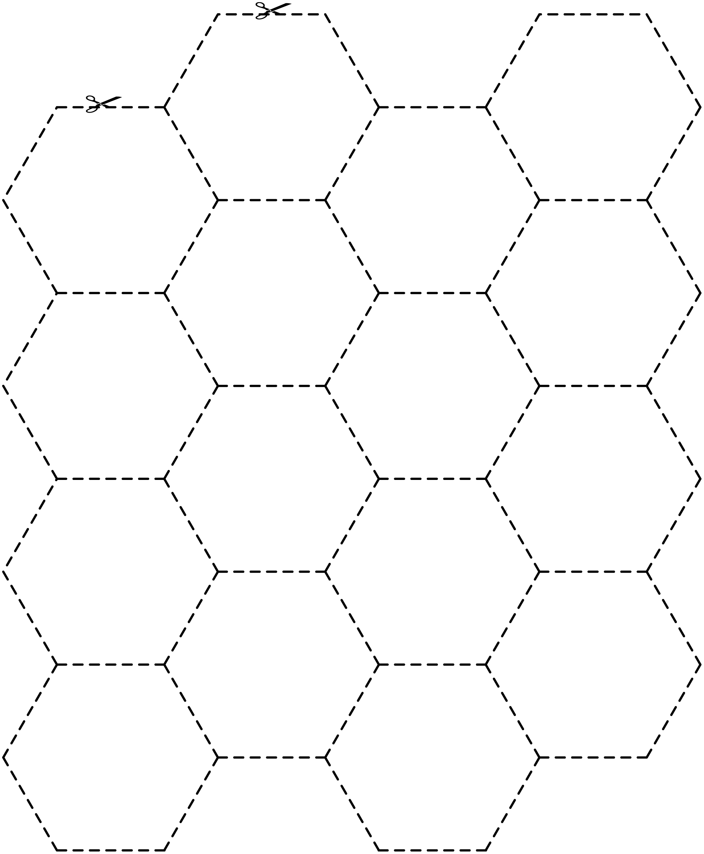

My Flowers Line Master 6
Name: _____________________________

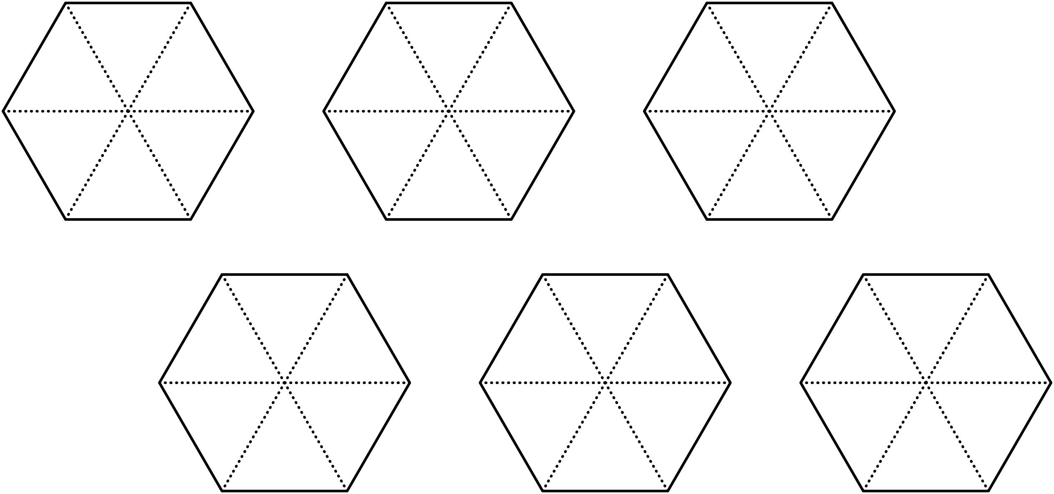

Symmetry Cards Line Master 7–1

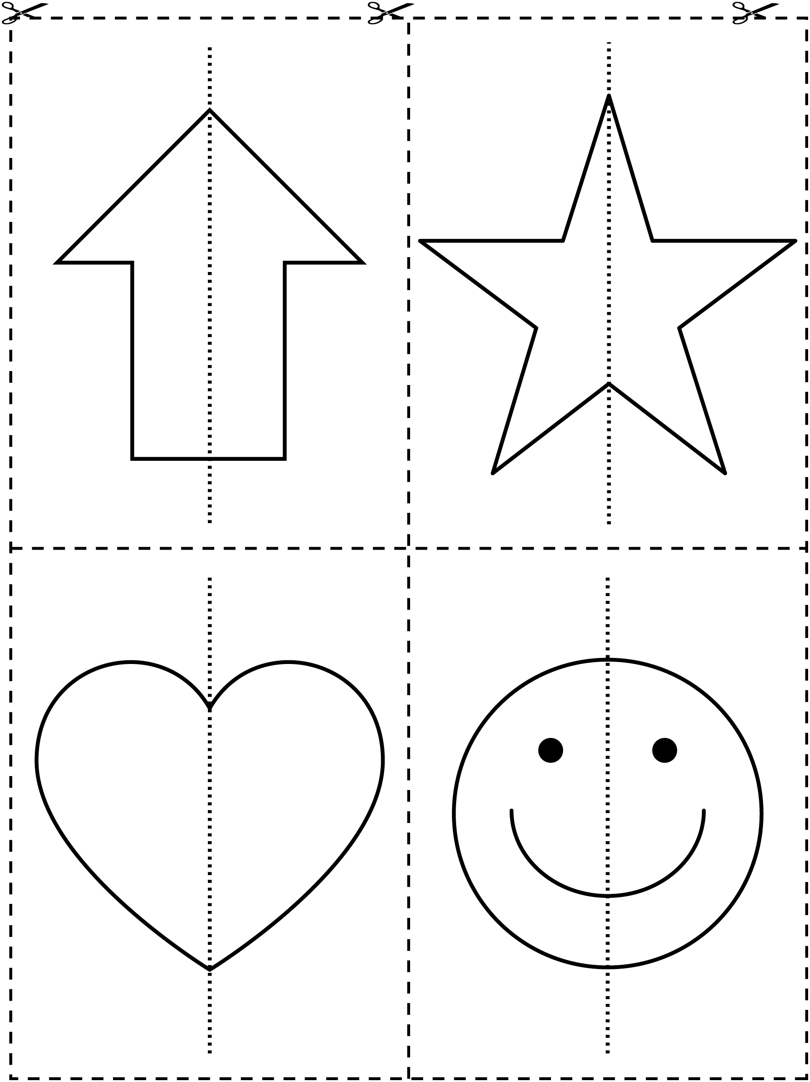

Symmetry Cards Line Master 7–2

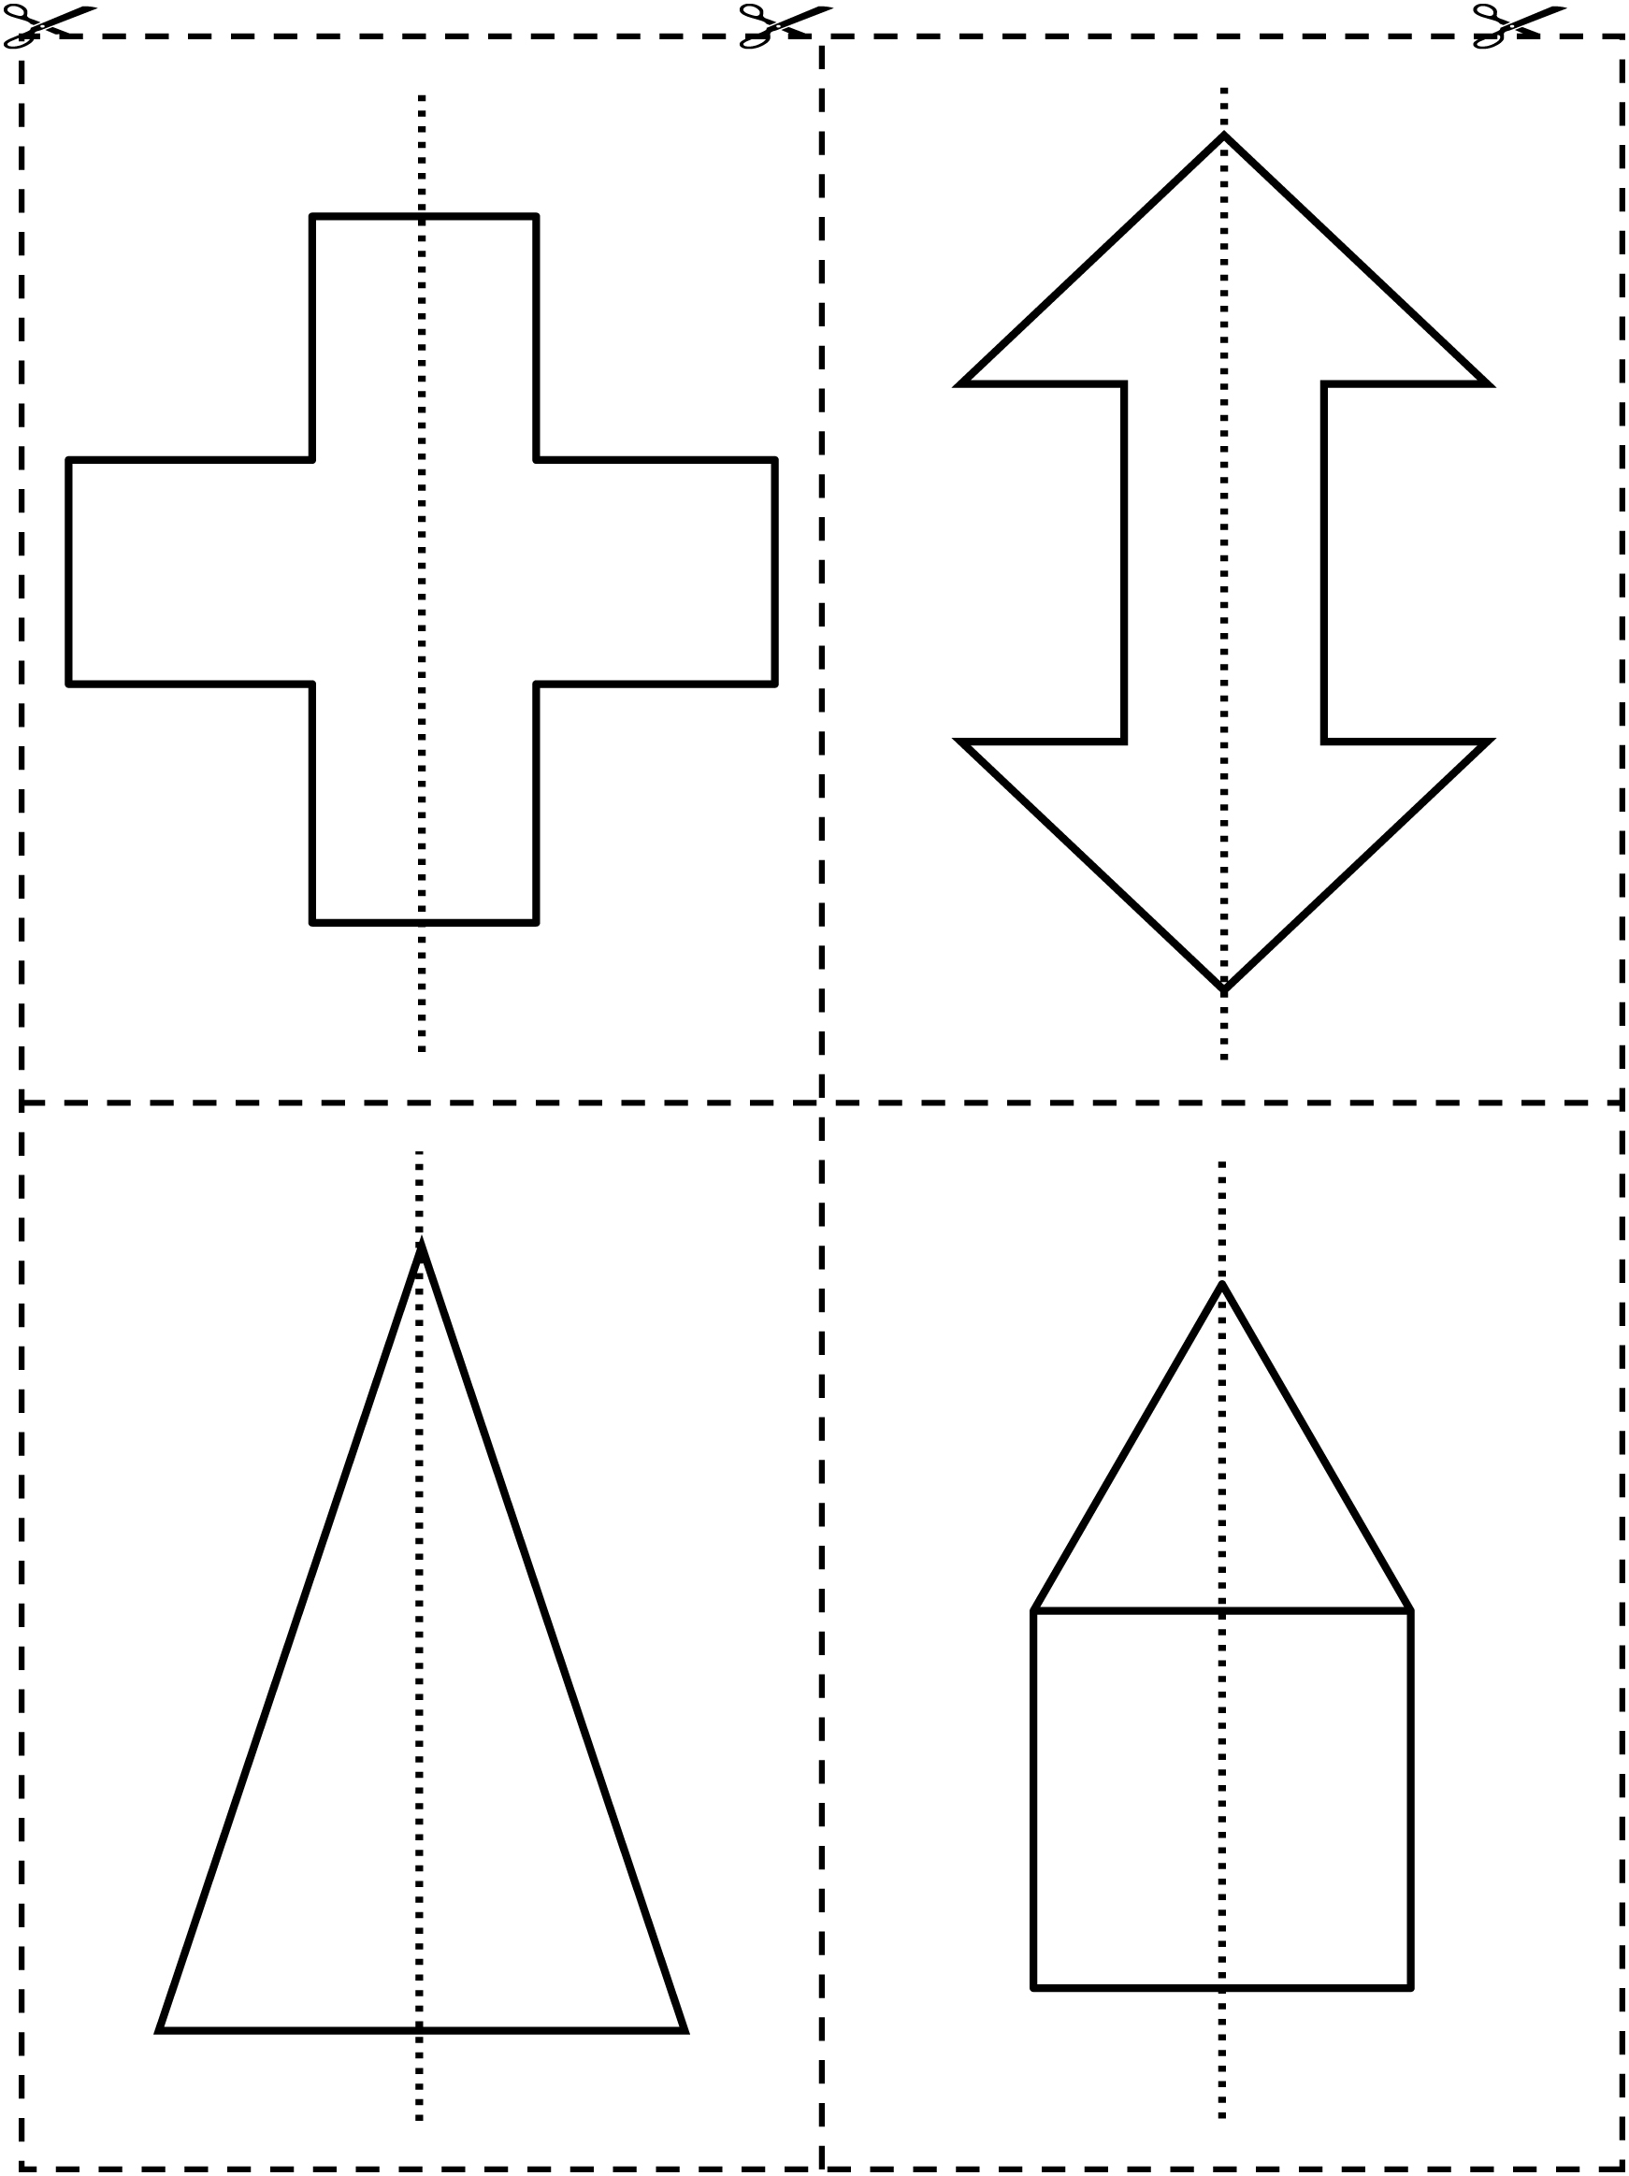

Symmetry Cards Line Master 7–3

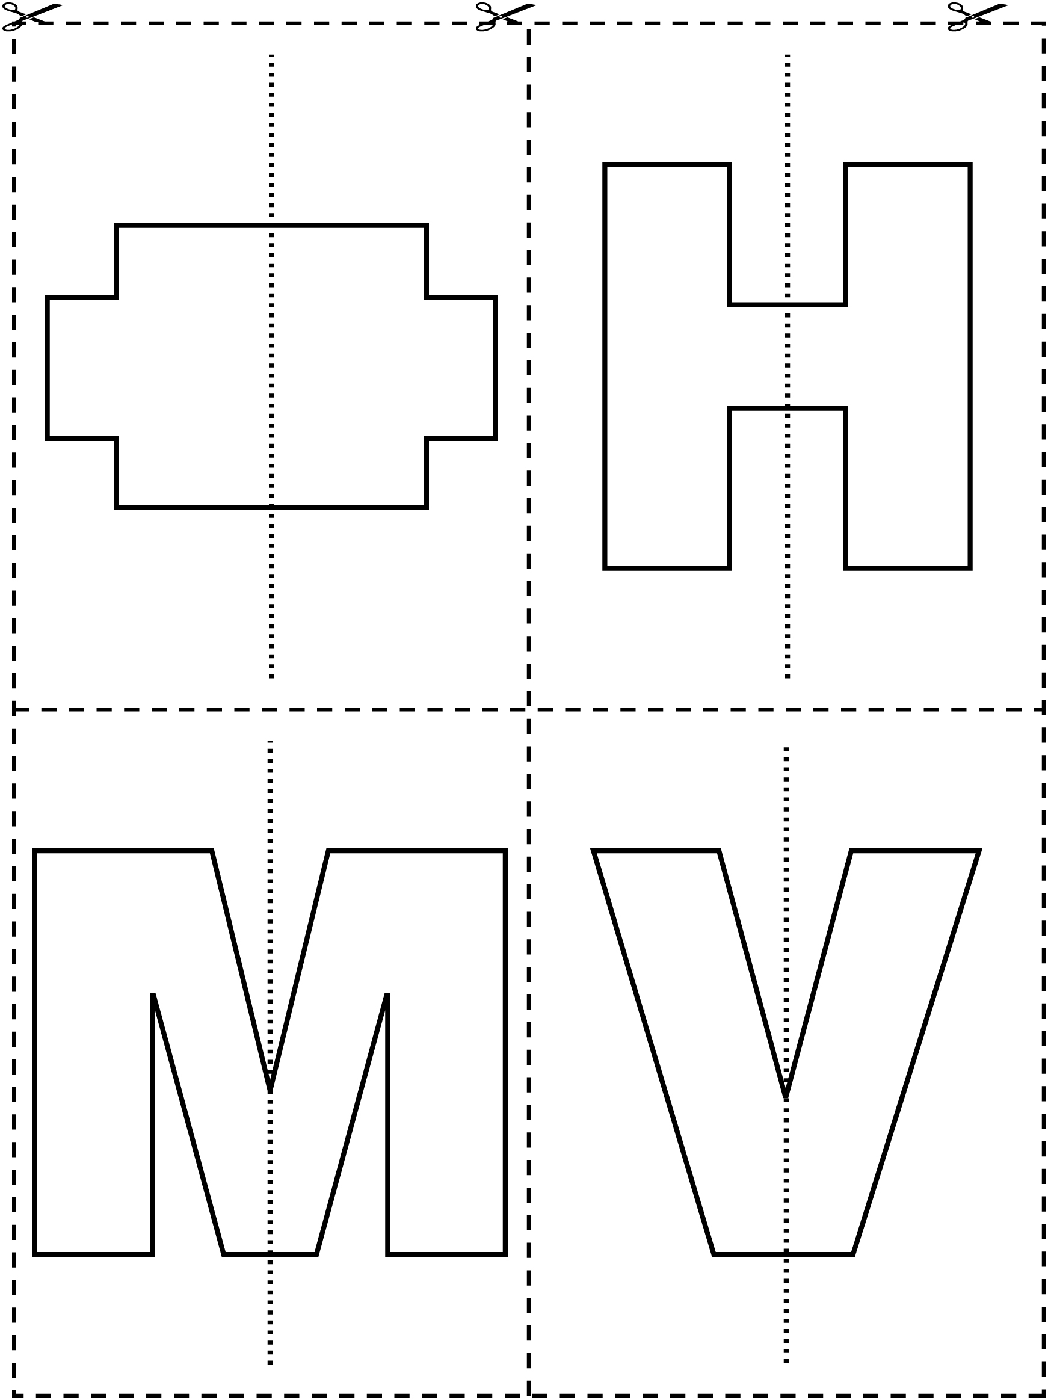

Symmetry Cards Line Master 7–4

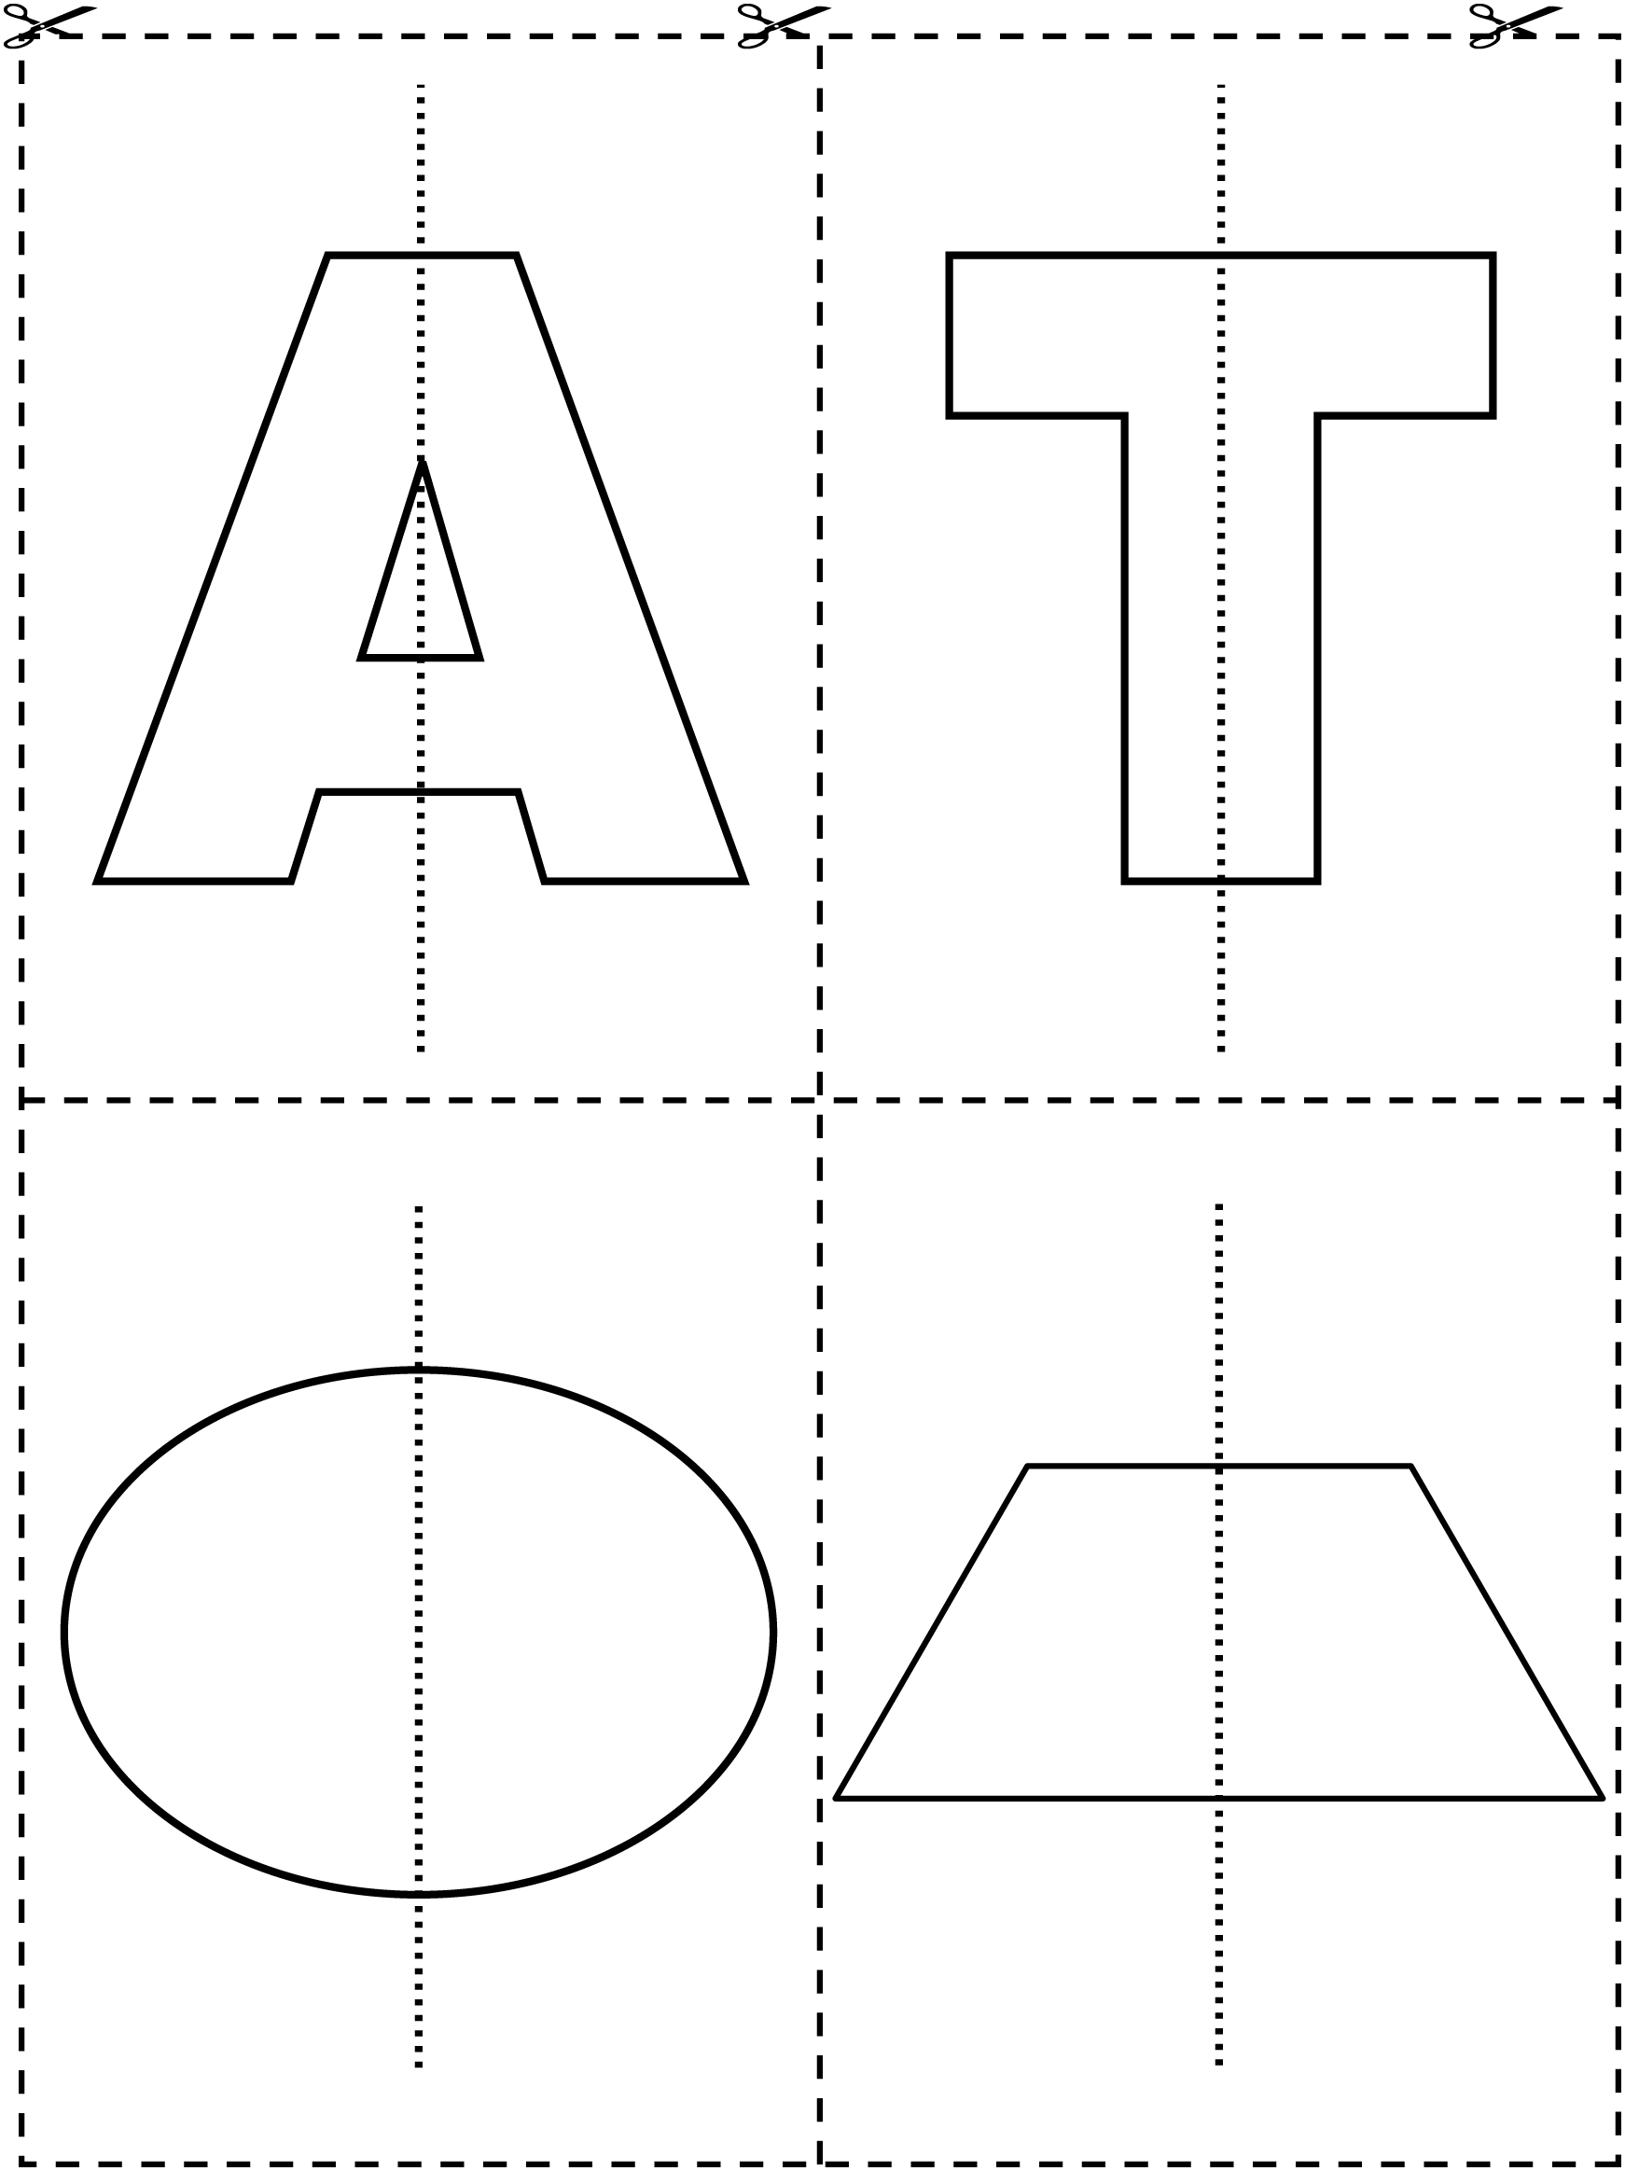

Grid Paper Line Master 8

Shapes with 5 Squares Line Master 9–1

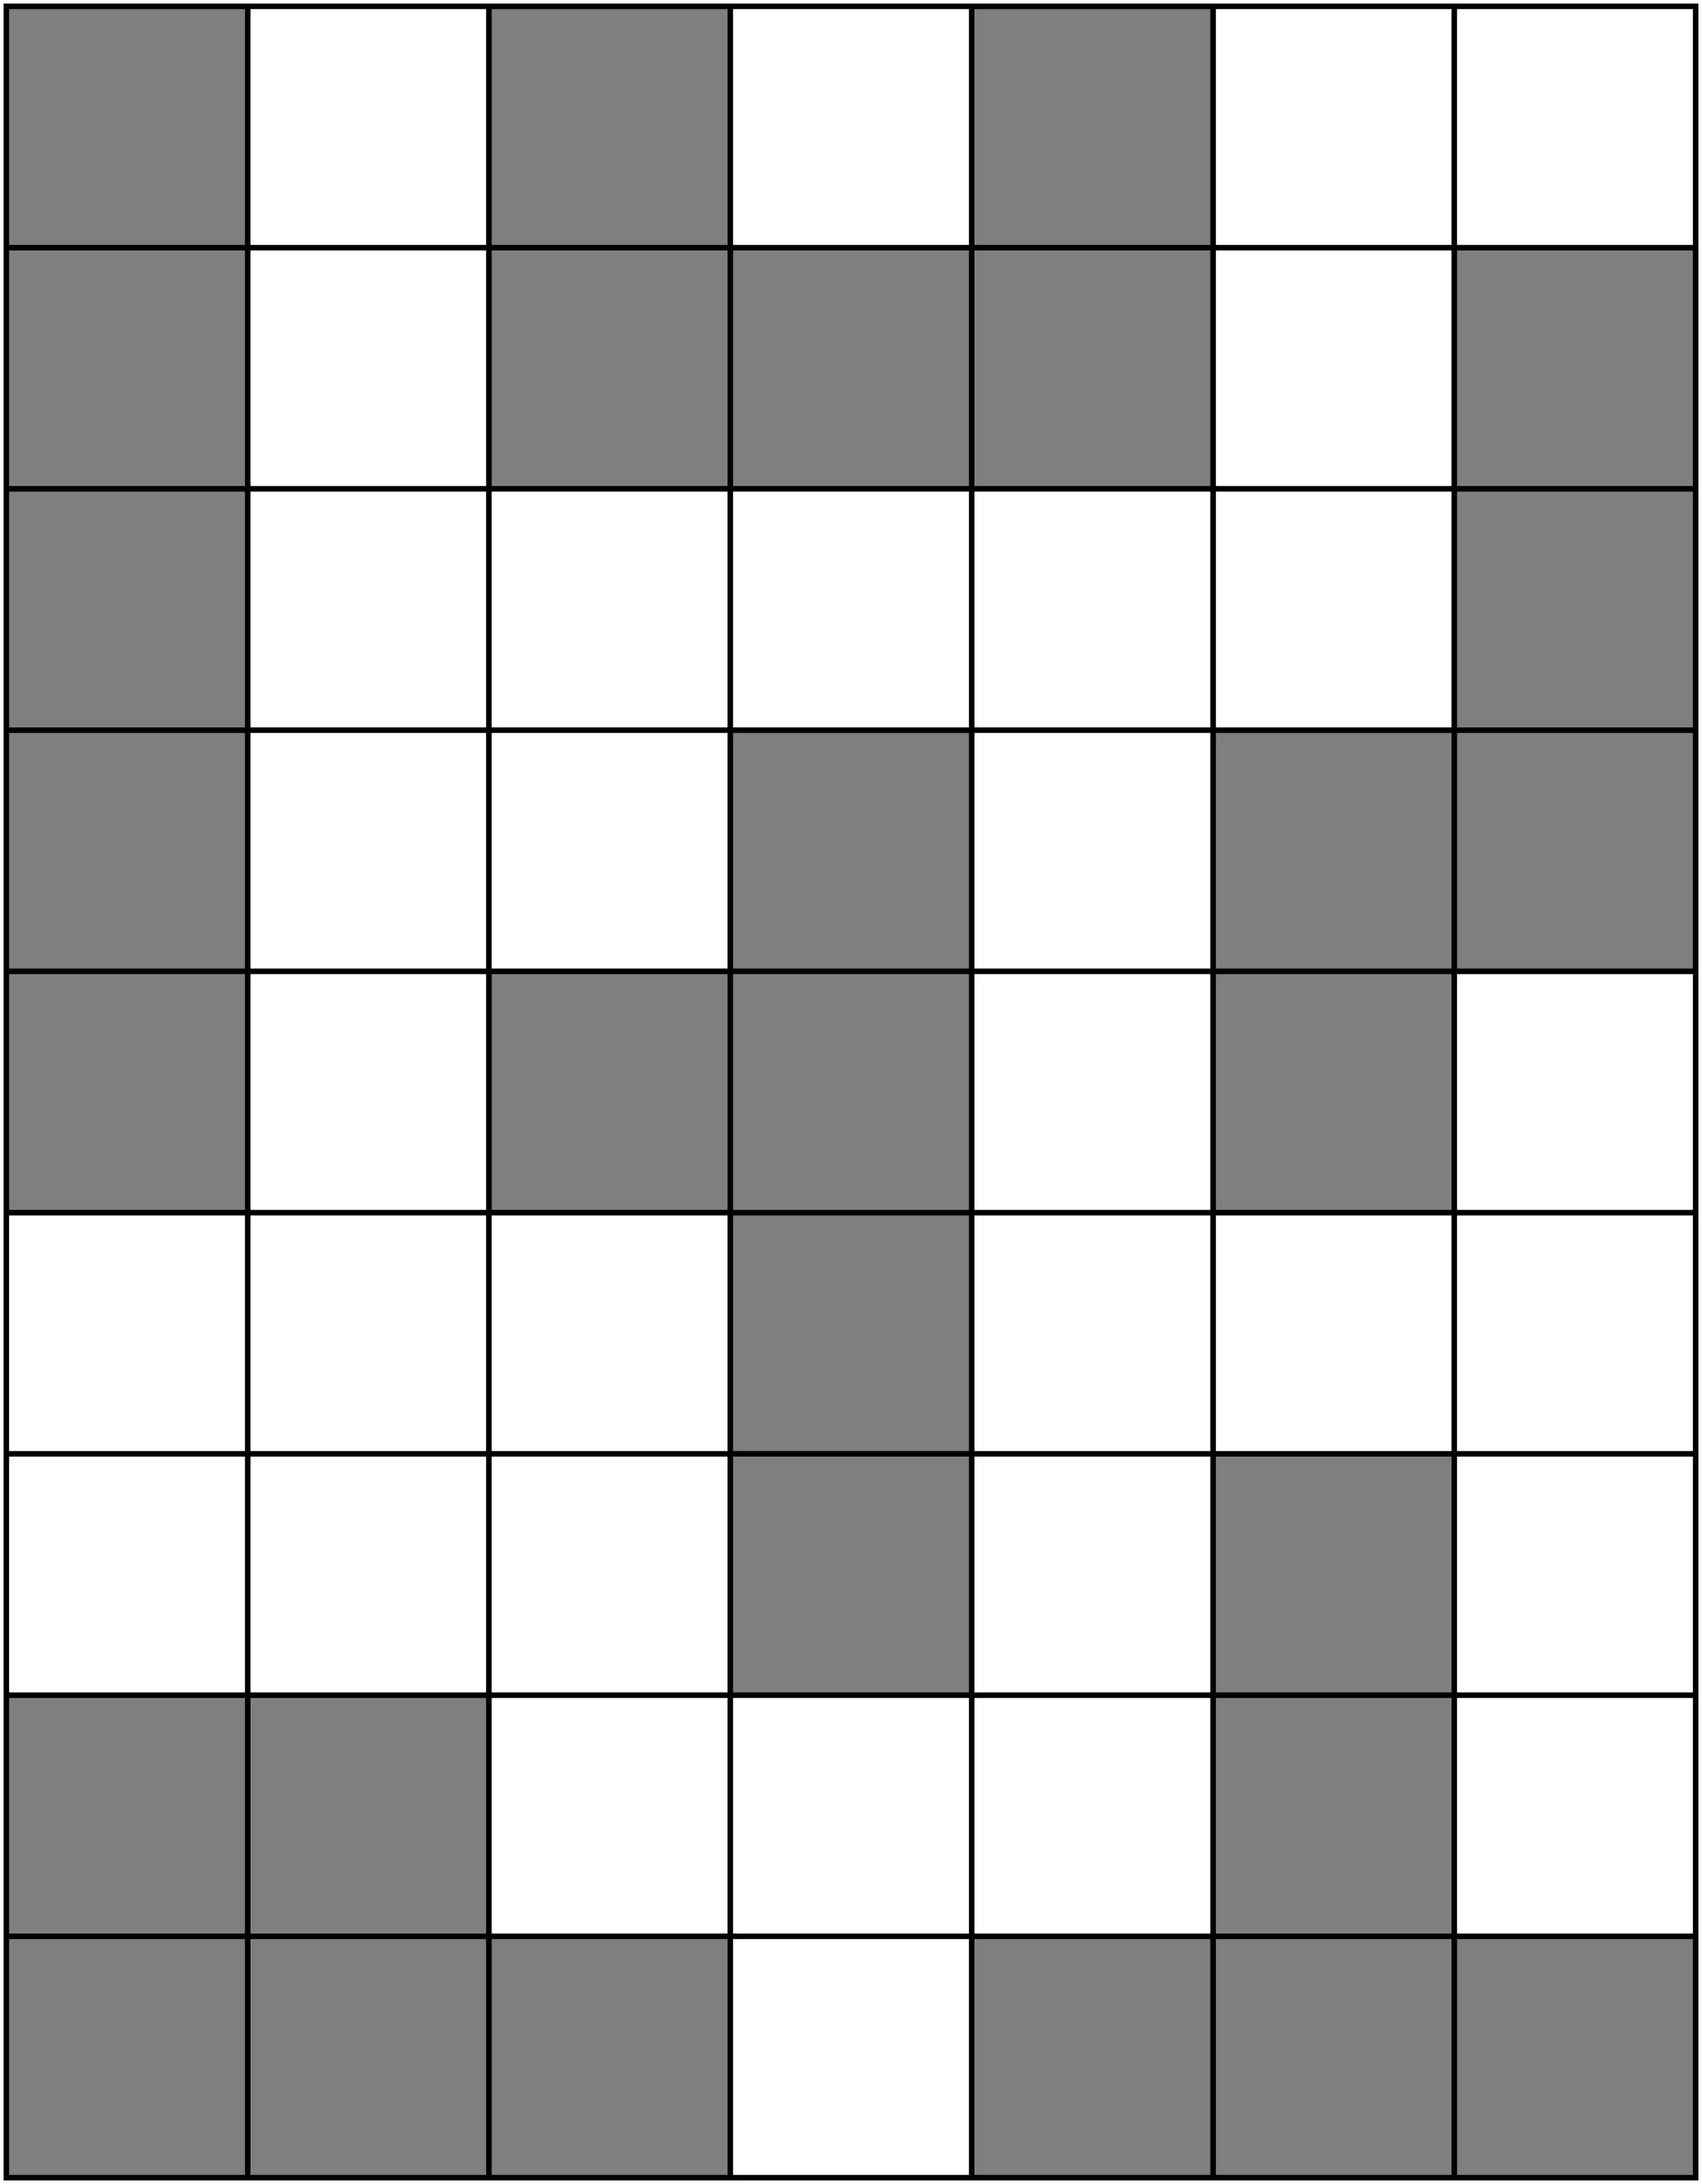

Shapes with 5 Squares Line Master 9–2

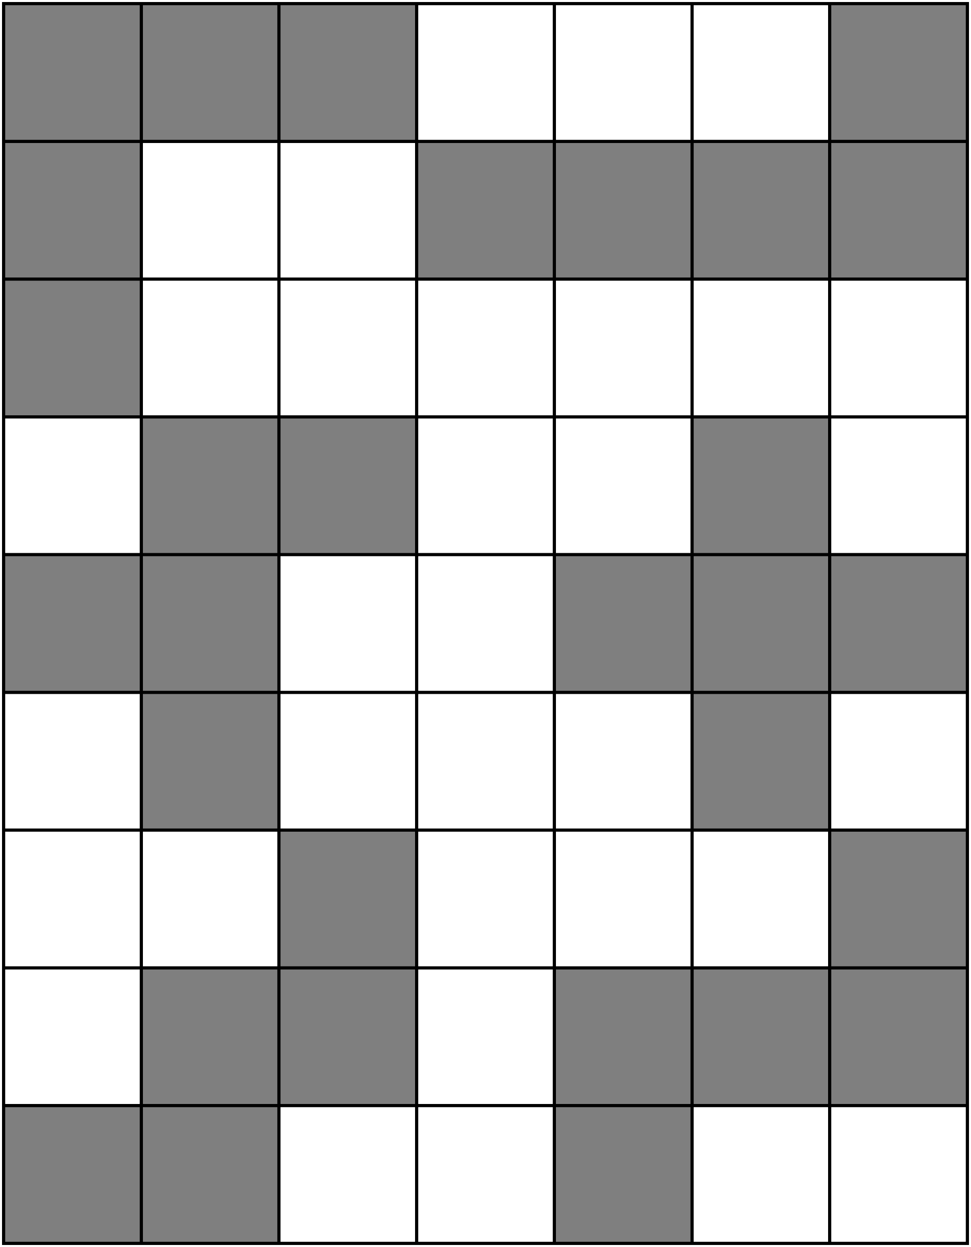

Giant Flower Line Master 10

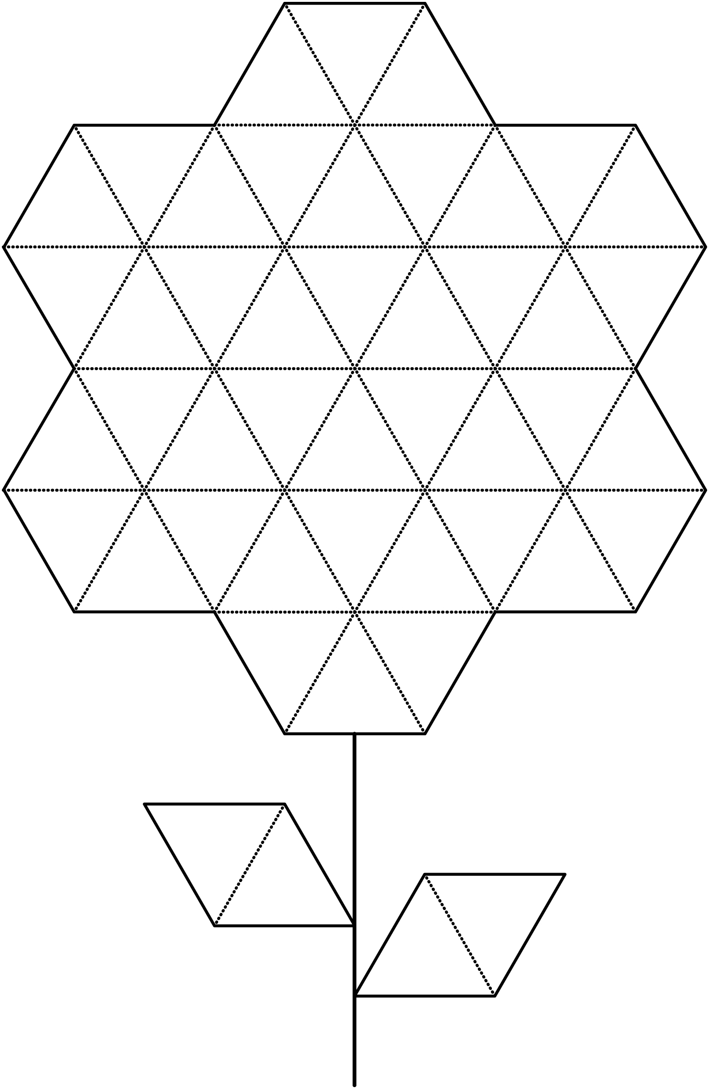

Pattern Block Puzzles Line Master 11–1
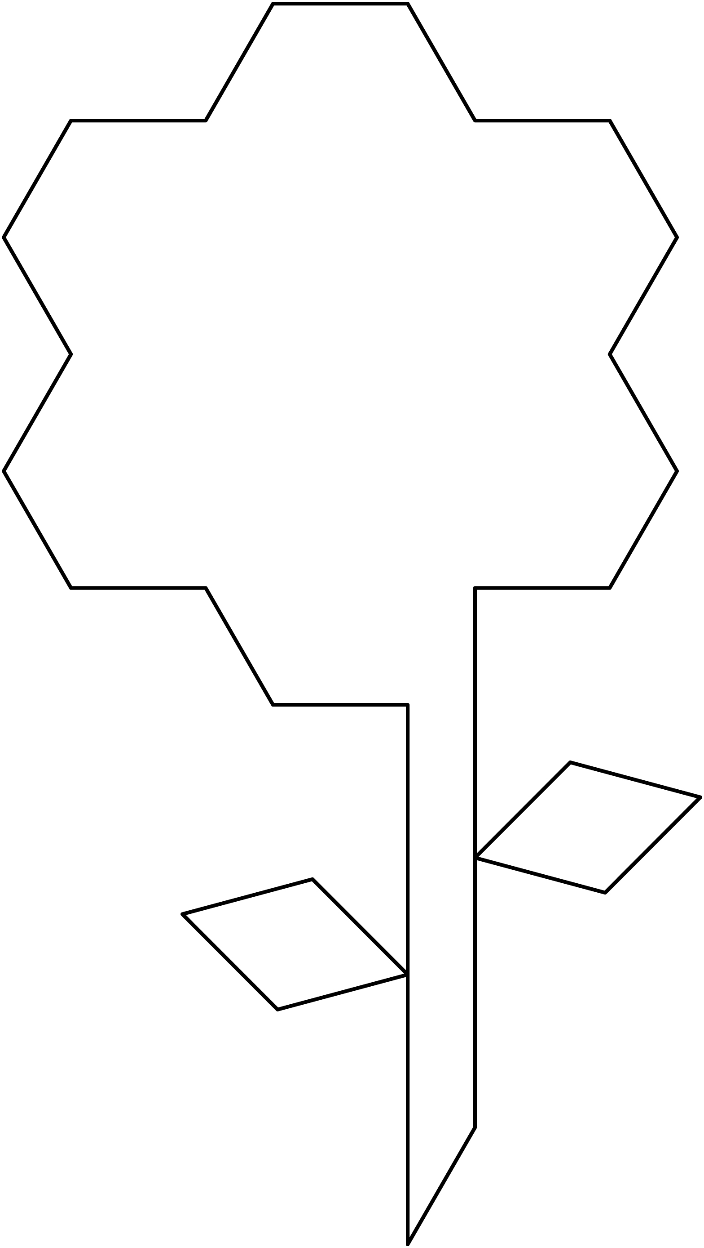

Pattern Block Puzzles Line Master 11–2

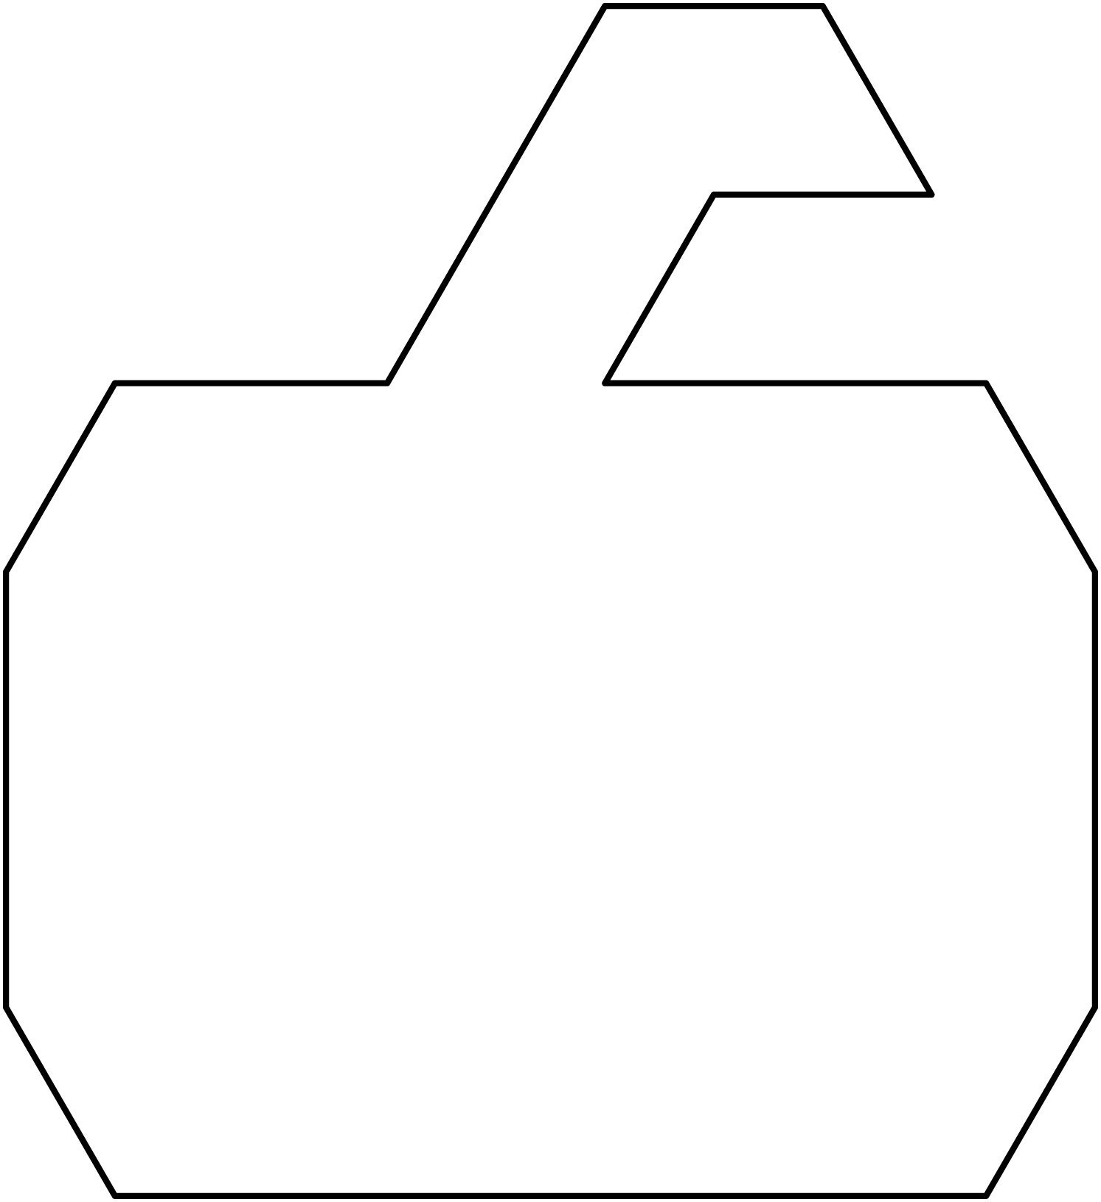

Pattern Block Puzzles Line Master 11–3

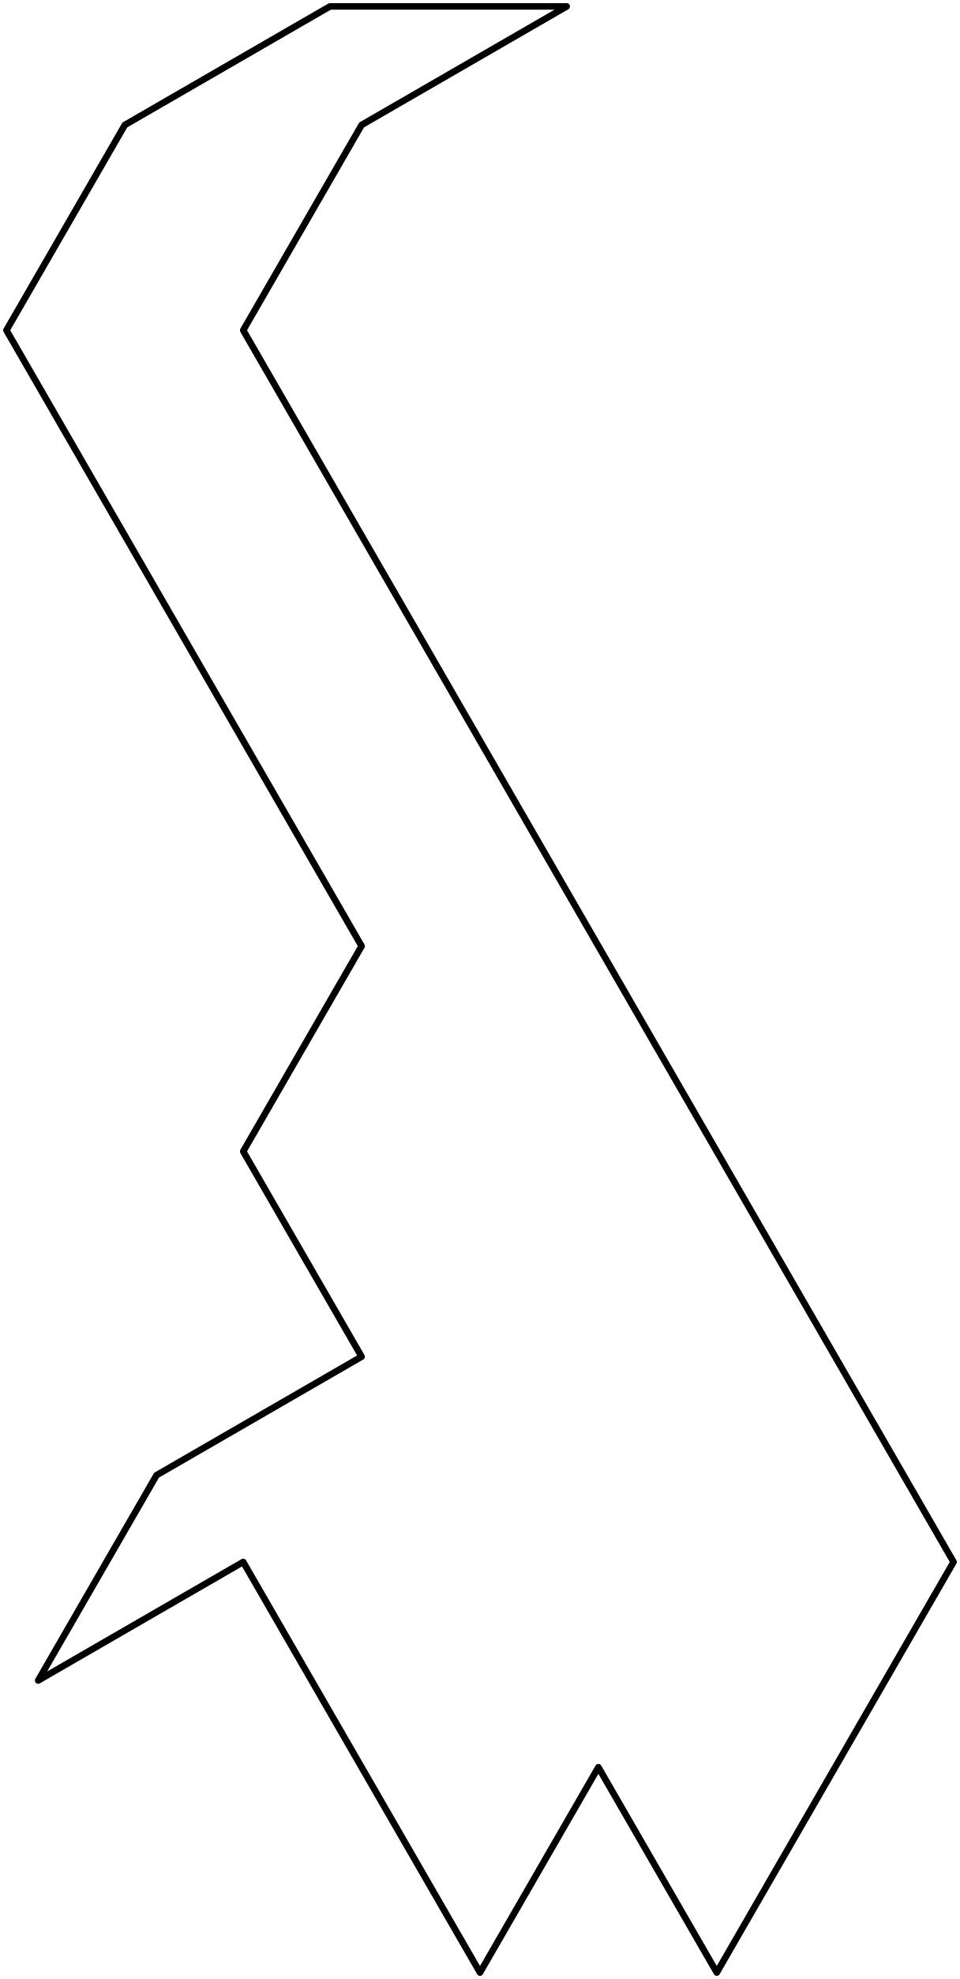

Pattern Block Puzzles Line Master 11–4

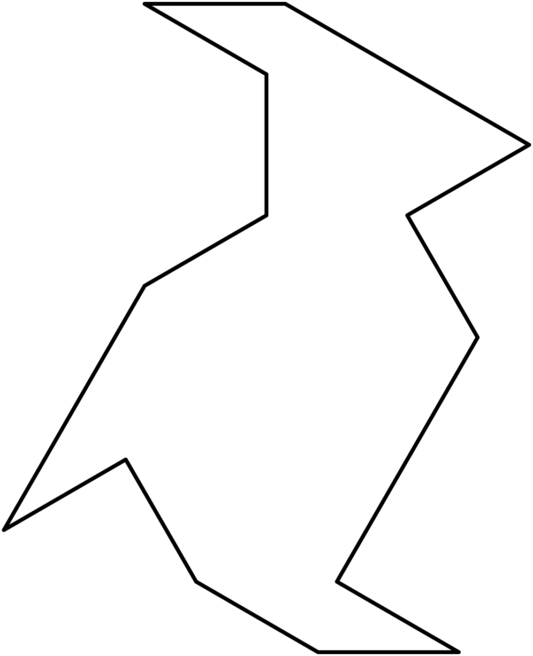

Pattern Block Puzzles Line Master 11–5

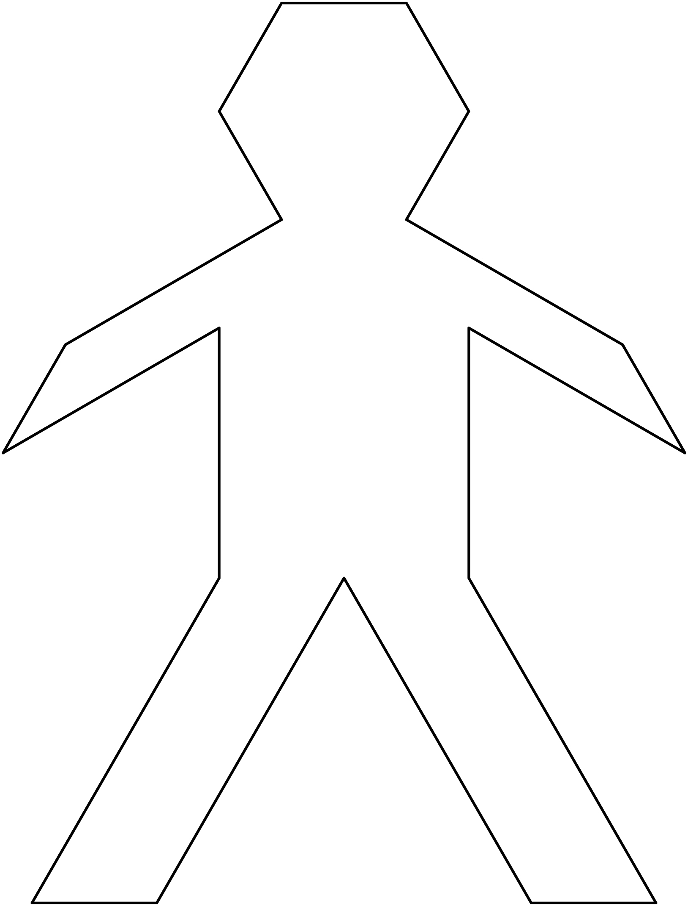

Pattern Block Puzzles Line Master 11–6

Pattern Block Puzzles Line Master 11–7

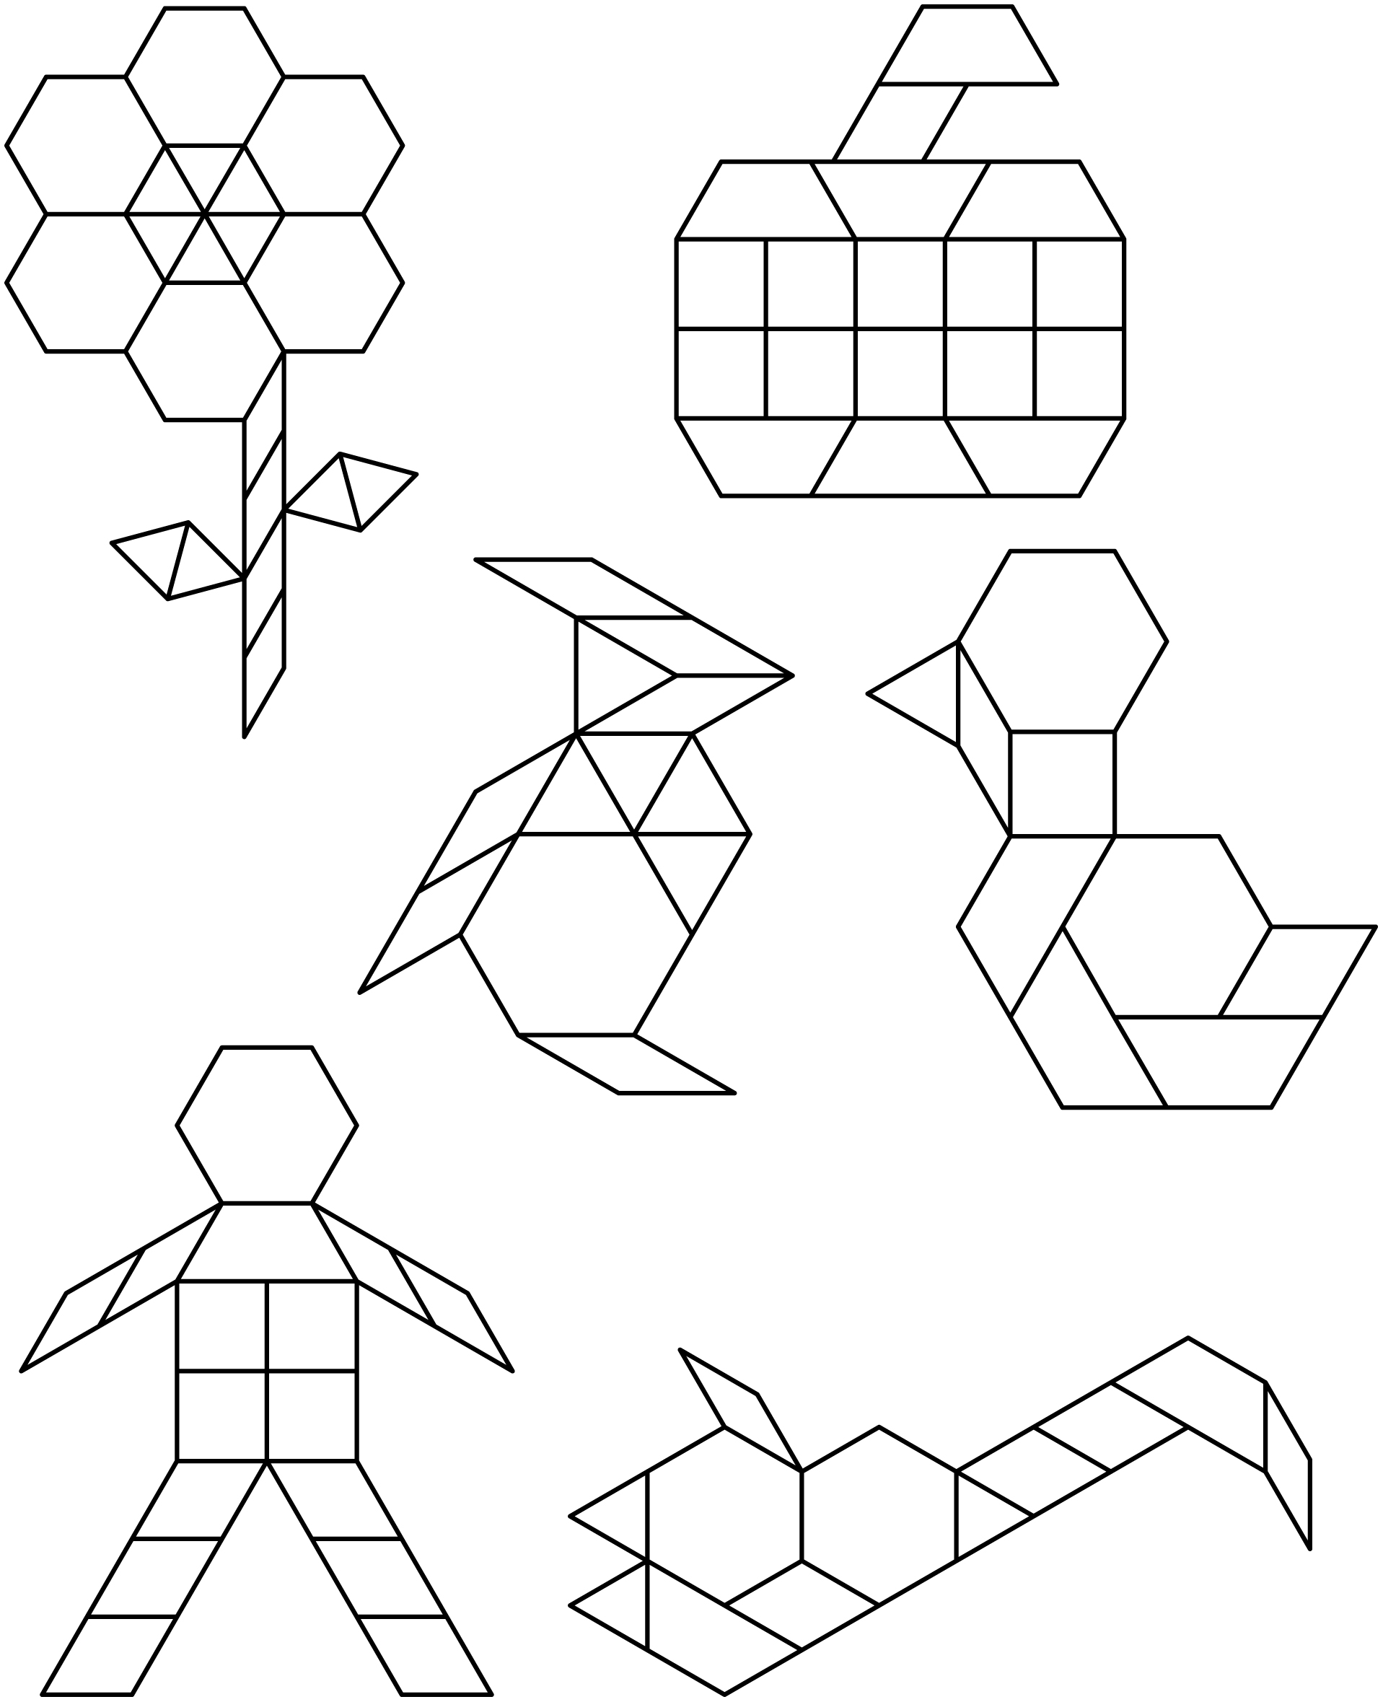

About My Shape Picture Line Master 12
Name: _____________________________
I made _____________________________

I used…

_____________ 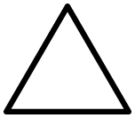 _____________
_____________ 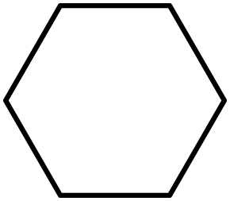 _____________ 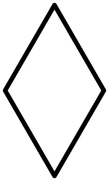
_____________ _____________ 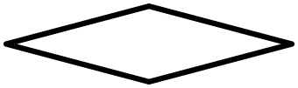

My shape picture is interesting because...

My shape picture reminds me of...

