Consolidation Attribute Cards
Master 6a

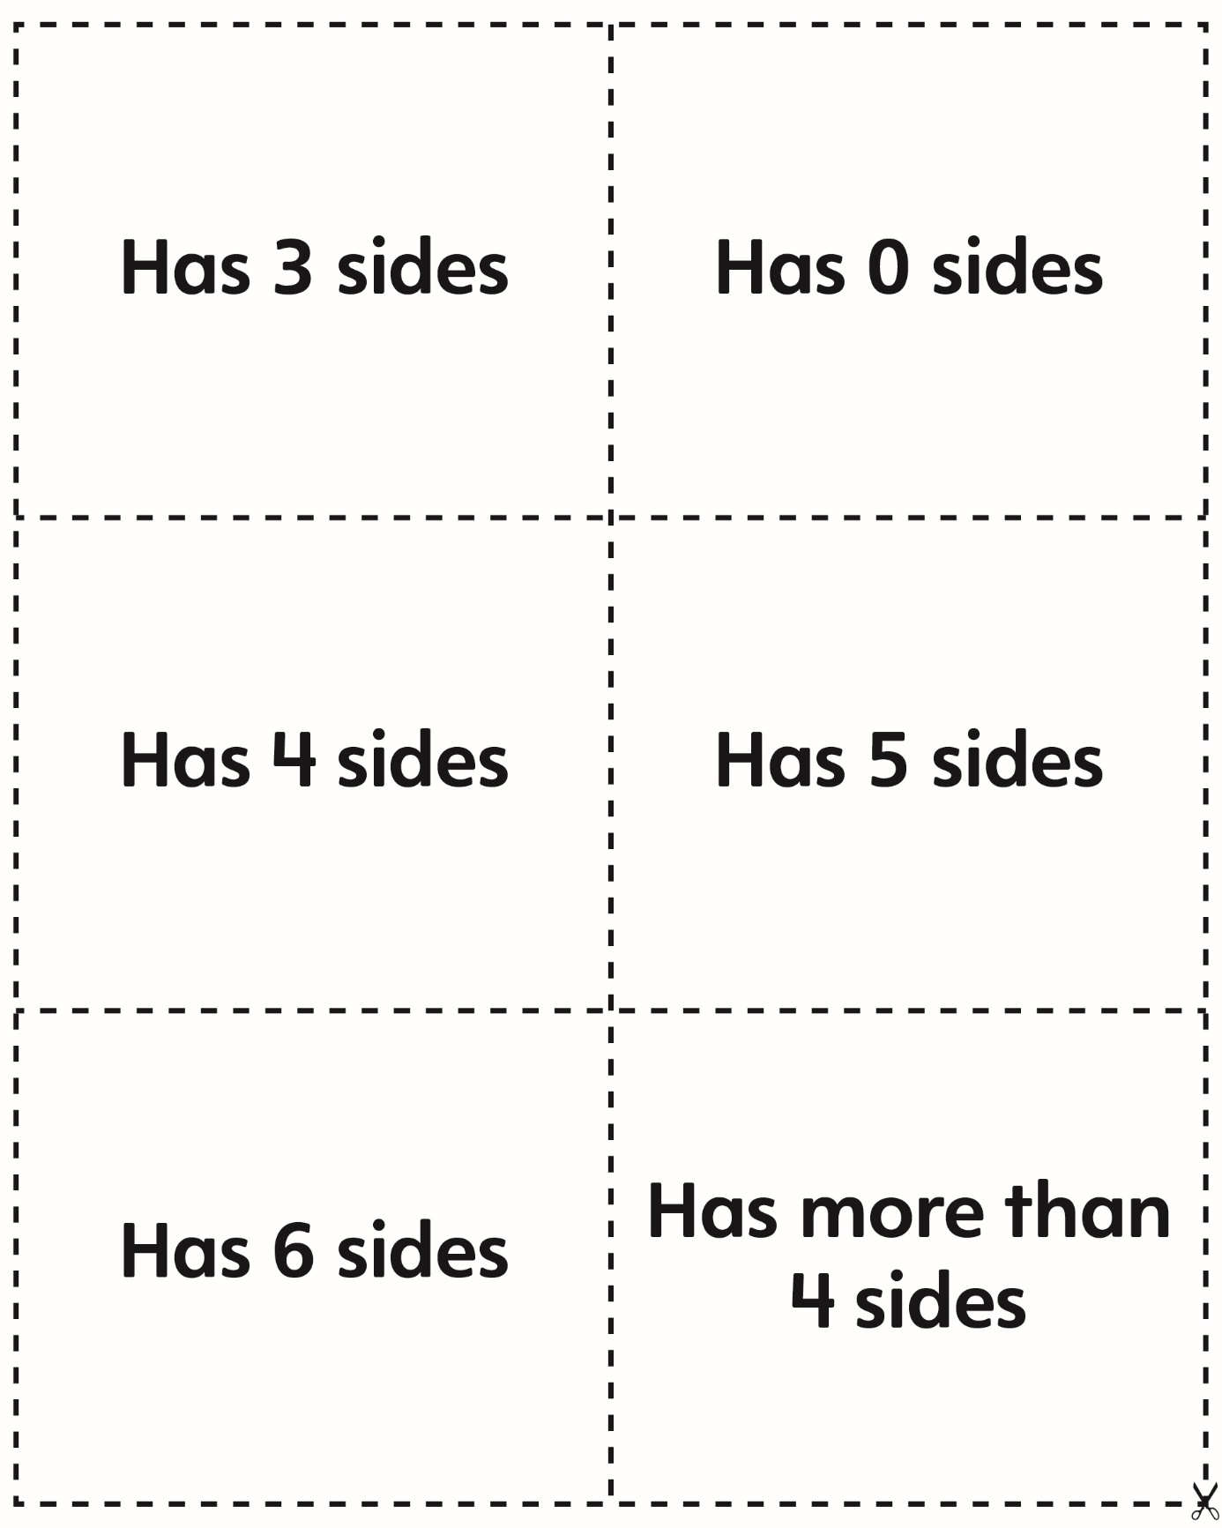
Consolidation Attribute Cards
Master 6b

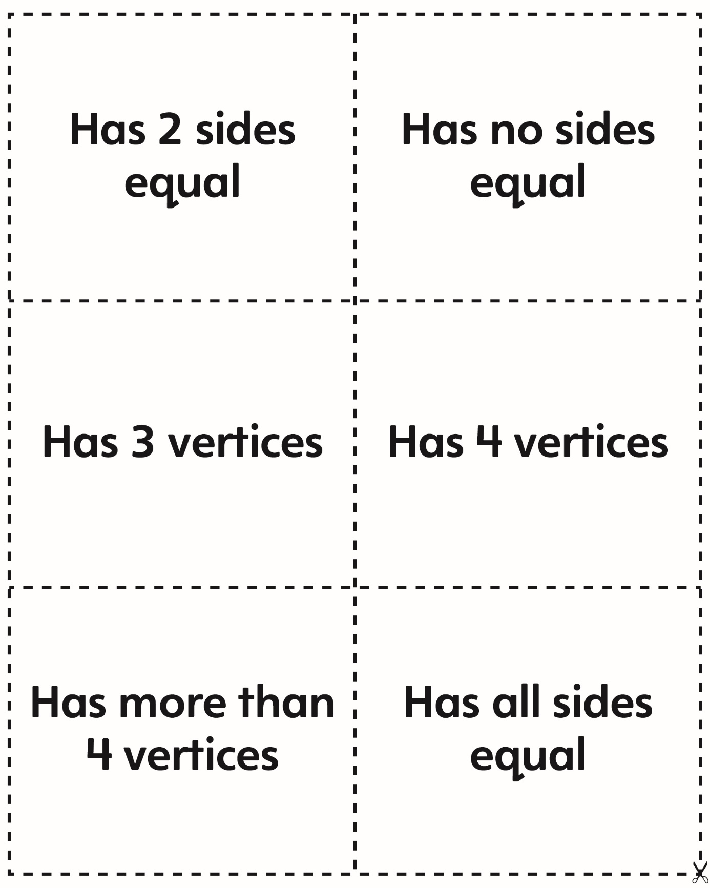
Consolidation Attribute Cards
(for Combined Grades Extension)
Master 6c

