Sorting 3-D Solids Using Two Attributes Behaviours/Strategies
- Student chooses a 3-D solid, but struggles to  analyze its geometric attributes and name the  solid.  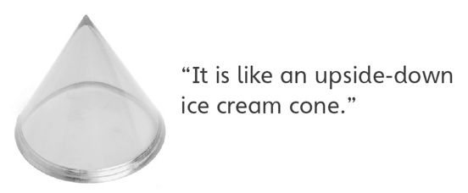 | - Student analyzes some geometric attributes of solids, but struggles to sort them based on two attributes.  “I don’t know what to do.” | - Student sorts the solids using a single attribute  at a time, but is unable to sort using two  attributes simultaneously (ignores overlap).  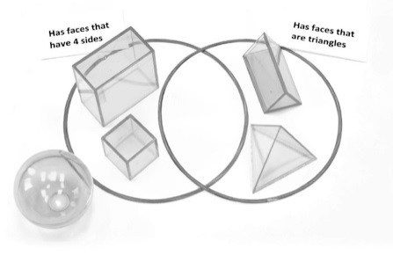
Observations/Documentation
- Student sorts the solids using two attributes,  but has difficulty justifying placement of solids. | - Student sorts the solids using two attributes,  but cannot identify the sorting rule. | - Student successfully analyzes geometric  attributes of solids, sorts them based on two  attributes, and identifies the sorting rule.  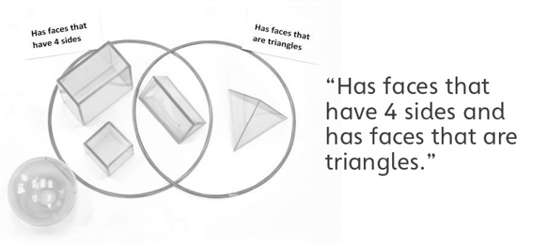
Observations/Documentation

