Iterating the Unit to Measure Length Behaviours/Strategies
- Student looks at the tail, but struggles to  estimate its length with non-standard units.  “About 200 paper clips!” | - Student measures length by iterating a single non-standard unit, but struggles to iterate the unit (leaves gaps or overlaps). | - Student measures length by iterating a single  non-standard unit, but has difficulty keeping  track of the count.  “I am not sure how many paper clips I used.”
Observations/Documentation
- Student measures length by iterating a single  non-standard unit, but ignores leftover amount.  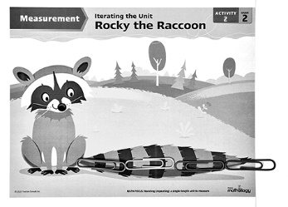  “3 paper clips” | - Student measures length by iterating a single non-standard unit, but forgets to include the unit when stating the measure.  “It is about 3 long.” | - Student successfully measures length by  iterating a single non-standard unit and includes  units with measures.  “It is a little more than 3 paper clips long.”
Observations/Documentation

