Determining 10 or Multiples of 10 Less Behaviours/Strategies
- Student counts three times to determine 10 or  multiples of 10 less than a number (models with counters/cubes).  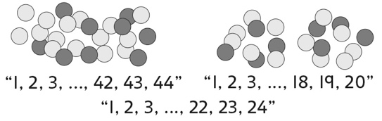 | - Student counts back to determine 10 or  multiples of 10 less than a number (models with counters/cubes).  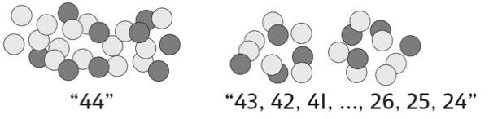 | - Student counts back by ones on a hundred chart to determine 10 or multiples of 10 less than a number.  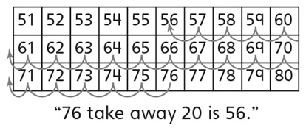
Observations/Documentation
- Student takes jumps of 10 backward on a  hundred chart to determine 10 or multiples of  10 less than a number, but does not recognize  how the tens digit changes.  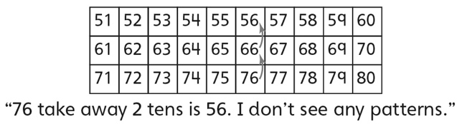 | - Student takes jumps of 10 backward on a  hundred chart to determine 10 or multiples of 10 less than a number and recognizes that the tens digit decreases by 1 for each ten taken away.  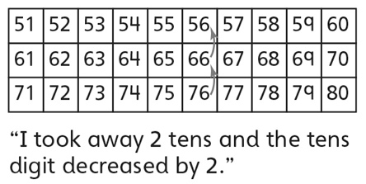 | - Student fluently determines 10 or multiples  of 10 less than a number without using the  hundred chart.
Observations/Documentation

