**Domino Cards**

**Intervention: Master 13a**

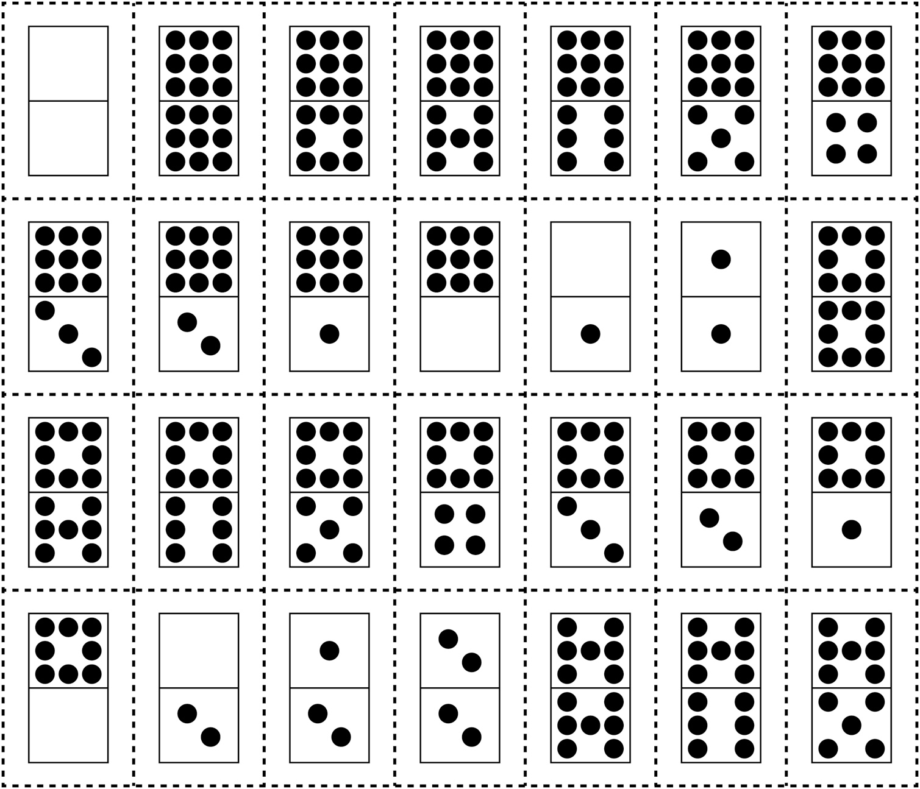

**Domino Cards**

**Intervention: Master 13b**

