Representing Patterns in Different Ways Behaviours/Strategies
- Student chooses a pattern, but struggles to  identify the core of the pattern.  “How do I find the core?” | - Student identifies the core of the pattern, but  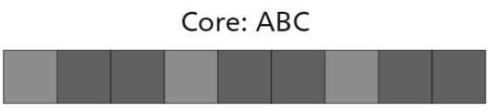  struggles to represent the core with letters. | - Student identifies the core of the pattern  and represents the core with letters, but has  difficulty selecting objects to make another  pattern.
Observations/Documentation
- Student identifies the core of the pattern  and represents the core with letters, but has  difficulty using the core to make another  pattern using different materials.  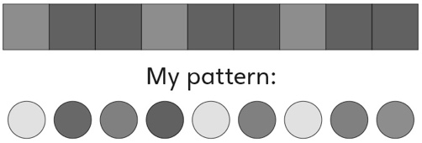 | - Student represents the same pattern in  different ways, but struggles to use math  language to explain how the patterns are alike  and how they are different. | - Student successfully identifies the core of a  pattern, represents the same pattern in different  ways, and uses math language to explain how  the patterns are alike and how they are different.  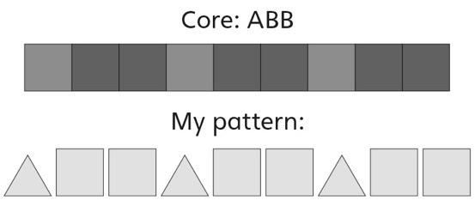
Observations/Documentation

