Using Benchmarks to Estimate and Measure Length Behaviours/Strategies
- Student finds object in classroom, but struggles to use benchmarks to estimate length in standard units (estimate is extreme or unreasonable).  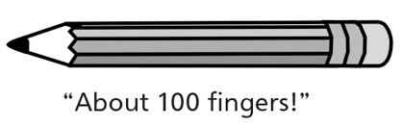 | - Student estimates length in standard units,  but does not use appropriate benchmark to  estimate and measure.  “I am using a paper clip to measure  in centimetres.” | - Student selects and uses appropriate  benchmarks to estimate and measure length  in standard units, but leaves gaps or overlaps  or has difficulty tracking the finger/step while  measuring.
Observations/Documentation
- Student uses the measurement of familiar  objects as benchmarks to estimate and measure length in standard units, but loses track of the count when measuring.  “I forget how many fingers I used.” | - Student uses the measurement of familiar  objects as benchmarks to estimate and measure length in standard units, but forgets to include the unit when stating the measure.  “It is 7 long.” | - Student successfully uses the measurement of  familiar objects as benchmarks to estimate and  measure length in standard units and includes  units with measures.  "The length of the pencil is about 20 finger widths, or about 20 cm."
Observations/Documentation

