Measurement Recording Sheet
Master 12a

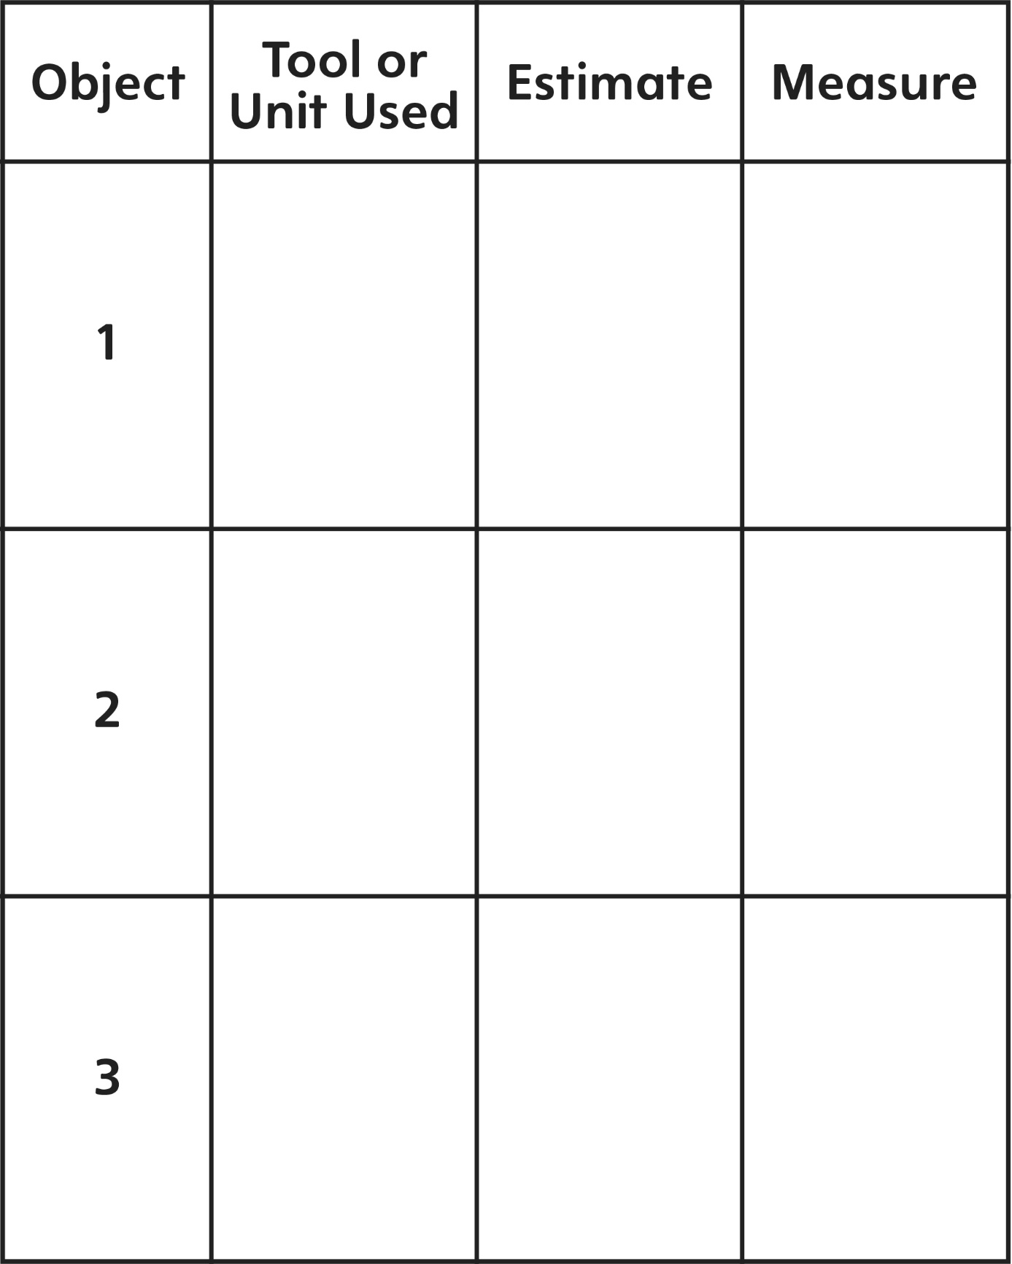

Measurement Recording Sheet
Master 12b

Write one thing that is important to remember when measuring length:

