Calendar Puzzle Cards
Master 17a

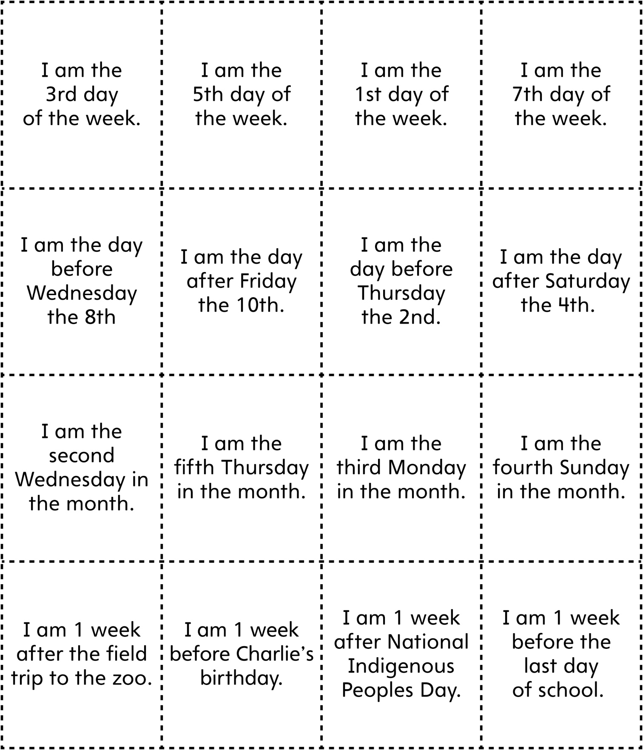

Calendar Puzzle Cards
(for Accommodations)
Master 17b

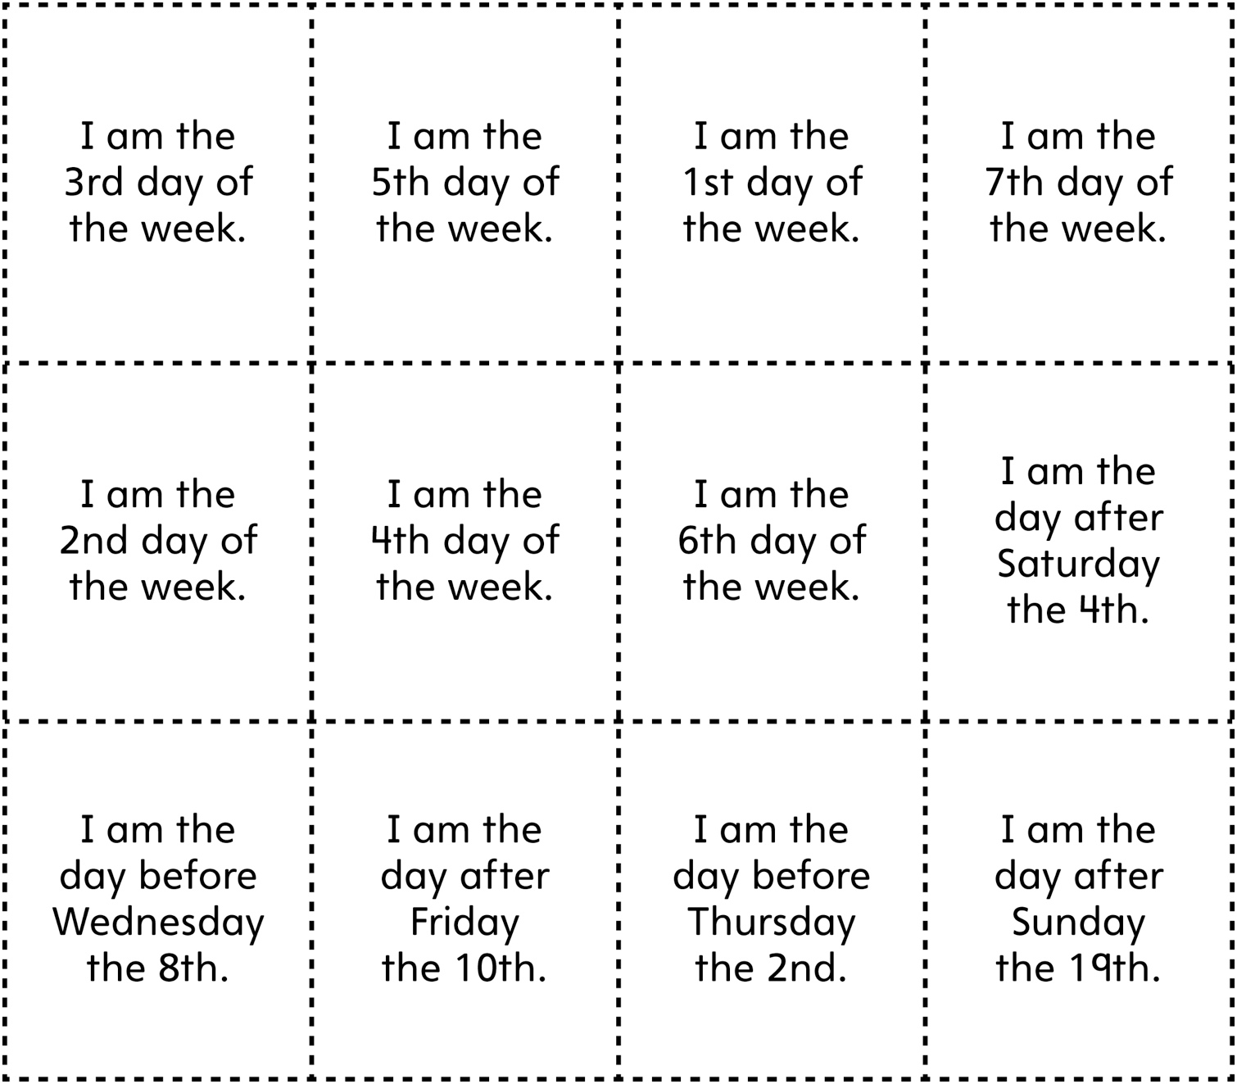

Calendar Puzzle Cards
Master 17c

(for Extension)

