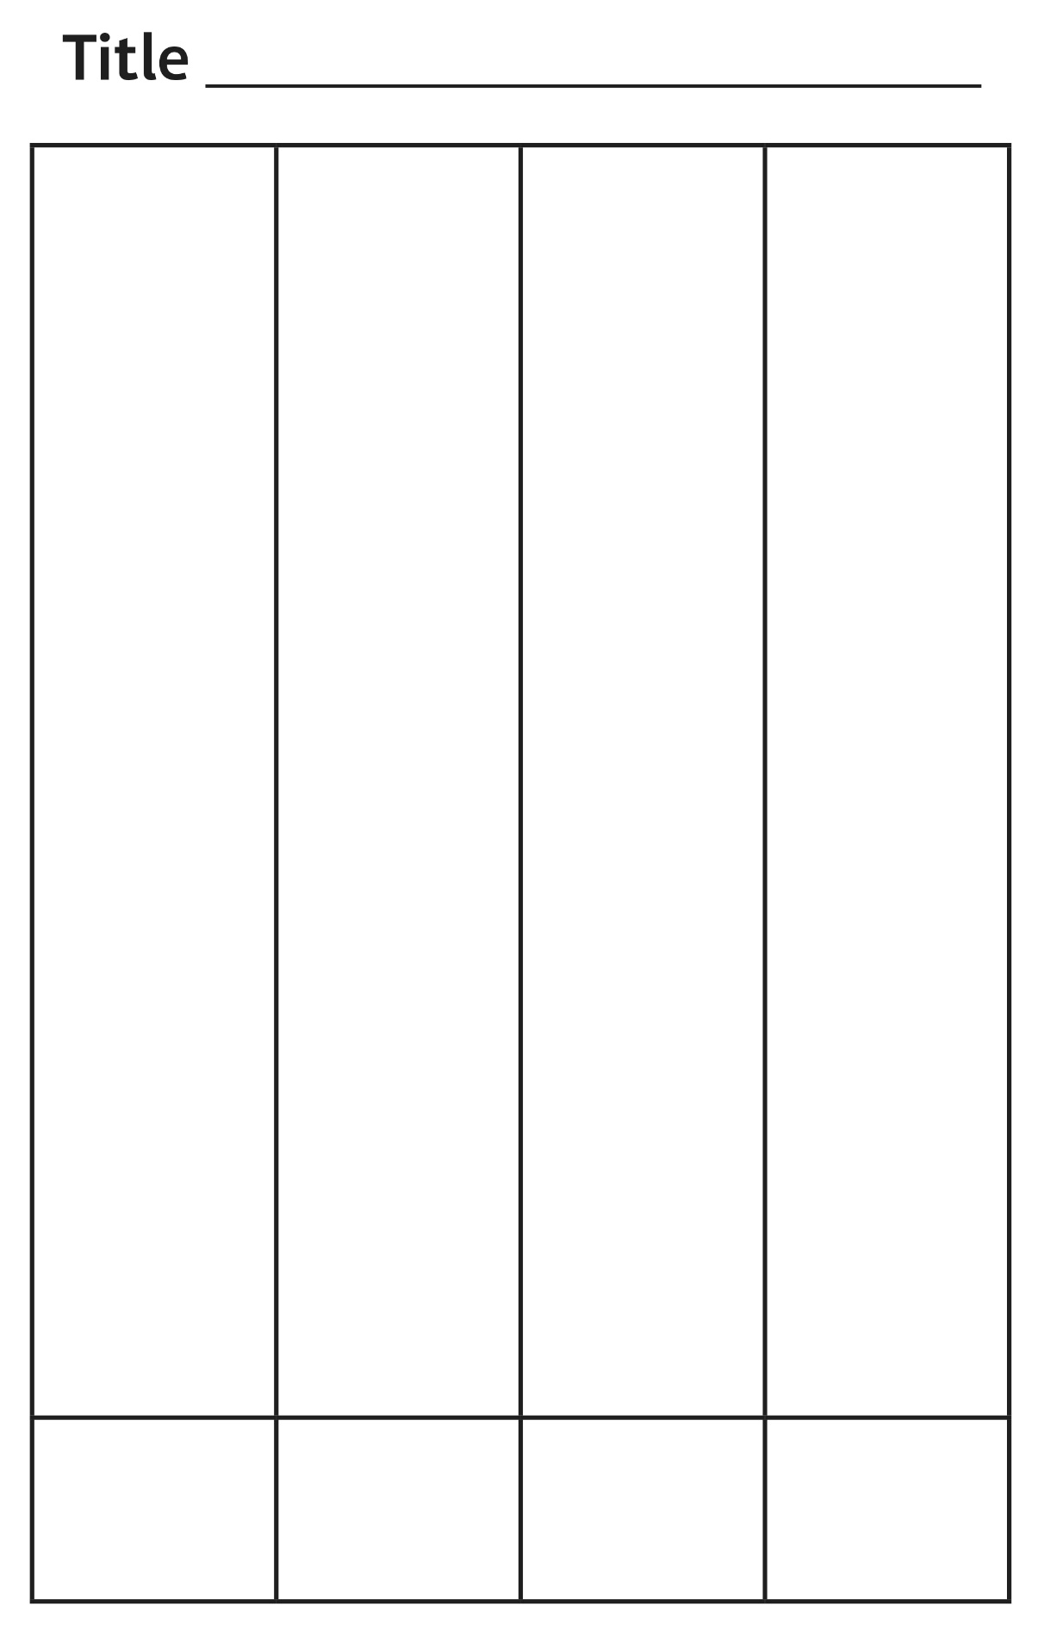**Graphing Mat**

**Multi-Use Master 7**