Skip-Counting by 2s Spider Webs
Master 4a

Start at 0. Skip-count by 2s.

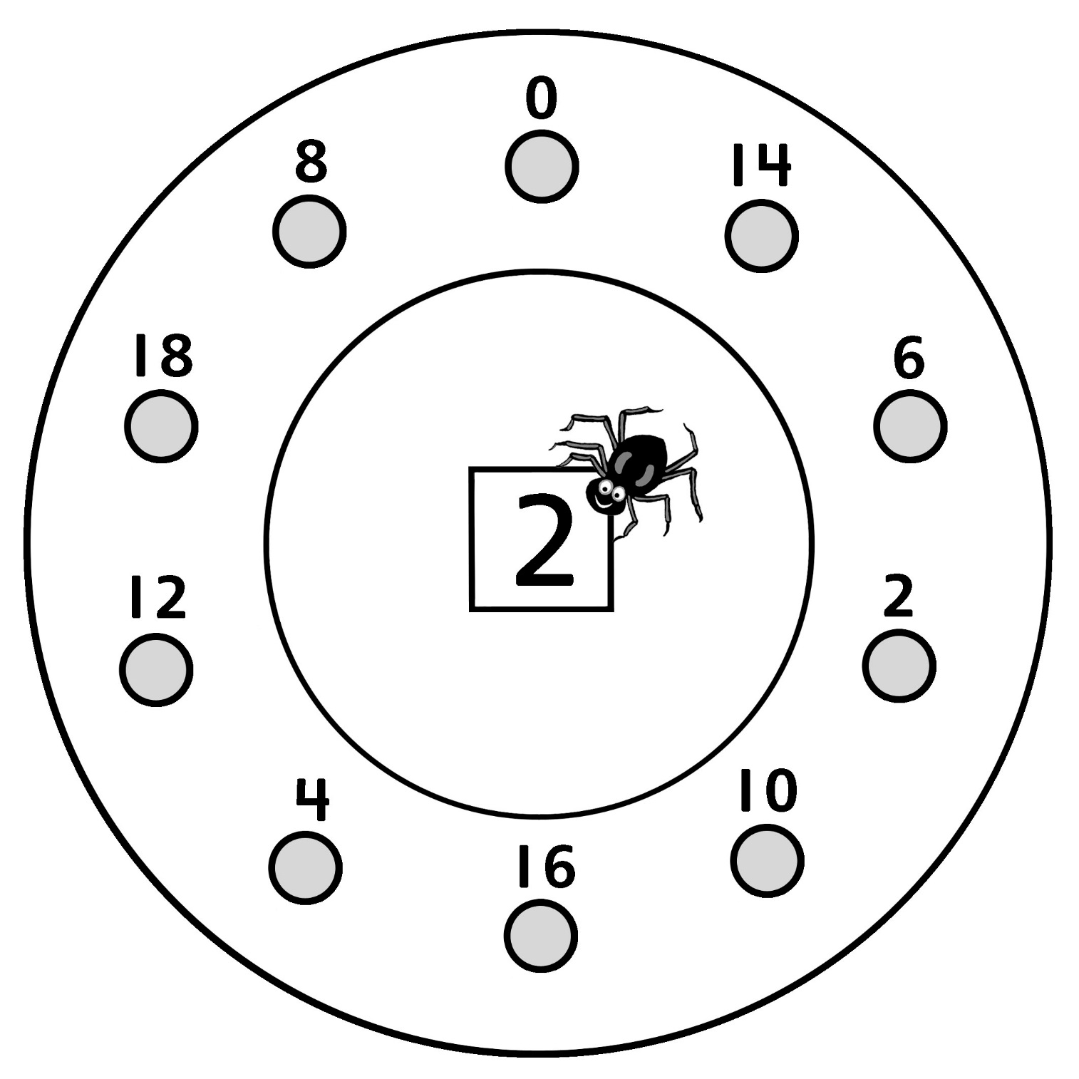
Skip-Counting by 2s Spider Webs
Master 4b

Start at 22. Skip-count by 2s.

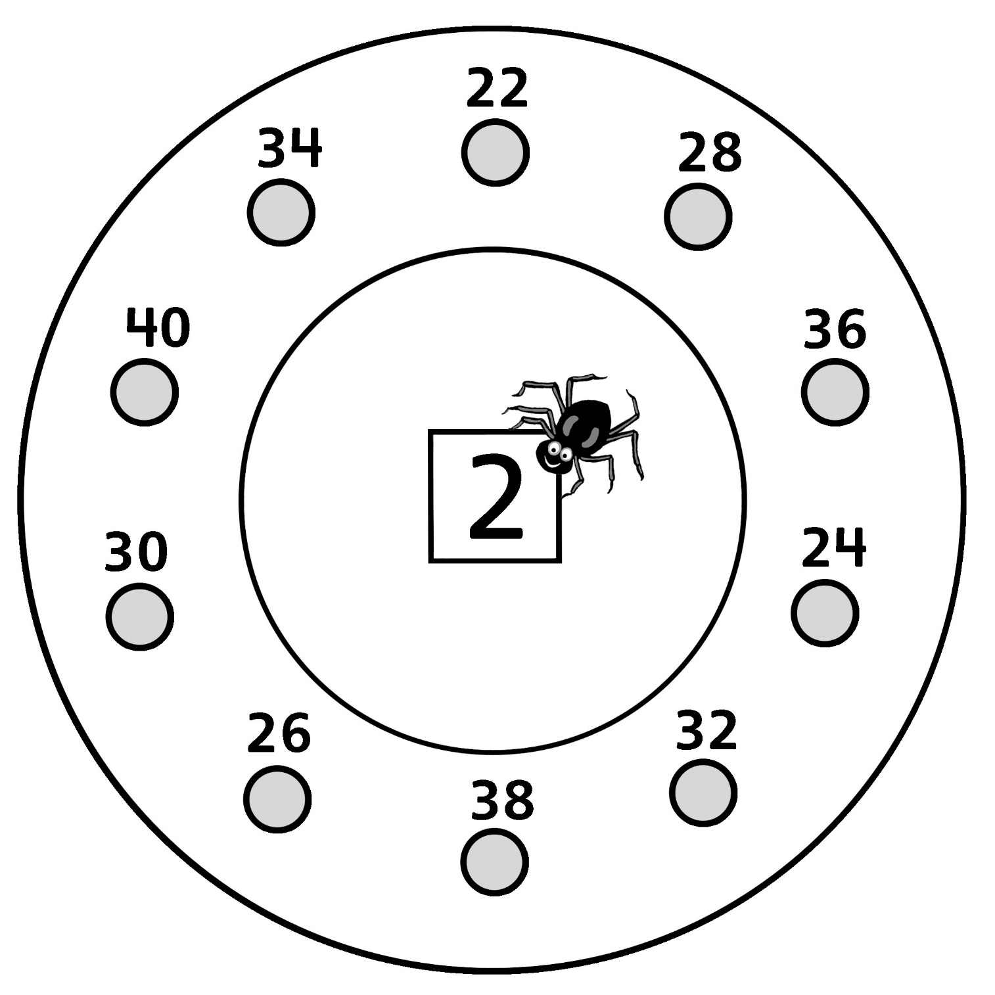

Skip-Counting by 2s Spider Webs
Master 4c

Start at 154. Skip-count by 2s.

