**Money Cutouts**

**Master 11a**

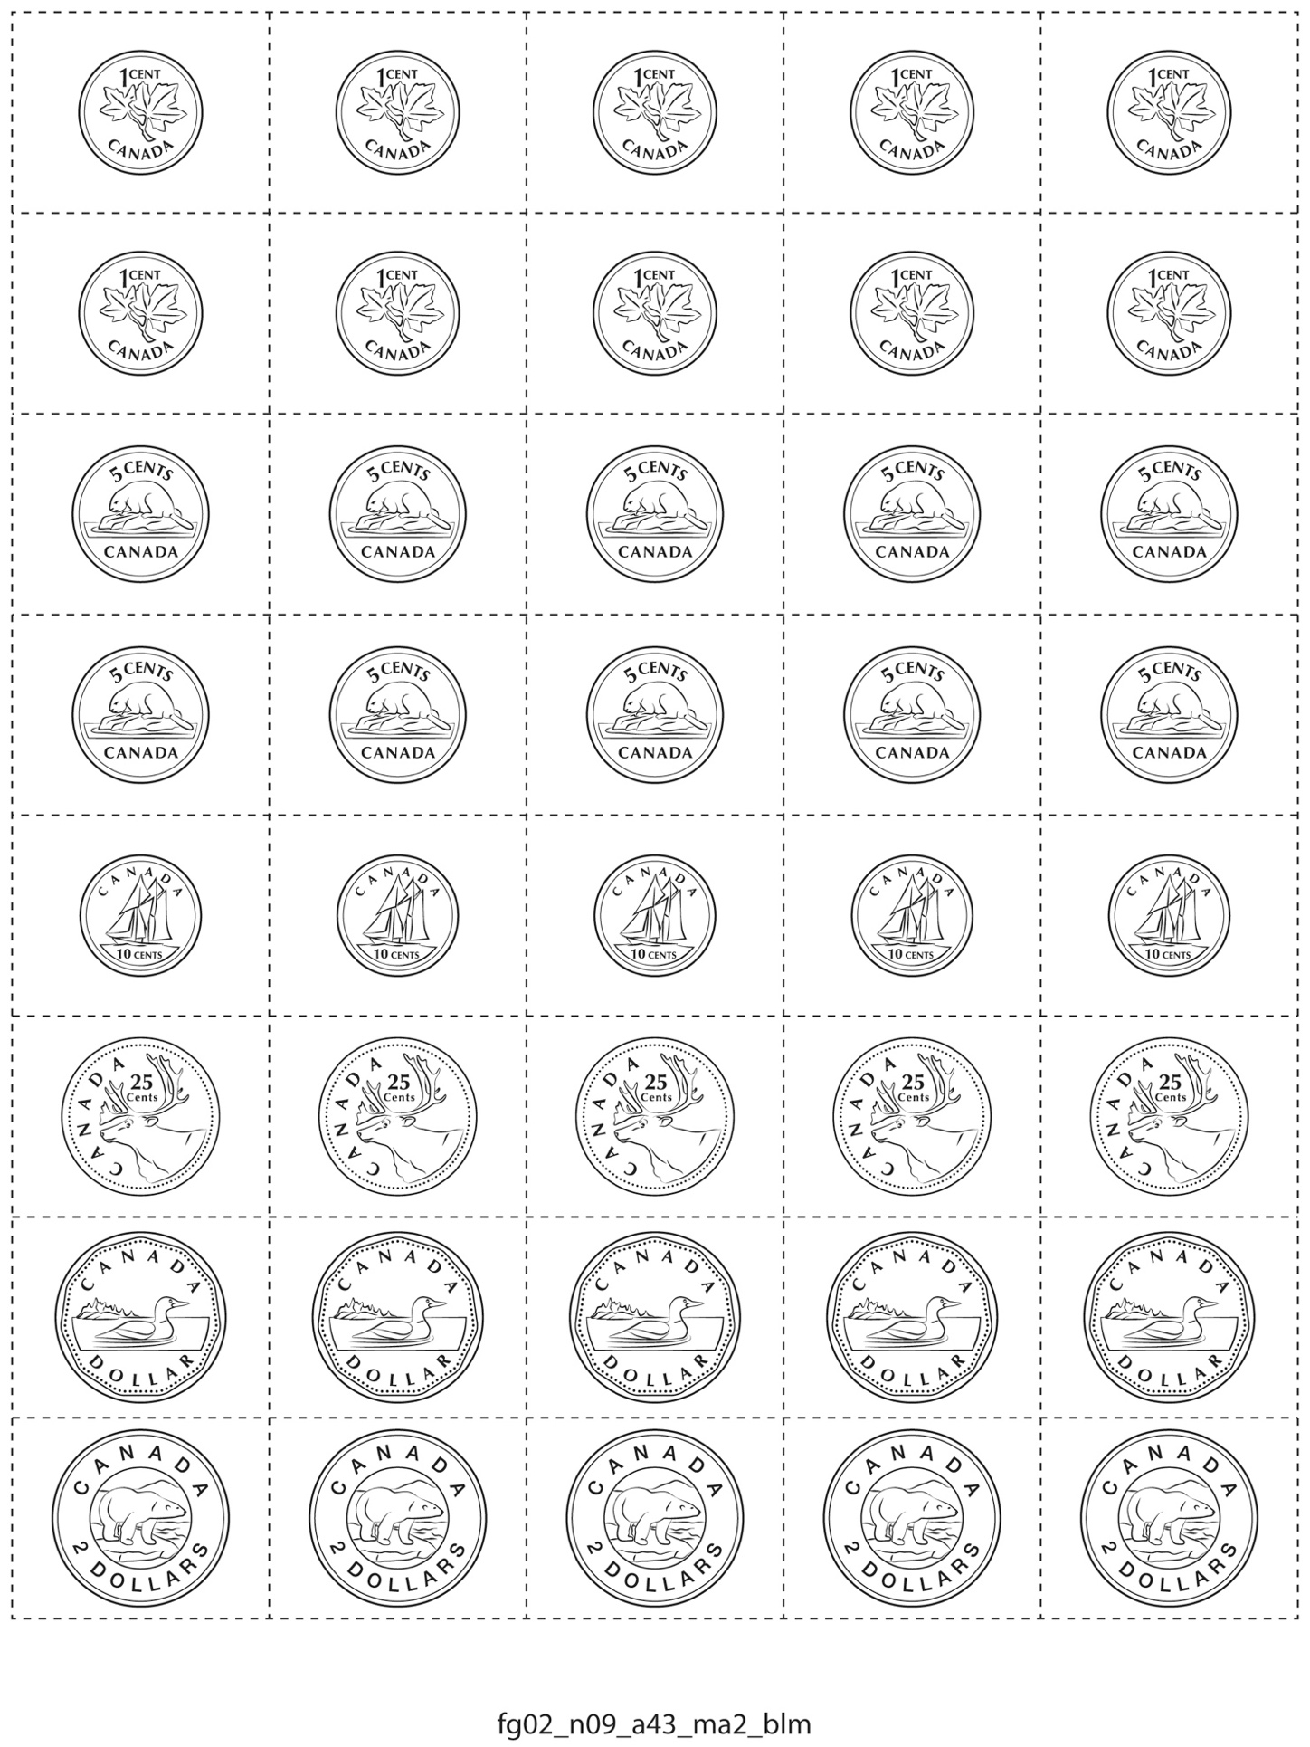

**Money Cutouts**

**Master 11b**

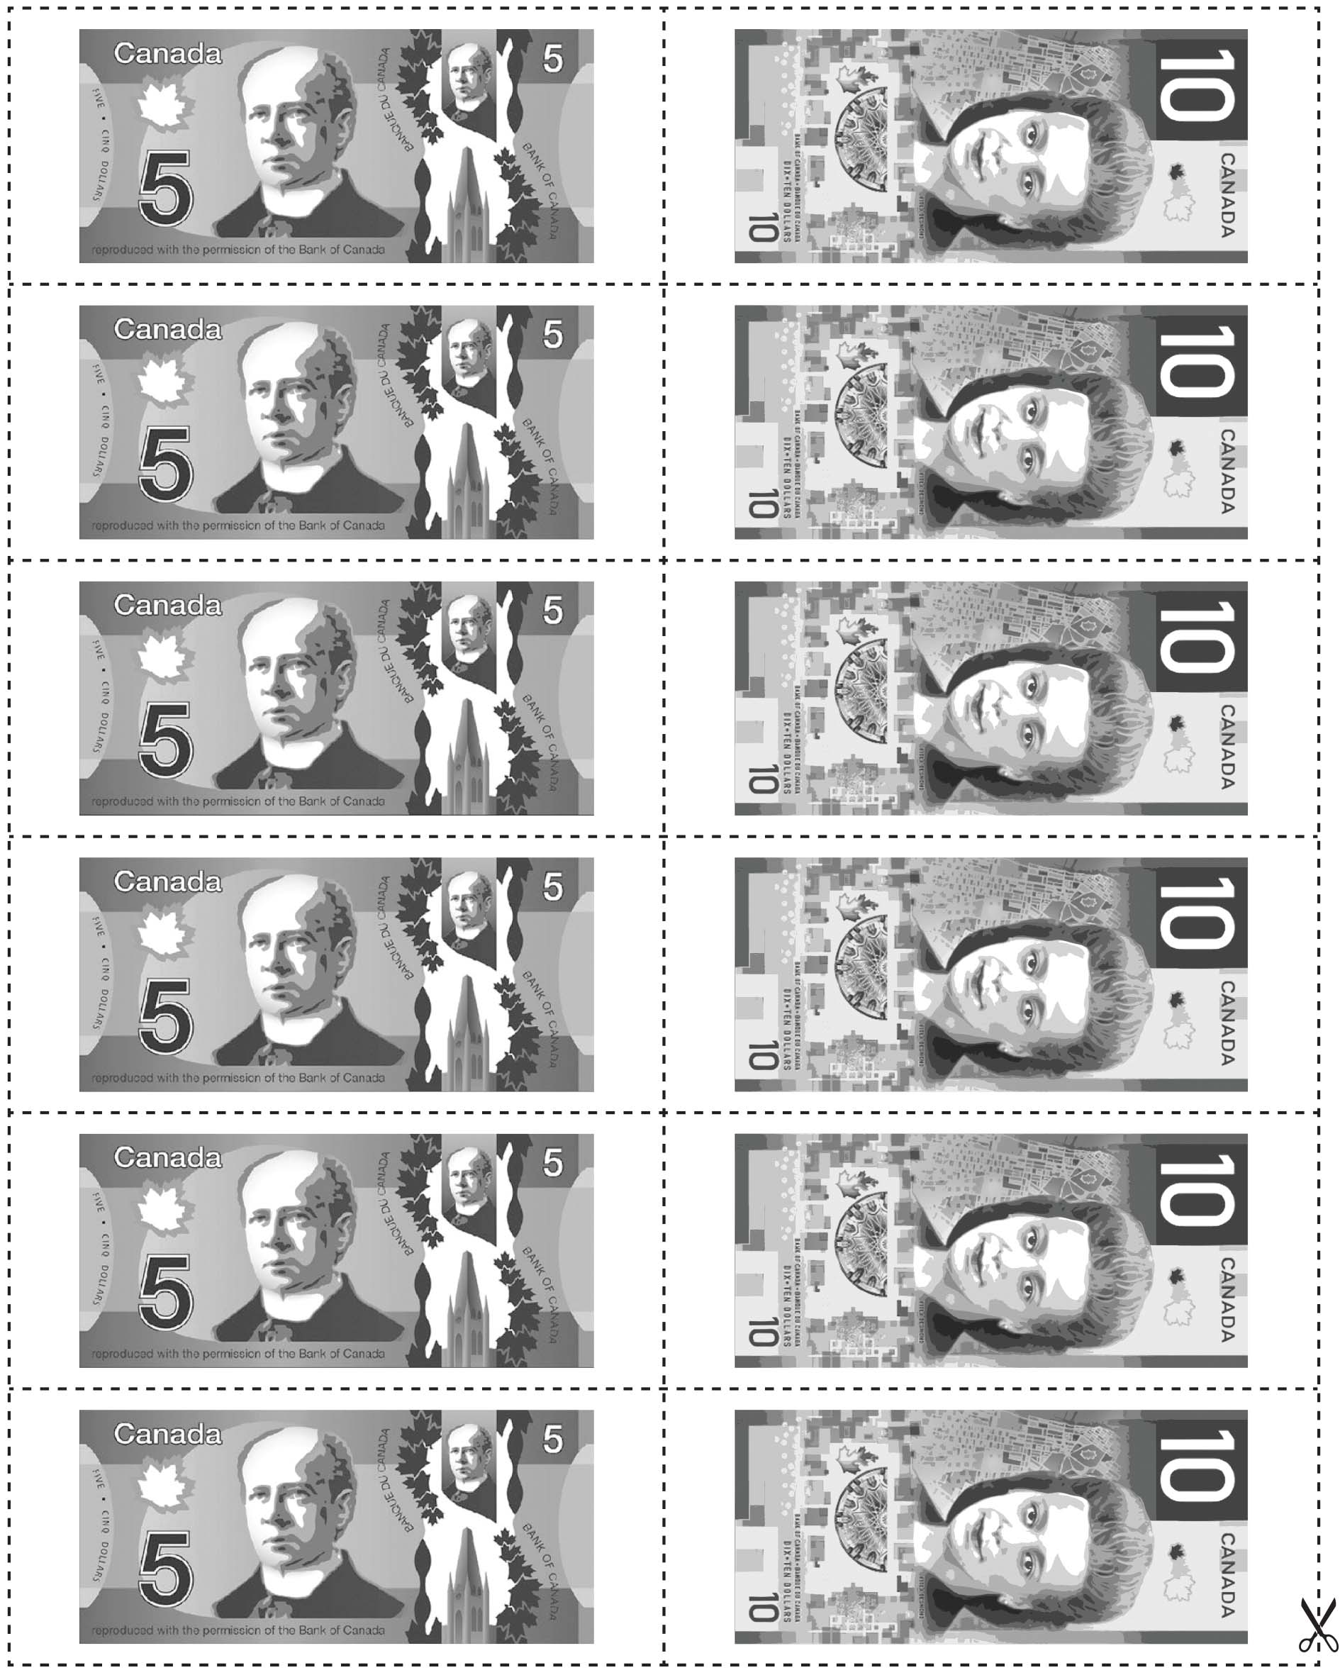

**Money Cutouts**

**Master 11c**

