**T-Shirt Cards**

**Master 21a**

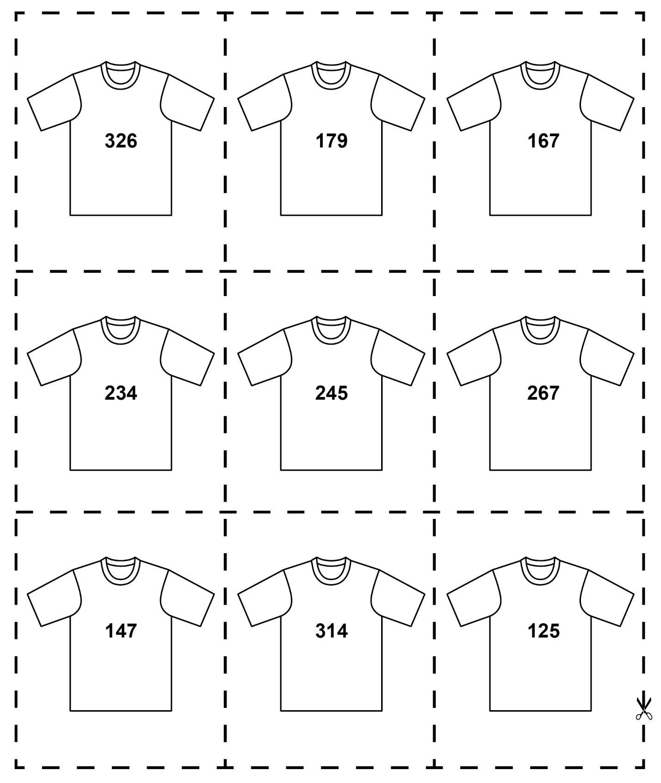

**T-Shirt Cards**

**Master 21b**

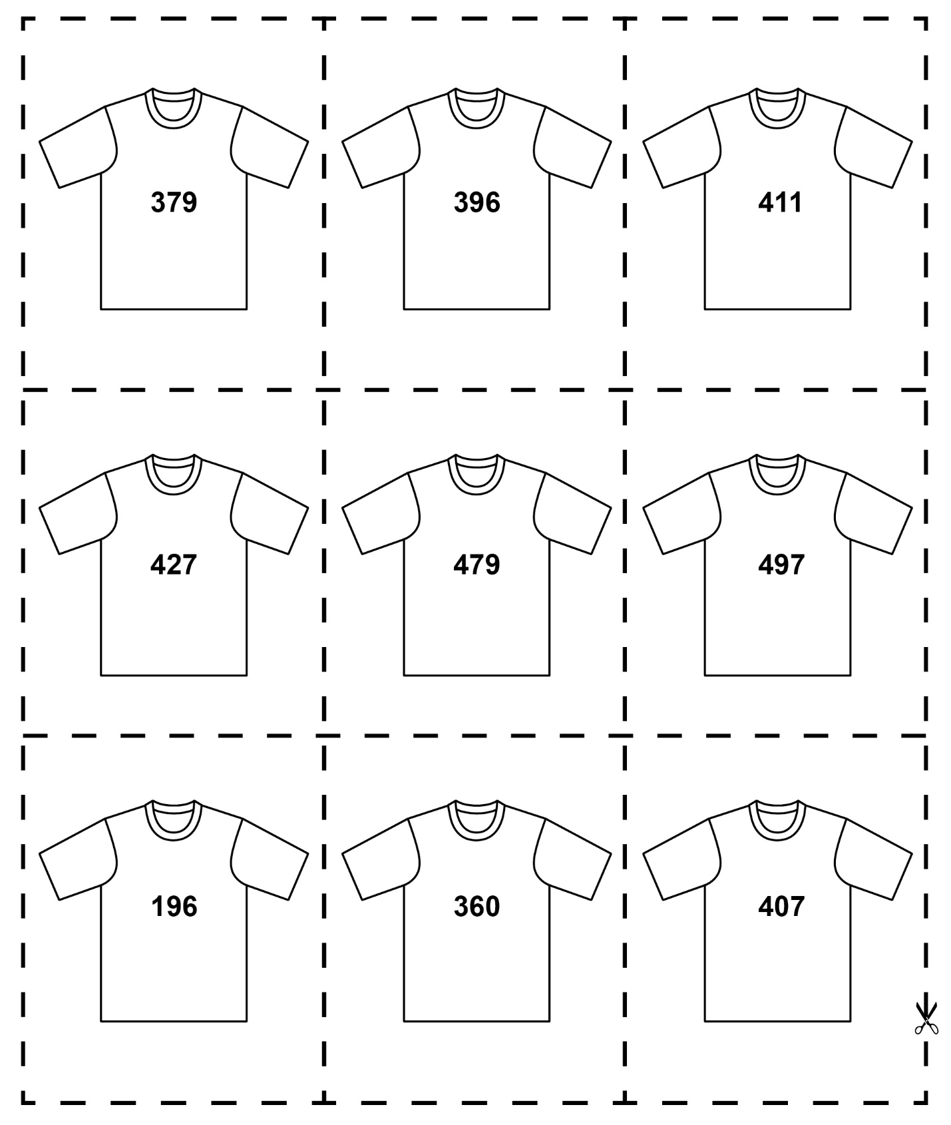

**T-Shirt Cards**

**Master 21c**

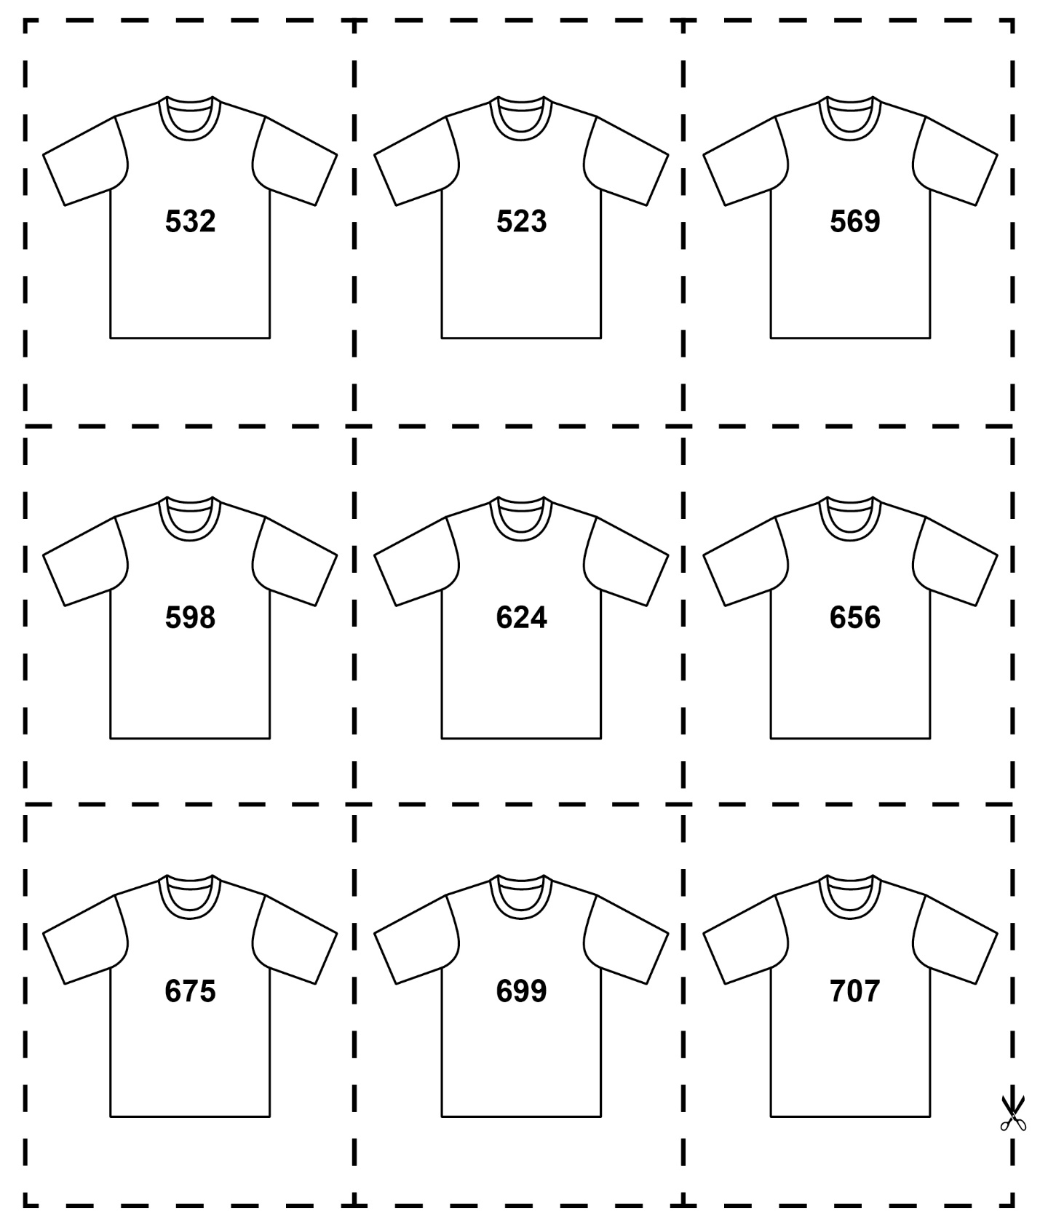

**Master 21d**

**T-Shirt Cards**

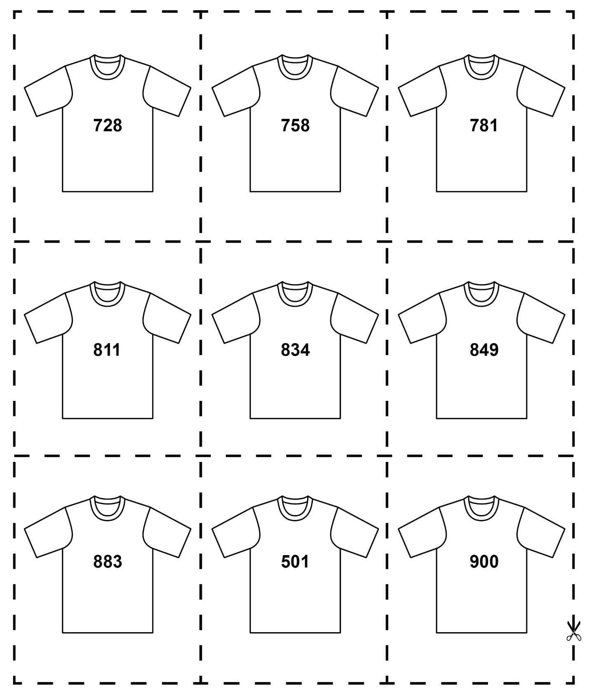

**Master 21e**

**T-Shirt Cards**

