**Number Cards (1–20)**

**Master 23a**

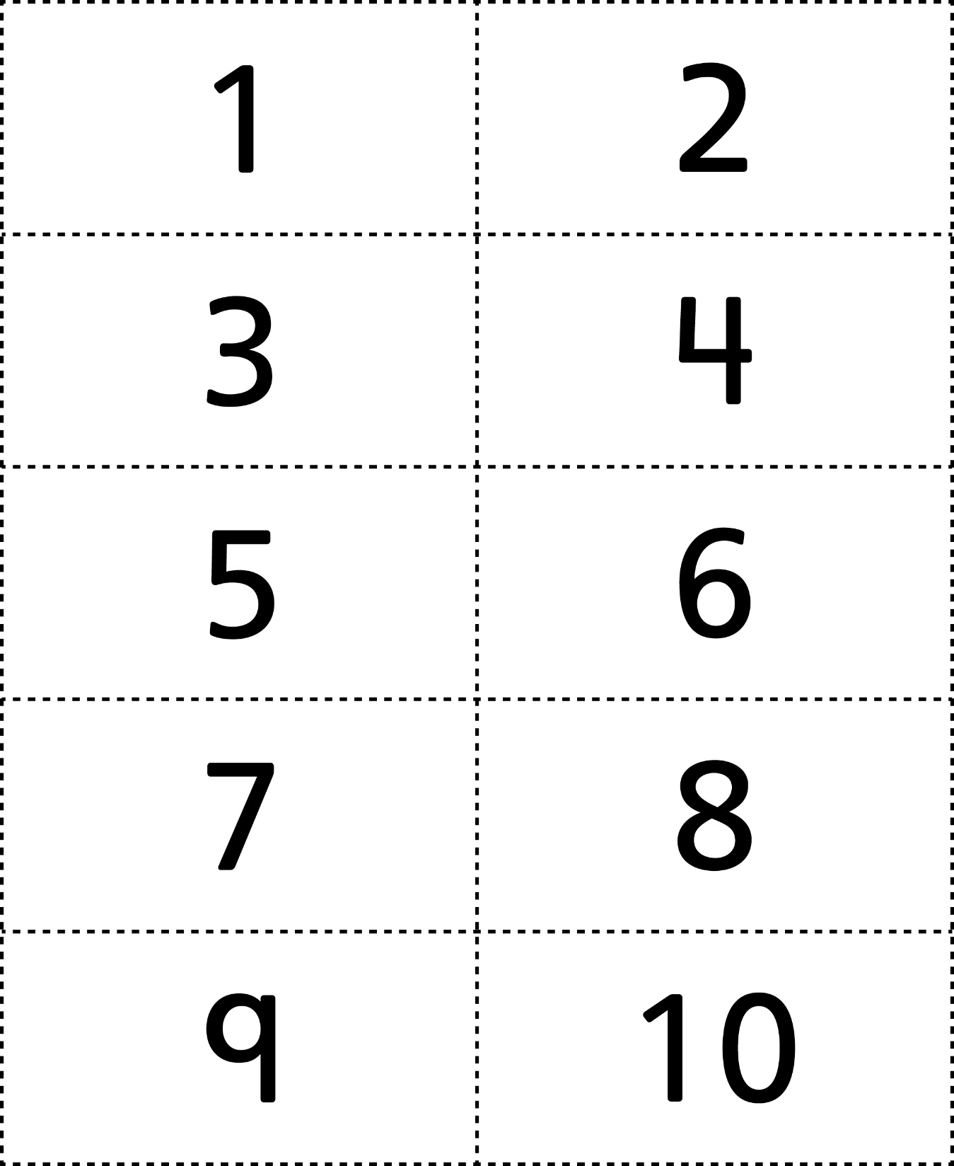

**Number Cards (1–20)**

**Master 23b**

