Building Numbers Behaviours/Strategies
1. Student composes and decomposes using tens and ones.  “48 is 4 tens and 8 ones.”  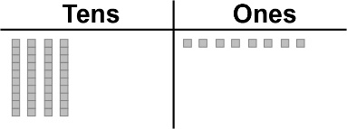  “74 is 7 tens and 4 ones.”  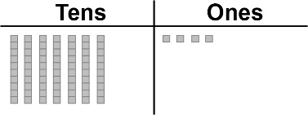 | 2. Student composes and decomposes using hundreds, tens, and ones (one way).  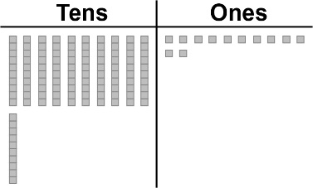  “I modelled 122 by combining  all the tens and all the ones.” | 3. Student composes and decomposes using hundreds, tens, and ones  (more than one way).  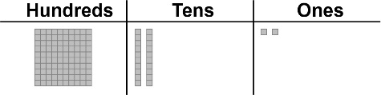  “I traded 10 ones for 1 ten  and 10 tens for one hundred.  I modelled 122.” | 4. Student uses place value to write a number in different ways.  “One hundred twenty-two  1 hundred, 2 tens, 2 ones;  1 hundred, 1 ten, 11 ones  ☐ II••”
Observations/Documentation

