Representing 3-Digit Numbers Behaviours/Strategies
1. Student models number using Base Ten Blocks.  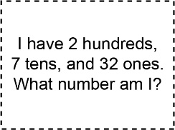  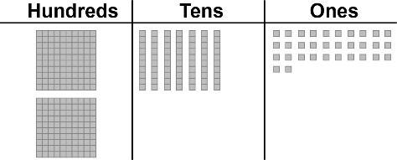  “I modelled 302.” | 2. Student models number using fewest hundreds, tens, and ones.  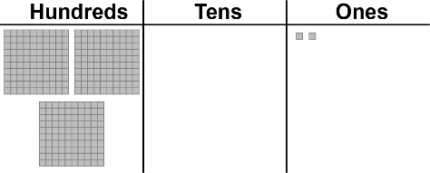  "I traded 30 ones for 3 tens." | 3. Student identifies the number modelled and writes it in  different ways.  Three hundred and two or 302  “2 hundreds, 10 tens, 2 ones  2 hundreds, 9 tens, 12 ones  1 hundred, 20 tens, 2 ones  ☐ ☐ I I I I I I I I I I ▪ ▪” | 4. Student models 3-digit number in different ways.  “The fewest hundreds:  3 tens and 2 ones.  The greatest number of ones:  302 ones.”
Observations/Documentation

