**Number Chart (101–200)**

**Master 34a**

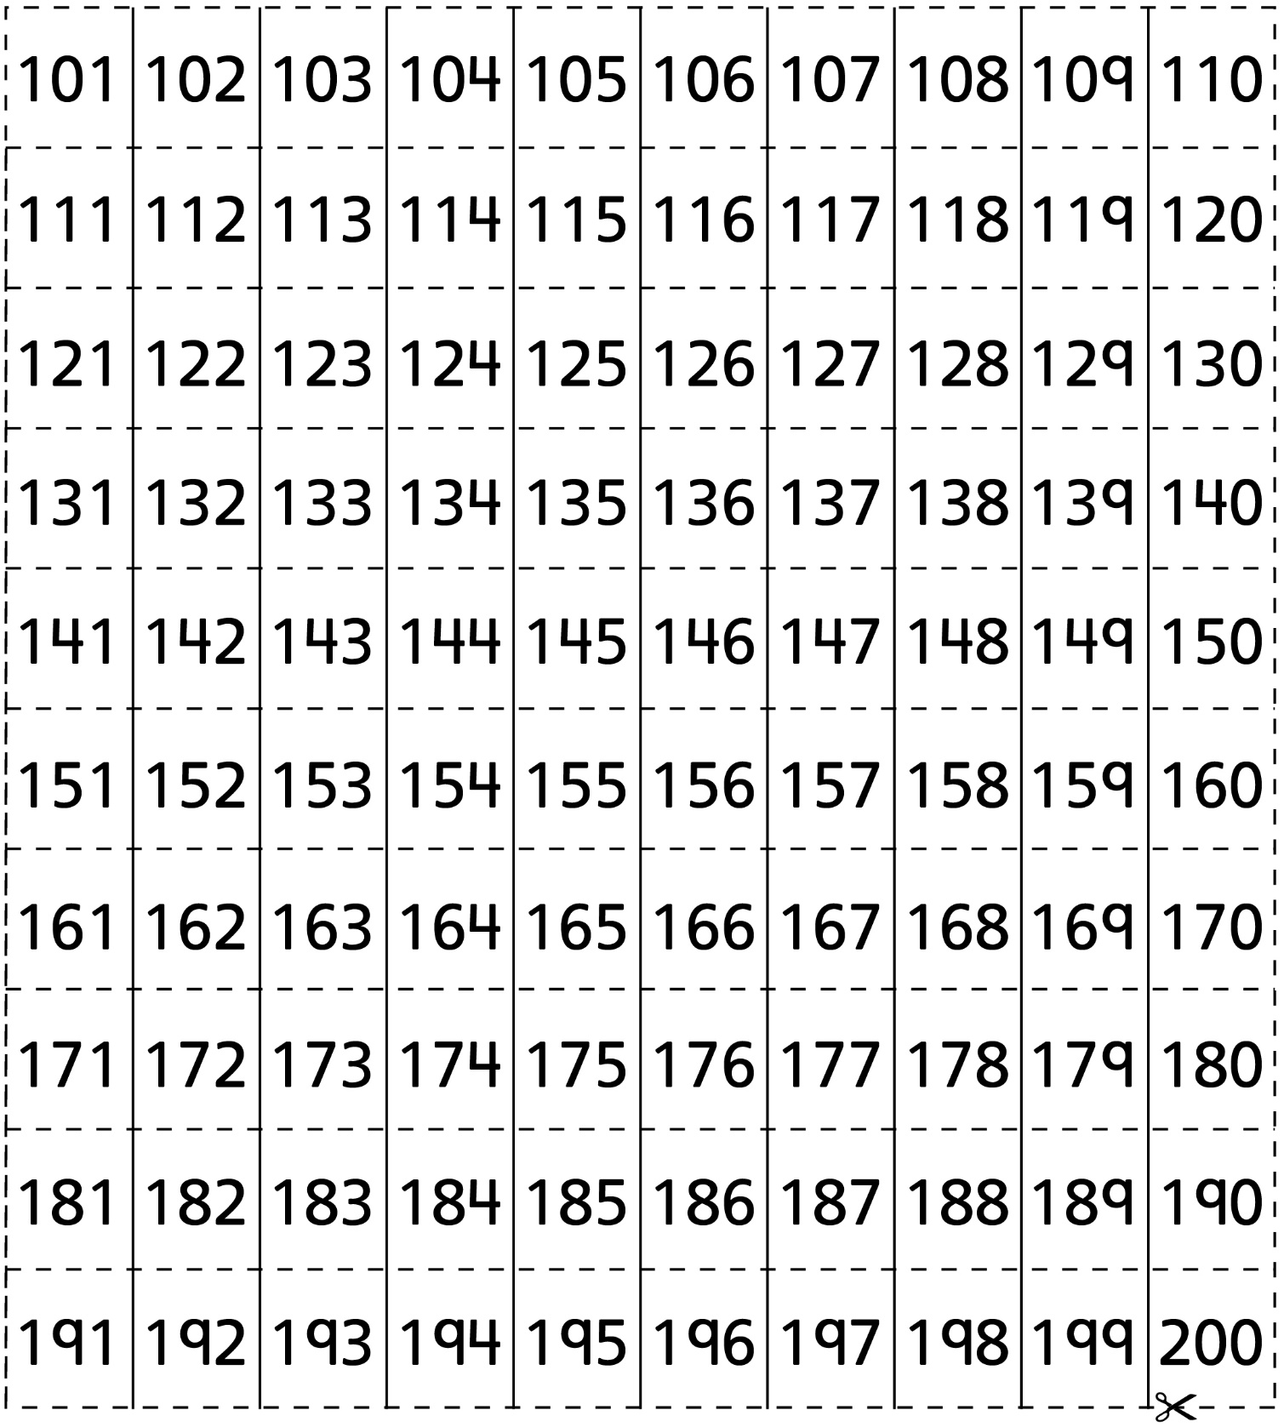

**Number Chart (201–300)**

**Master 34b**

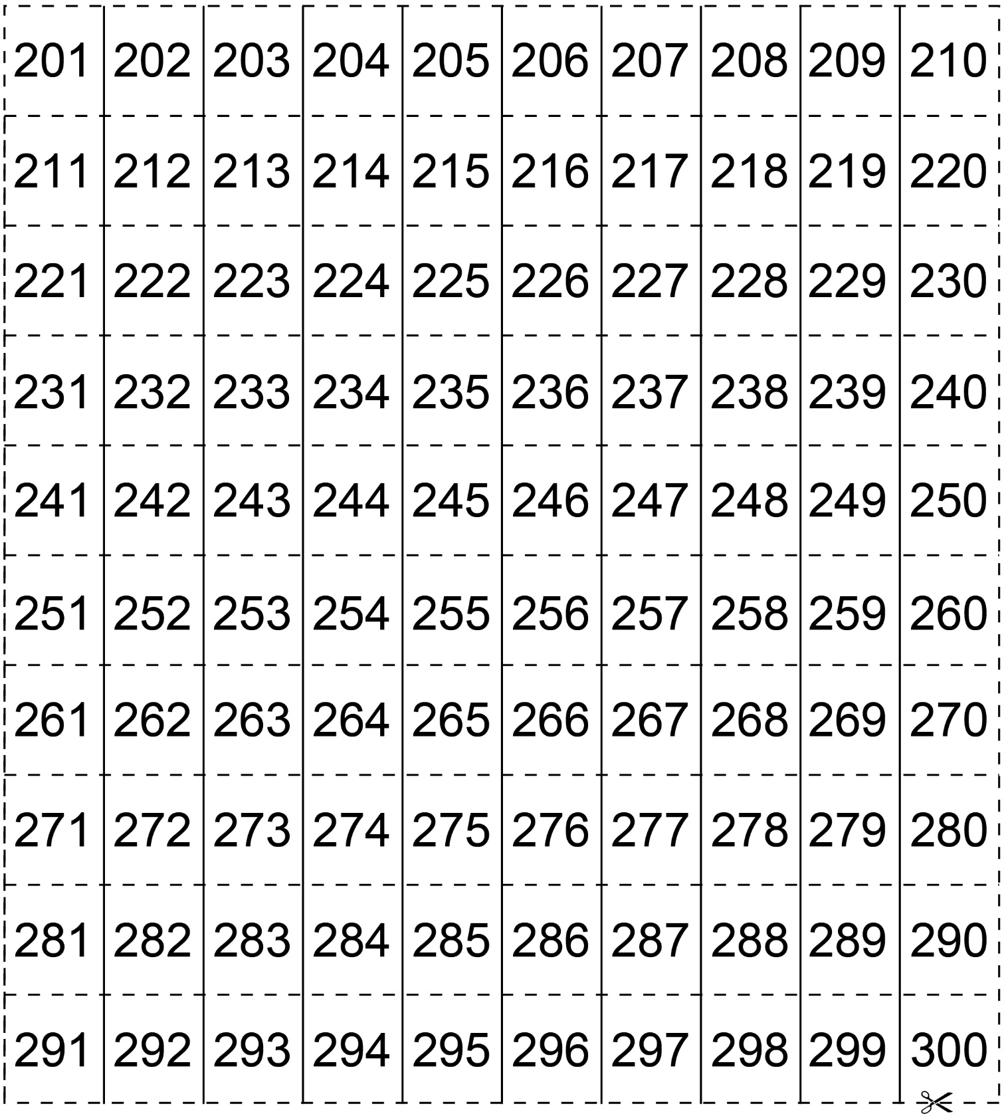

**Number Chart (301–400)**

**Master 34c**

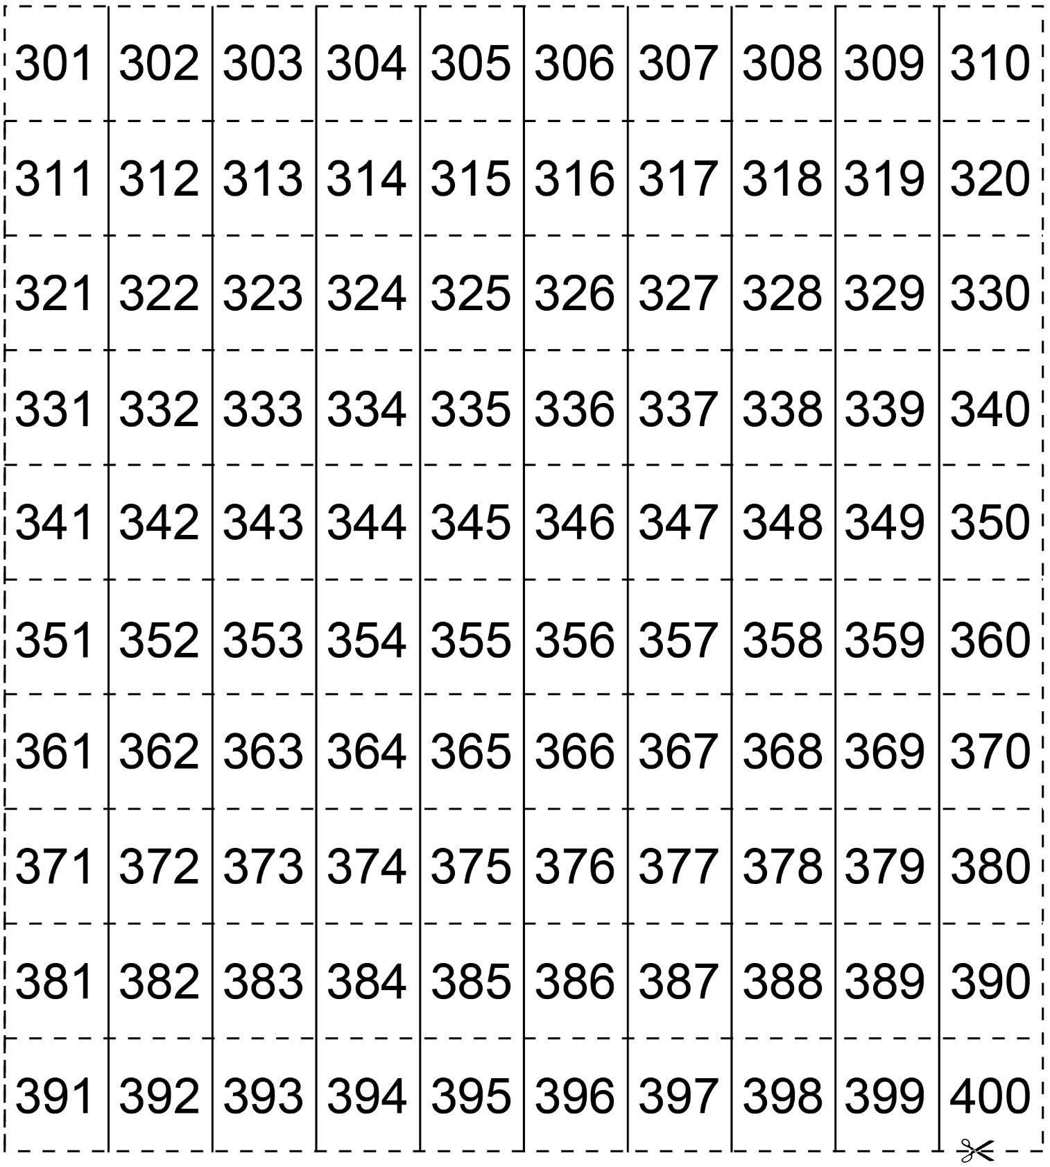

**Number Chart (401–500)**

**Master 34d**

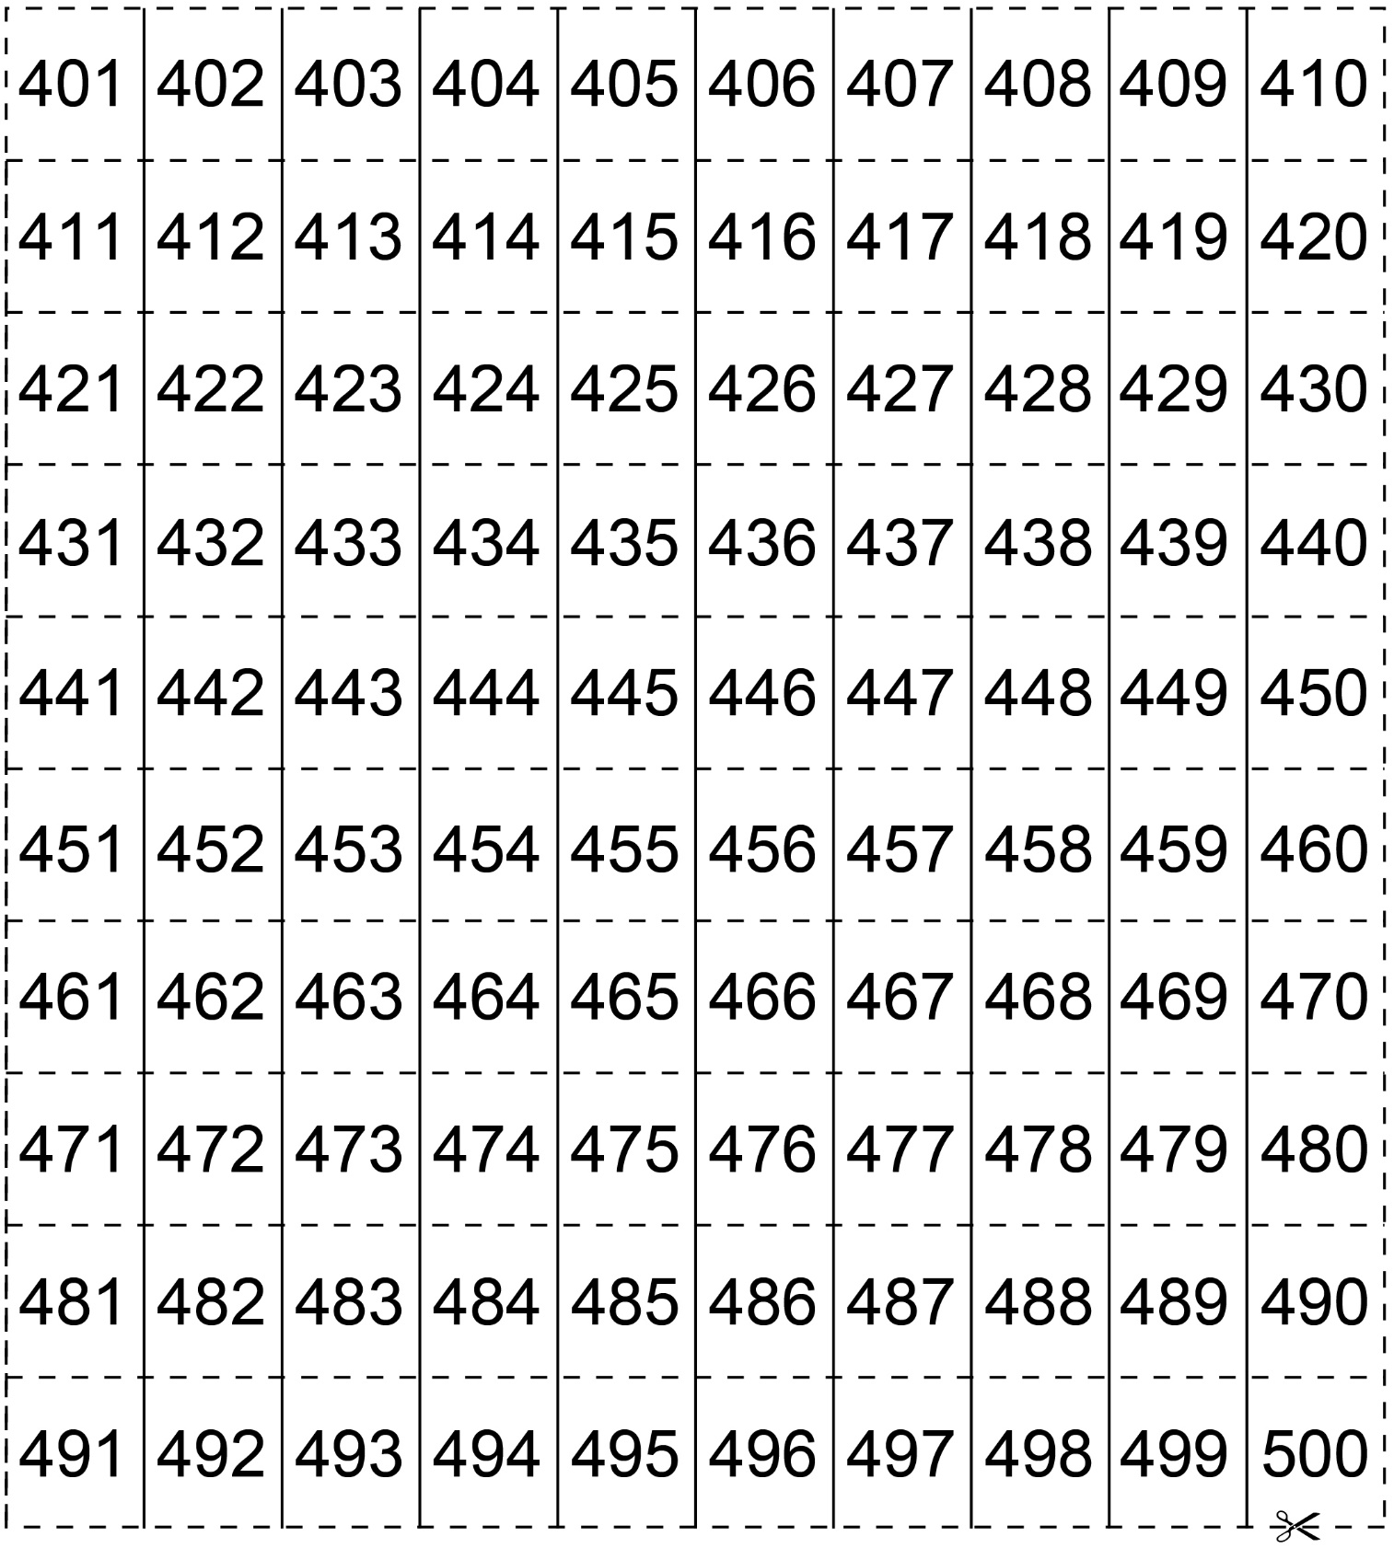

**Number Chart (501–600)**

**Master 34e**

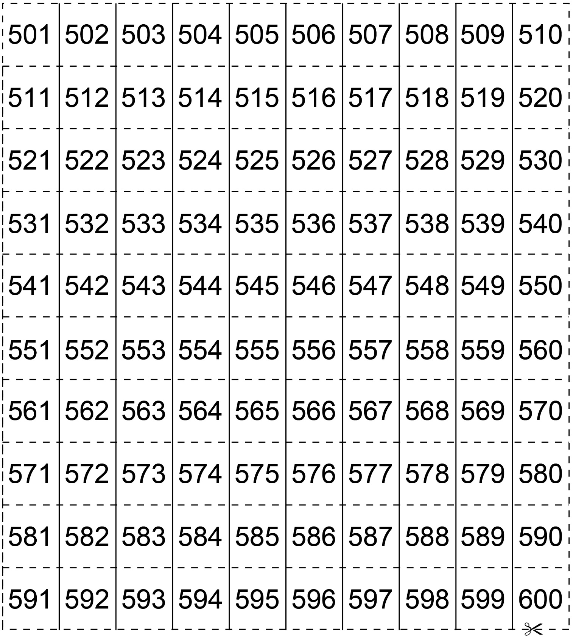

**Number Chart (601–700)**

**Master 34f**

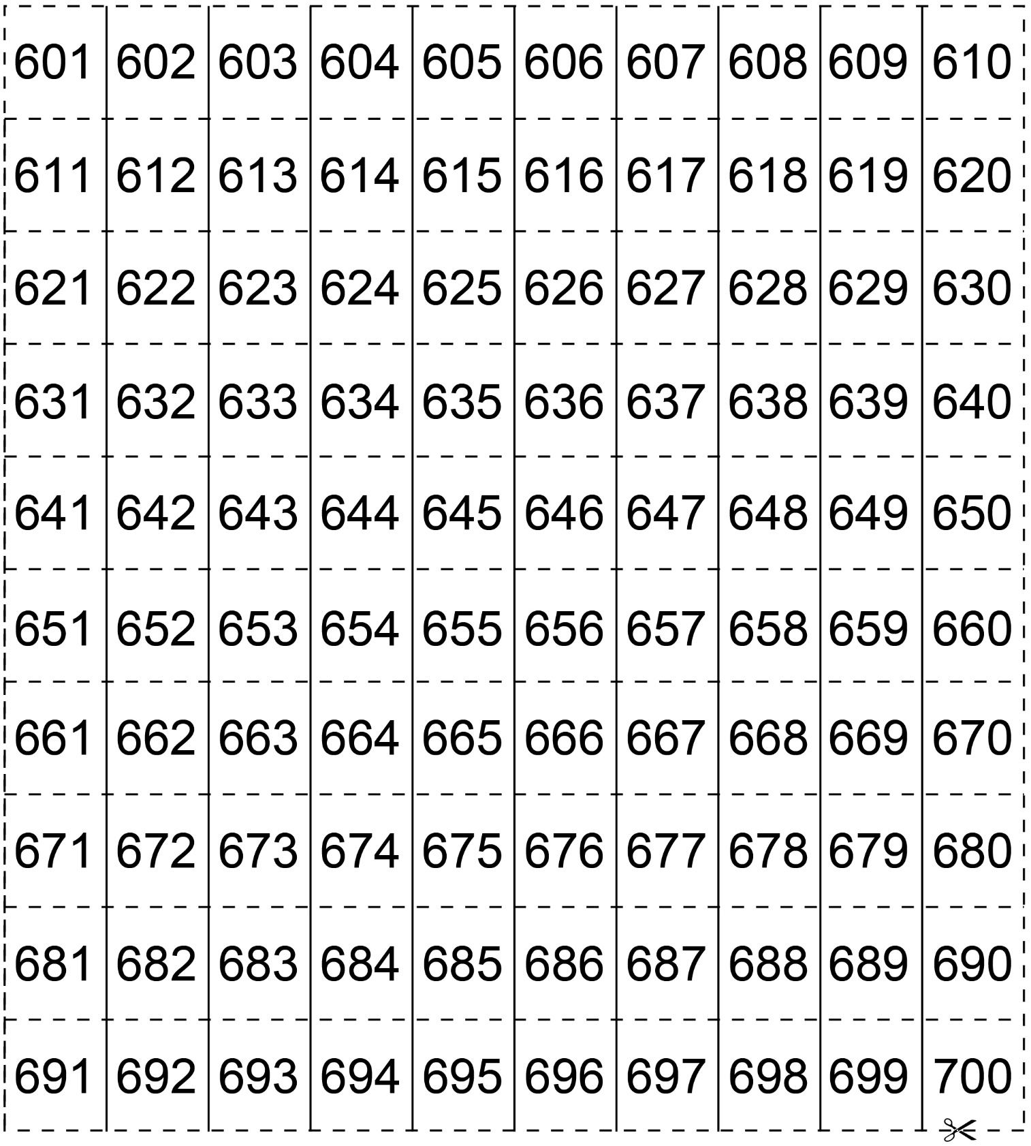

**Number Chart (701–800)**

**Master 34g**

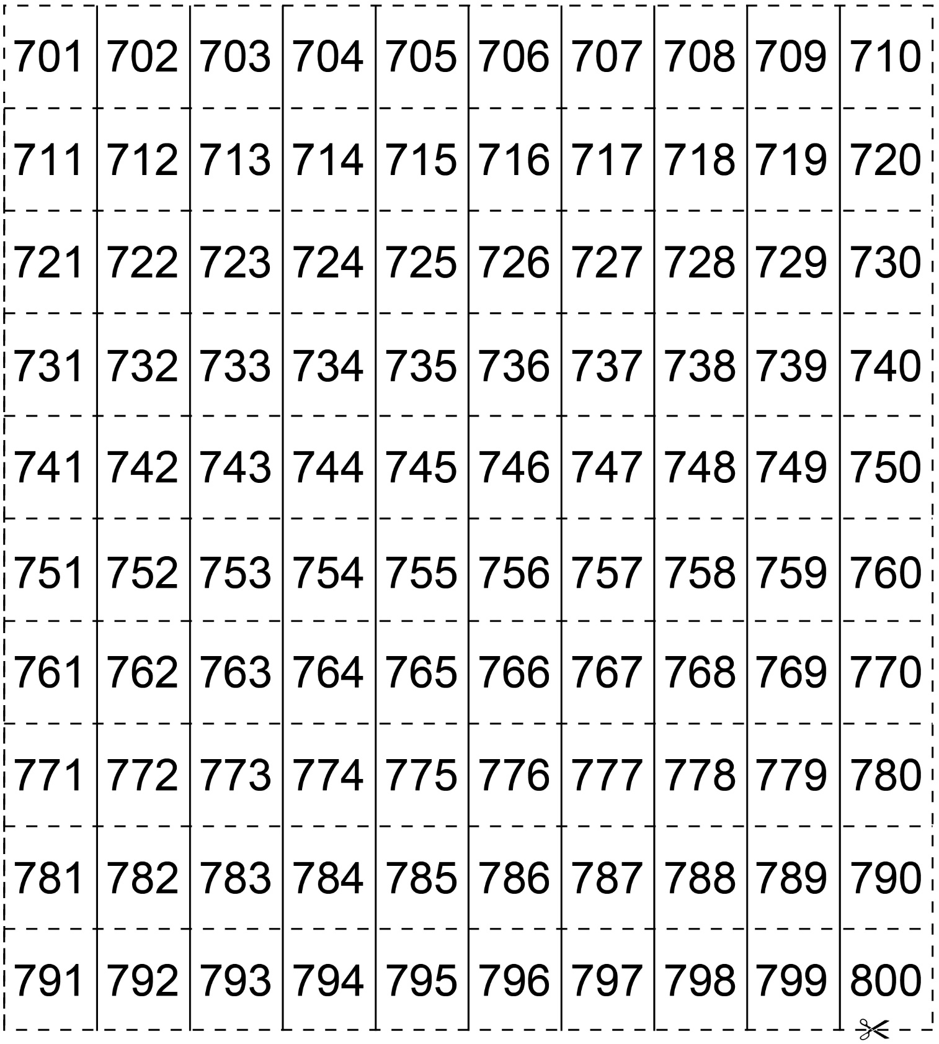

**Number Chart (801–900)**

**Master 34h**

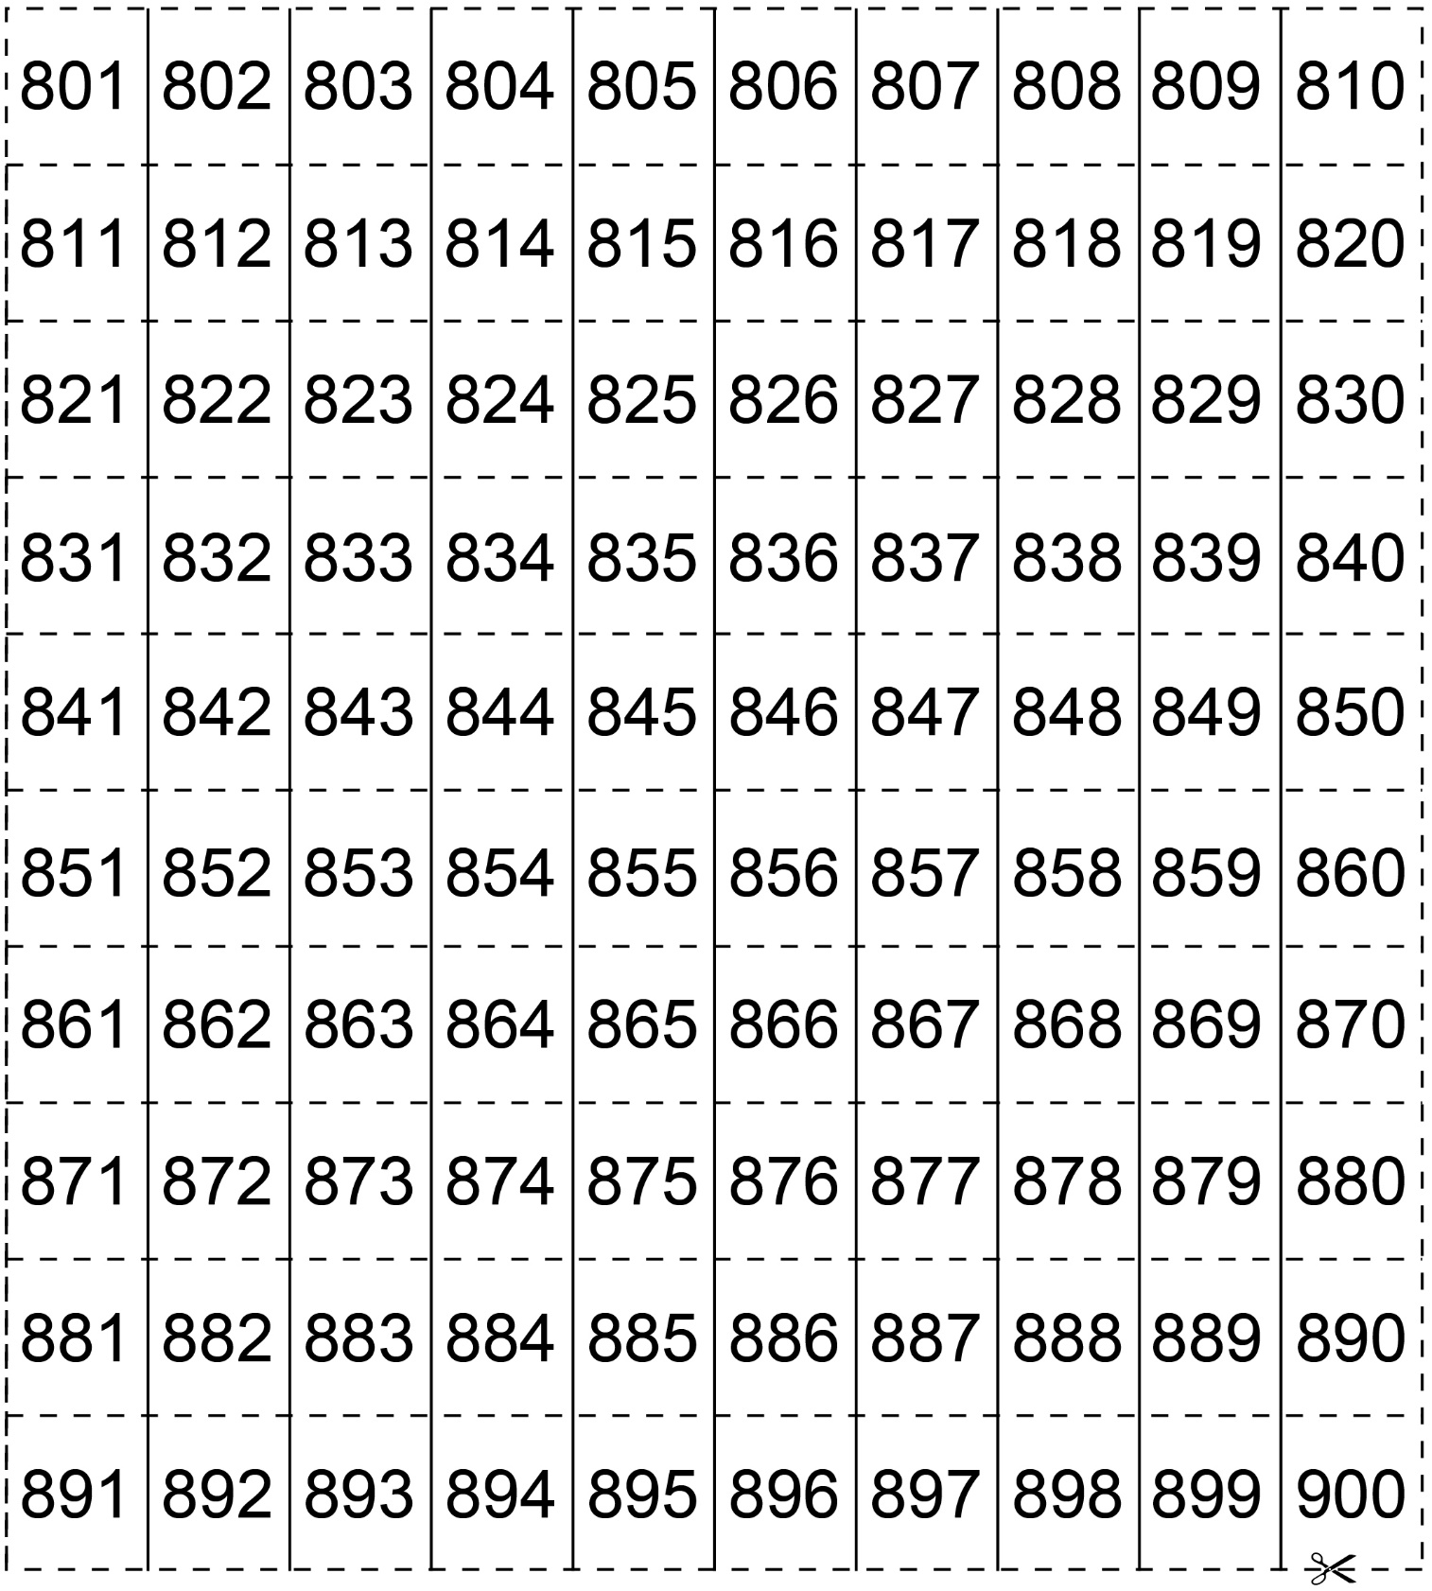

**Number Chart (901–1000)**

**Master 34i**

