Comparing Fractions of Different Wholes Behaviours/Strategies
- Student struggles to divide a whole into equal unit fractions. | - Student is able to divide a whole into equal unit fractions.  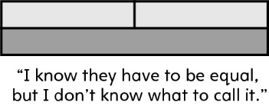 | - Student is unable to see various ways to show the same unit fraction with different wholes in order to compare  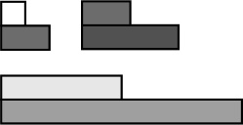
Observations/Documentation
- Student is able to partition unit fractions of different wholes but struggles to compare them.  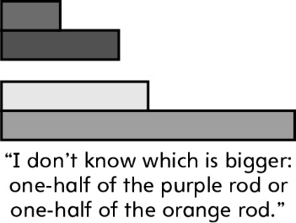 | - Student is able to partition and compare unit fractions of different wholes but does not realize that bigger wholes will produce bigger unit fractions.  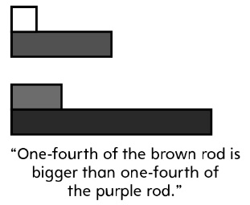 | - Student is able to successfully partition, name and compare unit fractions of different wholes, realizing that bigger wholes will produce bigger unit fractions.  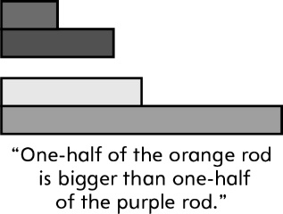
Observations/Documentation

