**Closer To Cards**

**Master 53a**

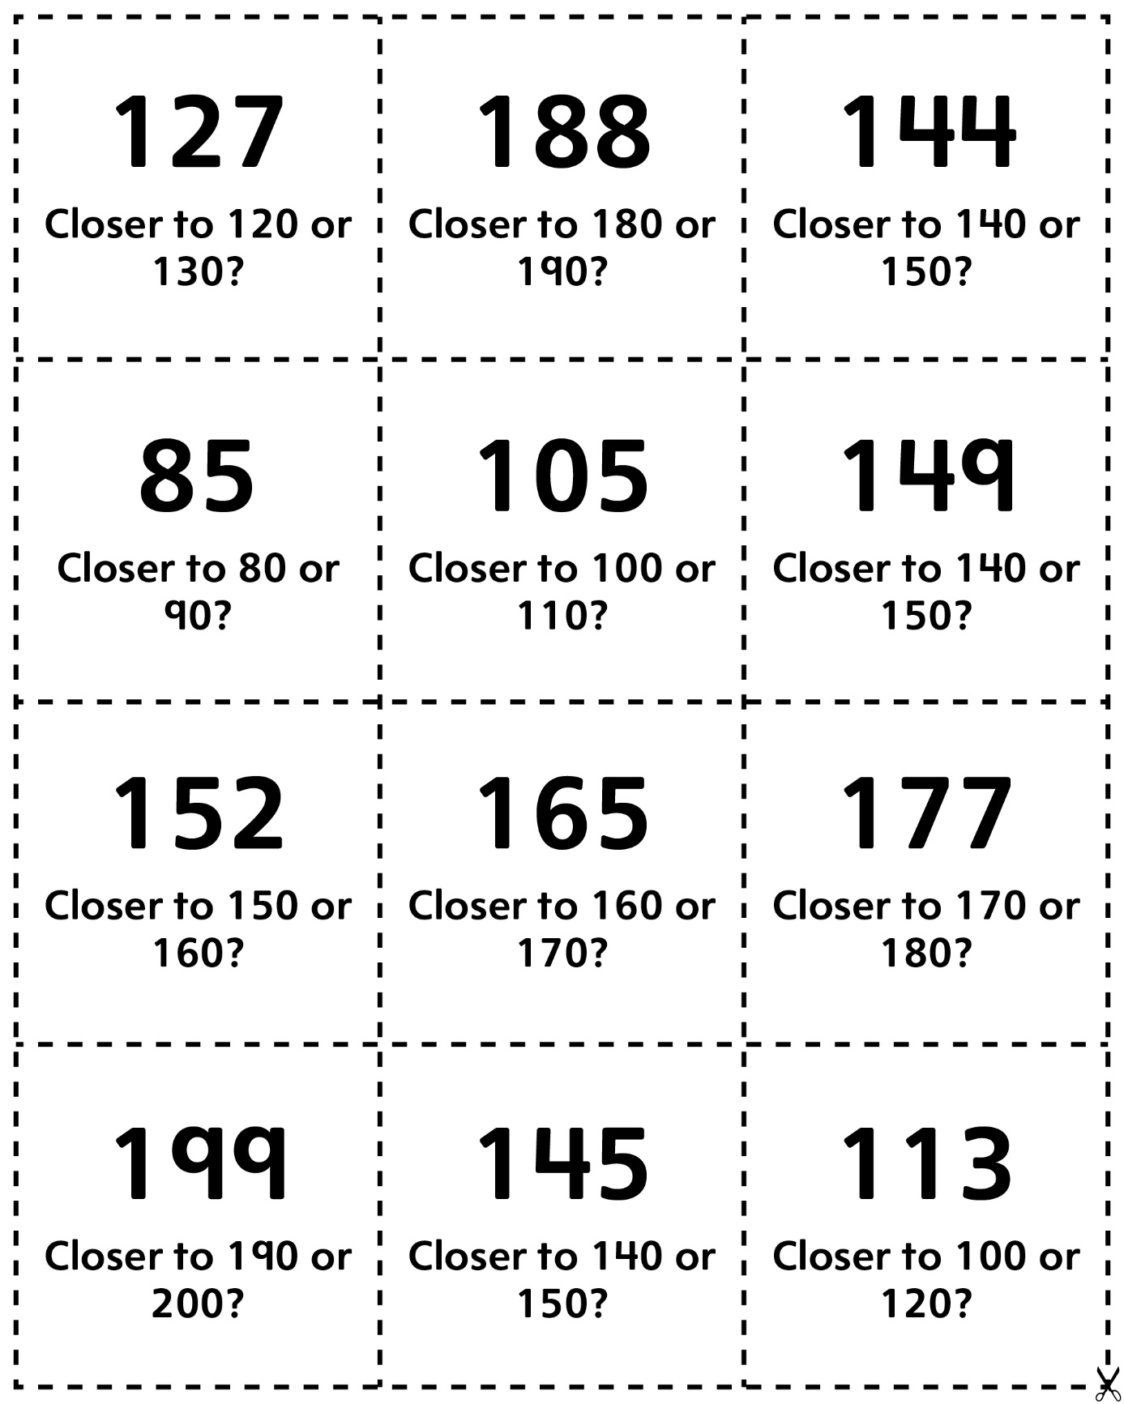

**Closer To Cards (for Accommodations)**

**Master 53b**

**Closer To Cards (for Extension)**

**Master 53c**

