Who Am I? Cards
Master 60a

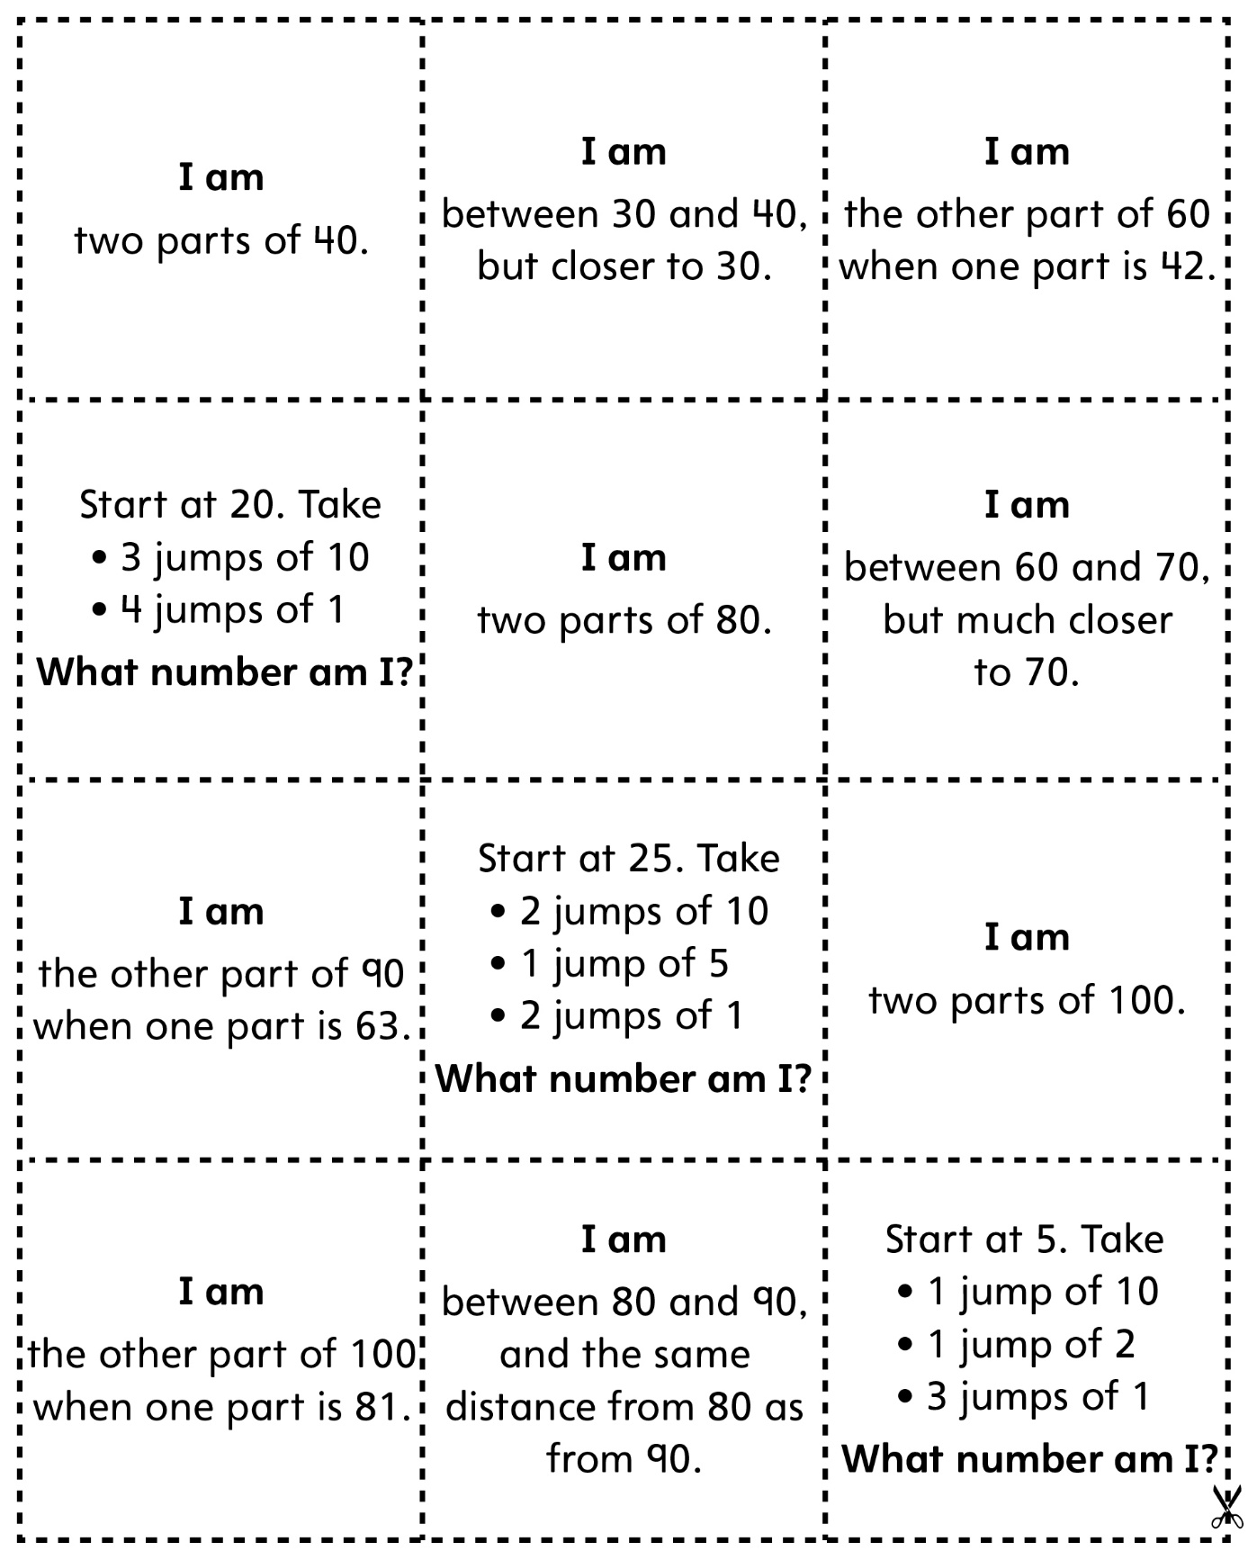

Who Am I? Cards (for Accommodations)
Master 60b

