Visualizing 100 with Groups of 10 Behaviours/Strategies
1. Student decomposes 100 into groups but does not connect to groups of 10.  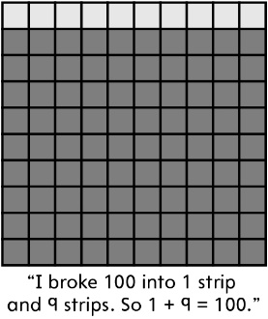 | 2. Student decomposes 100 into groups of 10 (one way).  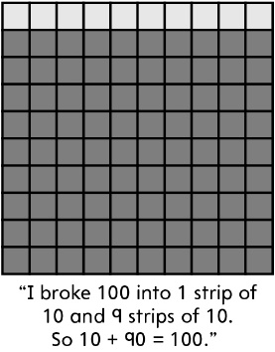 | 3. Student decomposes 100 into multiple groups of 10 (many ways) and records each sum.  “I can make 100 several ways.”  1 strip of 10 and 9 strips of 10  or 10 + 90 = 100  2 strips of 10 and 8 strips of 10  or 20 + 80 = 100  3 strips of 10 and 7 strips of 10  or 30 + 70 = 100  4 strips of 10 and 6 strips of 10  or 40 + 60 = 100  5 strips of 10 and 5 strips of 10  or 50 + 50 = 100 | 4. Student identifies the pattern of one addend increasing by 10 for every decrease in 10 of the other addend to make 100.  10 + 90 = 100  20 + 80 = 100  30 + 70 = 100  40 + 60 = 100  50 + 50 = 100  60 + 40 = 100  70 + 30 = 100  80 + 20 = 100  90 + 10 = 100
Observations/Documentation

