**Common Doubles**

**Master 81a**

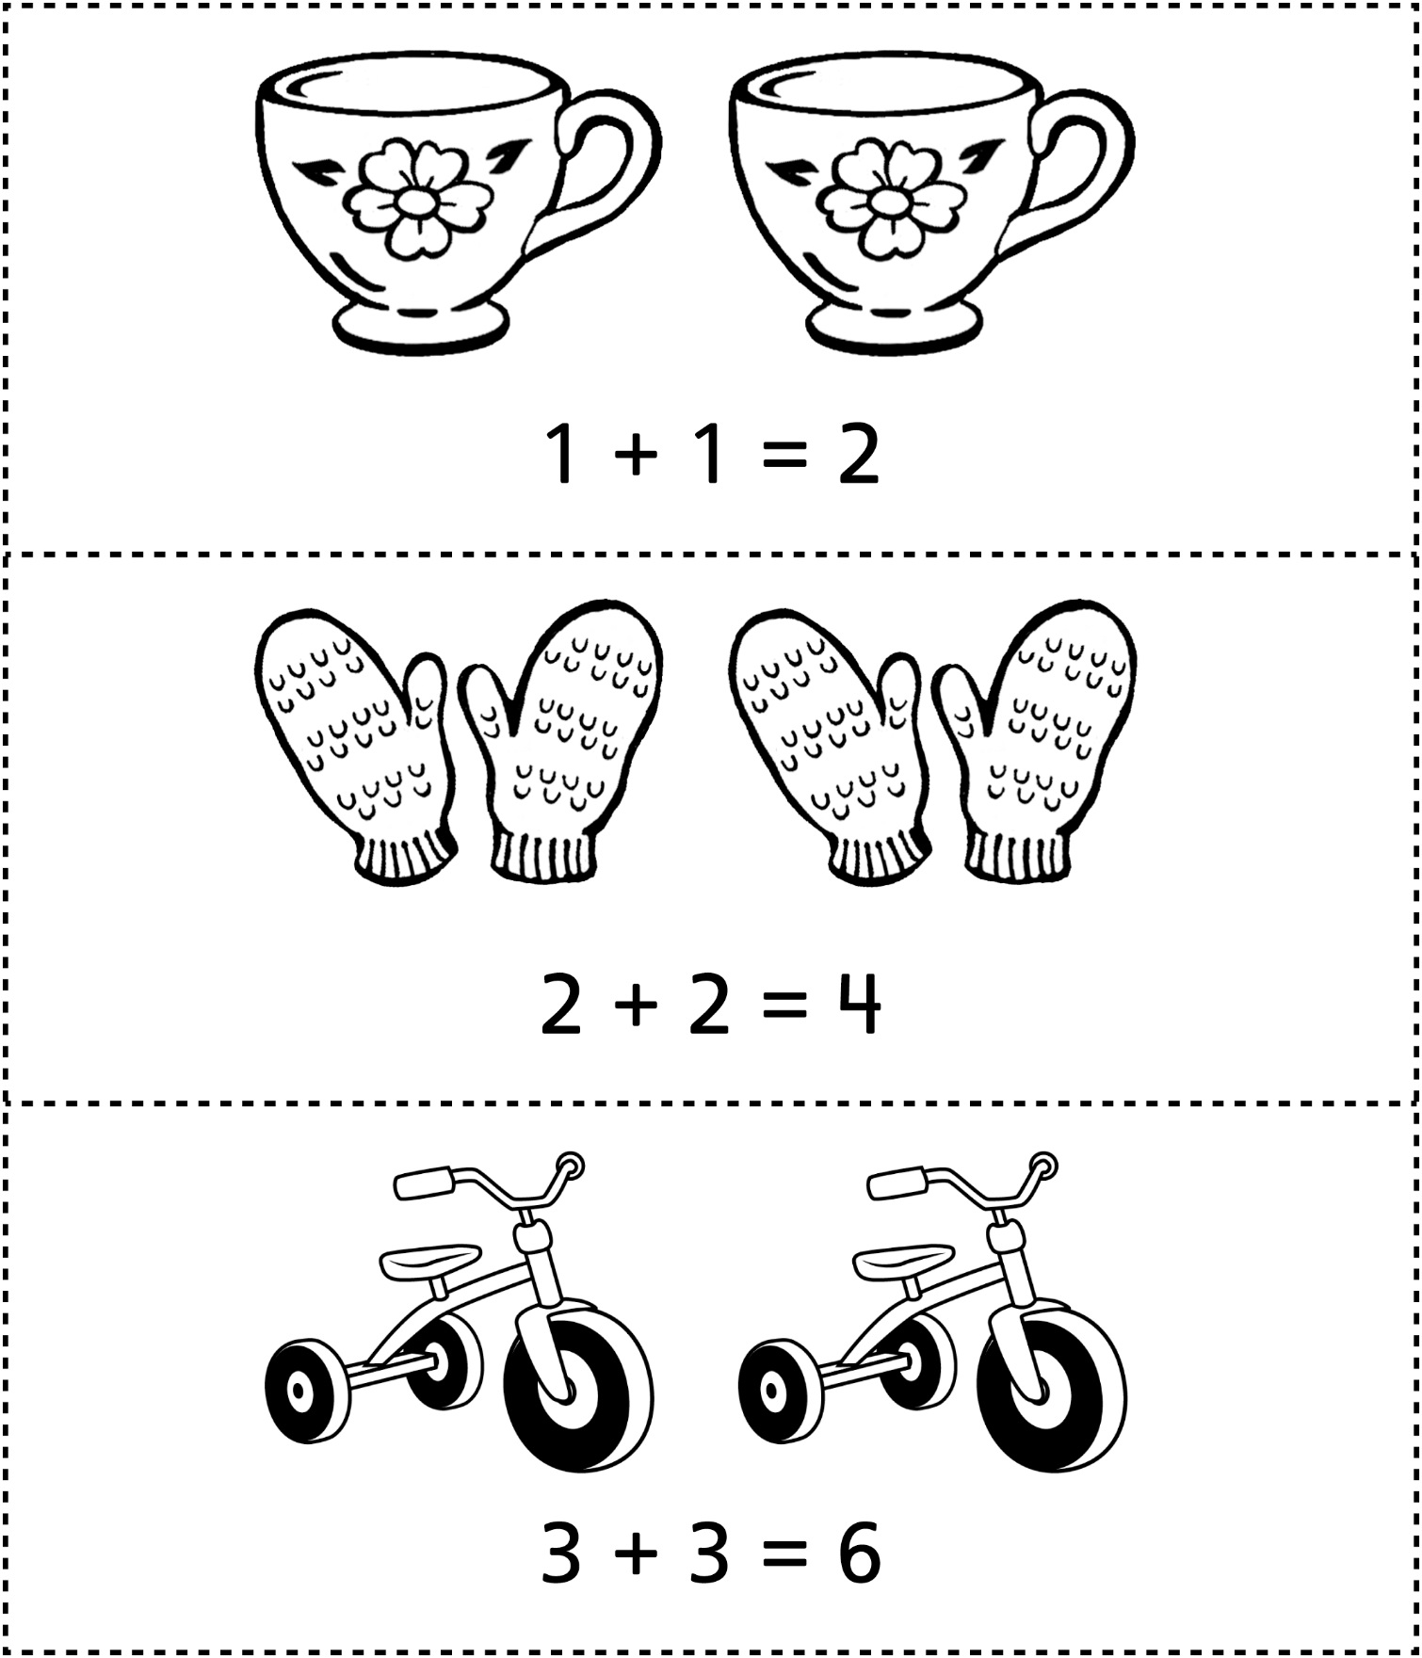

**Common Doubles**

**Master 81b**

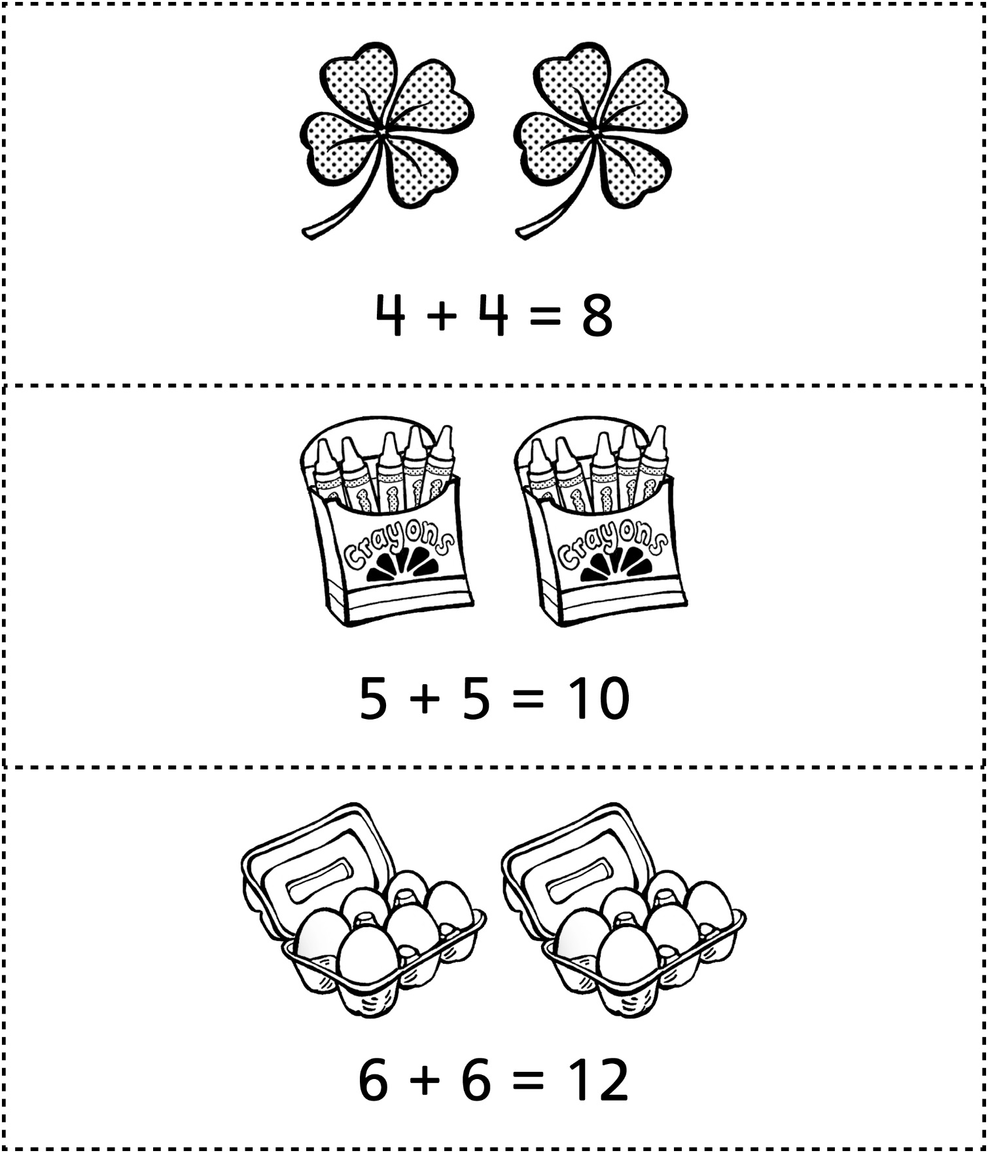

**Common Doubles**

**Master 81c**

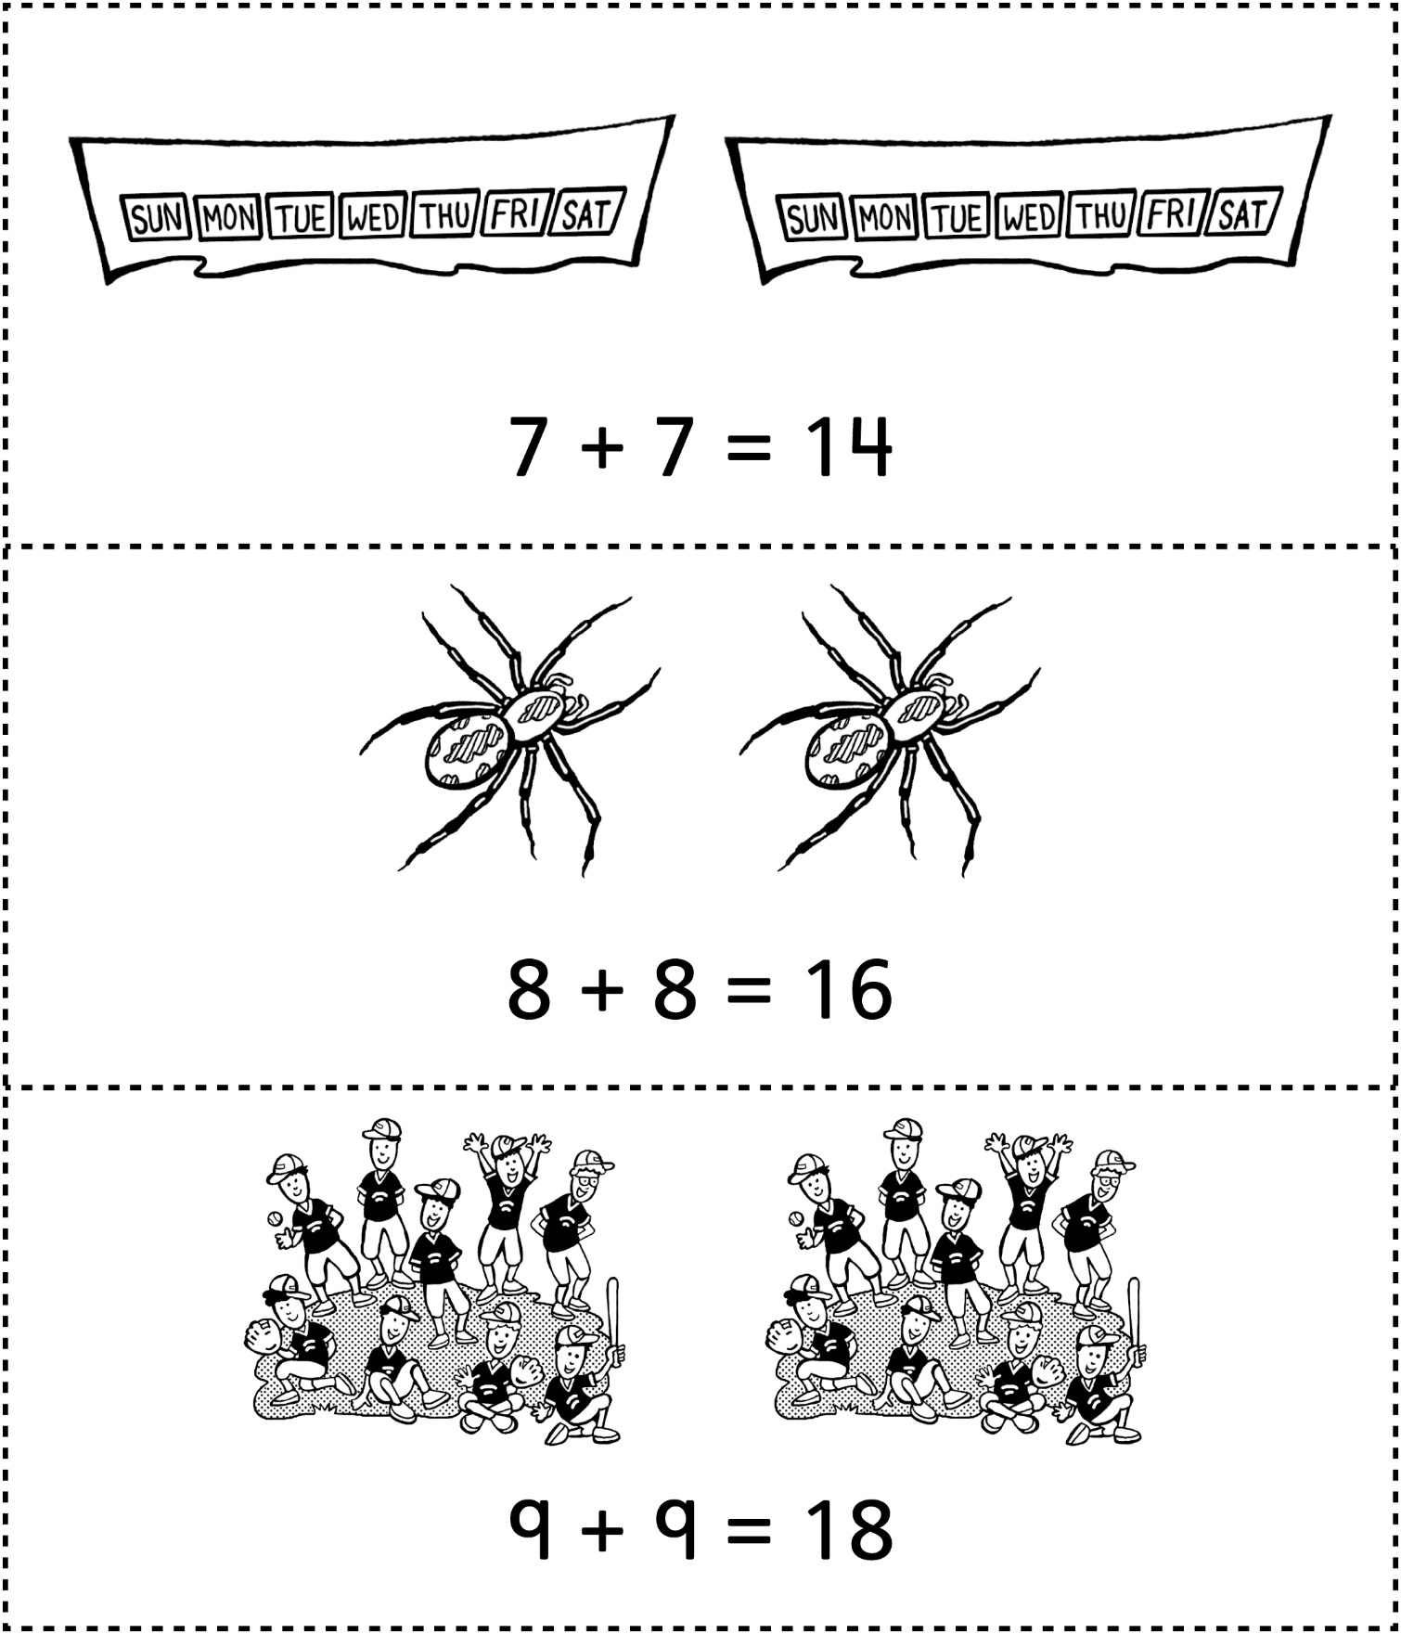

**Common Doubles**

**Master 81d**

|  |
| --- |
| 10 + 10 = 20 |