Adding and Subtracting Numbers Behaviours/Strategies
- Student counts to add and subtract quantities.  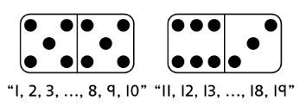 | - Student counts on or back to add  and subtract quantities.  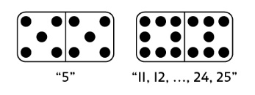 | - Student uses ten-frames and  counters or other materials to  show a strategy when adding and  subtracting quantities.  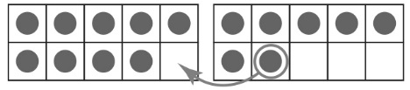 | 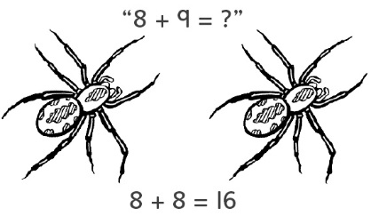  - Student refers to doubles pictures when extending known sums to add and subtract quantities.
Observations/Documentation
- Student uses the same strategy in every situation to add and subtract quantities.  “I like to use doubles!” | - Student fluently adds using a variety of strategies, but counts back by 1s to subtract. | - Student adds and subtracts fluently and extends known sums to solve other equations, but struggles to explain thinking. | - Student fluently adds and subtracts, extends known sums to solve other equations, and explains thinking.
Observations/Documentation

