Estimating Money Amounts Behaviours/Strategies
- Student guesses instead of using  relevant benchmarks to estimate  quantities.  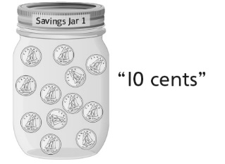 | - Student counts instead of using  relevant benchmarks to estimate  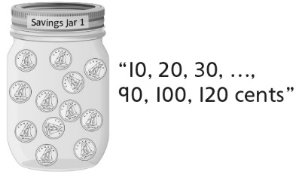  quantities. | - Student uses relevant benchmarks to estimate quantities, but estimates are unreasonable.  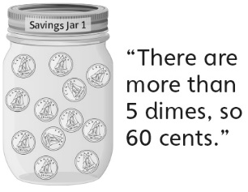 | - Student successfully uses relevant benchmarks to estimate quantities and makes reasonable estimates.  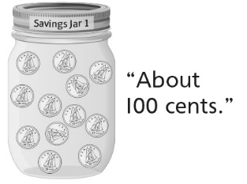
Observations/Documentation
Counting and Comparing Money Amounts Behaviours/Strategies
- Student places matching coins, but is unable to skip-count to find the value of the coins (unable to compose money amounts from parts). | - Student successfully composes  money amounts from parts, but  struggles to compare and order  quantities. | - Student successfully composes  money amounts from parts and  compares and orders quantities, but does not realize that the number of coins does not affect the value. | - Student successfully composes  money amounts from parts and  compares and orders quantities.
Observations/Documentation

