**Our Savings Plan**

**Master 111**

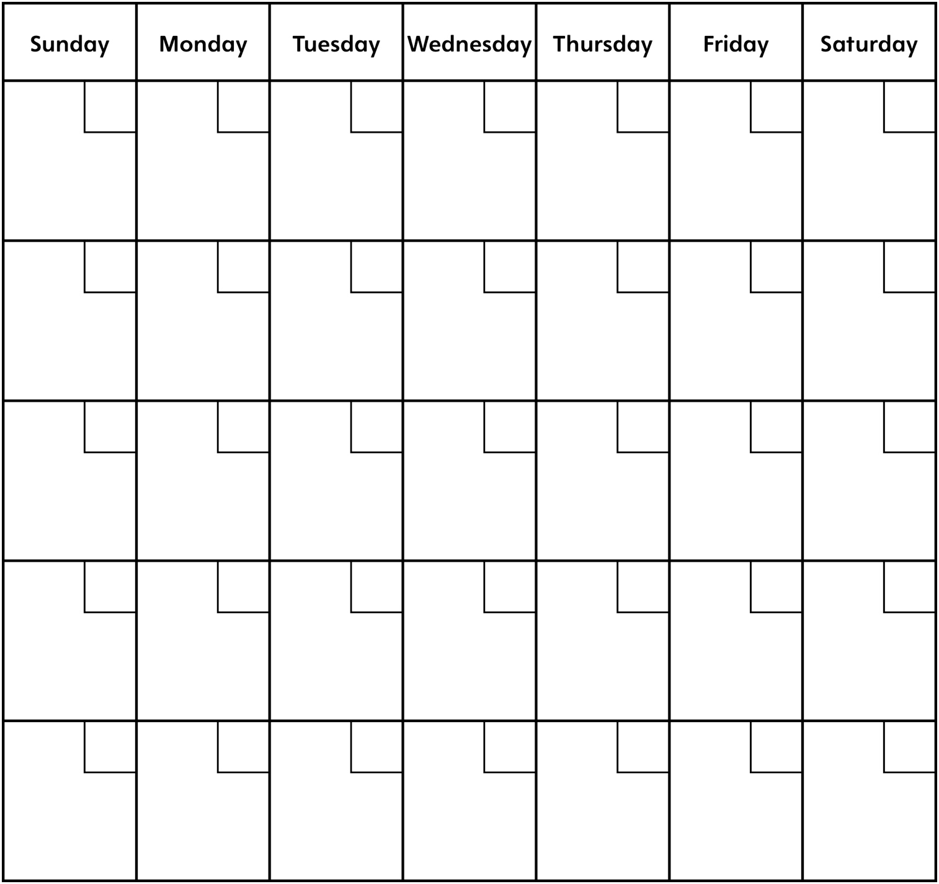

Money Student A saved: _____________

Money Student B saved: _____________

Total amount saved: _____________ Money spent: ______________

Amount left in savings: _________