Making a Savings Plan Behaviours/Strategies
- Student chooses a job, but when  making a savings plan, circles  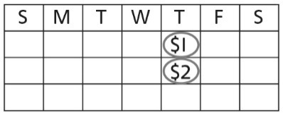  random dates, places wrong coin/bill on calendar, or does not place same amount on each date. | - Student makes a savings plan,  but does not consider wants and  needs.  “I will buy all of the items!” | - Student makes a savings plan, but requires support to revise the plan.  “I don’t have enough money.  What do I do?” | - Student successfully makes a  savings plan and has enough  money to buy all the items chosen.
Observations/Documentation
Adding and Subtracting Money Amounts Behaviours/Strategies
- Student circles dates, but cannot  add quantities to determine total  savings.  “How do I find how much I saved?” | - Student chooses items for party,  but cannot add quantities to  determine total cost of items.  “$5, $3, $2”  “How can I find the total?” | - Student adds quantities, but  struggles to subtract quantities to  find how much is left in savings.  “How do I find how much is left?” | - Student successfully and flexibly  adds and subtracts quantities.
Observations/Documentation

