Repeating Patterns Behaviours/Strategies
- Student chooses a core card, but struggles to  represent it with materials.  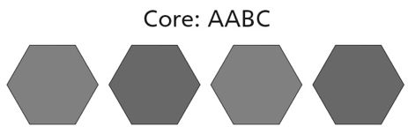 | - Student represents the core with materials, but struggles to use copies of the core to extend/create the pattern.  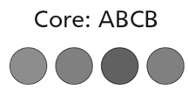 | - Student represents the core with materials, but  struggles to predict an element in the pattern.  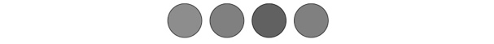  “How do I know what element 14 will be?
Observations/Documentation
- Student identifies the repeating unit (core) of a  pattern, but struggles to find errors or missing  elements. | - Student creates repeating patterns based on  one attribute, but struggles to create a core  based on two attributes.  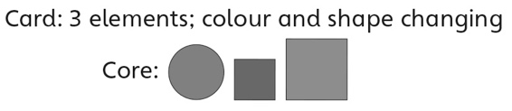 | - Student creates and extends repeating patterns  based on one or two attributes, and predicts  missing element(s) and corrects errors.
Observations/Documentation

