Exploring Number Sentences Behaviours/Strategies
- Student chooses a number sentence, but  struggles to compare expressions and compares one number on each side (e.g., compares 13 and 7 for 13 – 5 = 7 + 2). | - Student takes cubes, but struggles to model  add-to and take-from situations with cubes. | - Student models add-to and take-from  situations with cubes and compares expressions by comparing lengths or using one-to-one matching.  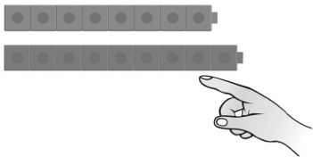
Observations/Documentation
- Student models add-to and take-from situations with cubes and compares expressions by counting.  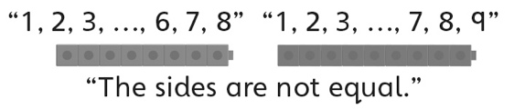 | - Student models add-to and take-from situations with cubes and compares expressions, but does not understand when to use the greater than (>) or less than (<) signs.  “I’m not sure which sign to use.” | - Student models add-to and take-from  situations with cubes, and understands and uses the equal (=) and greater than (>) or less than (<) signs when comparing expressions.
Observations/Documentation

