***Before* Sample Answers**

**Master 6**

**Venn Diagram**

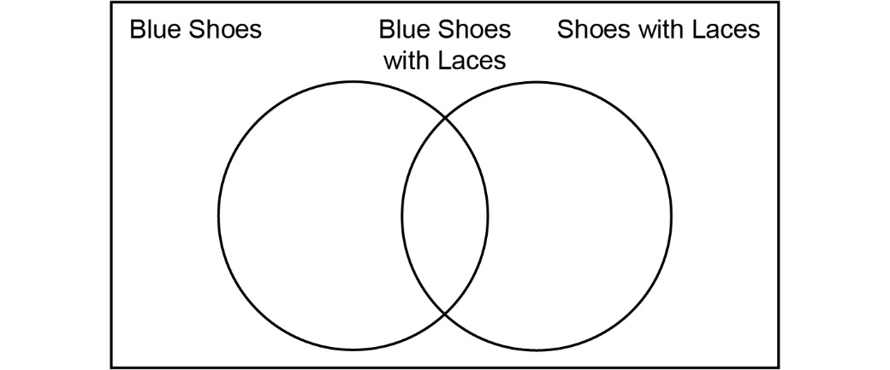

**Carroll Diagram**

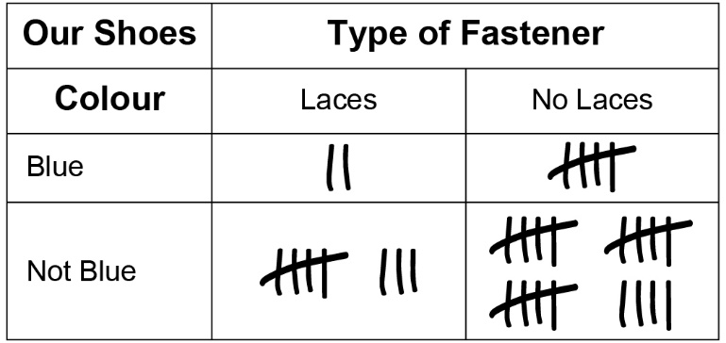

**Two-Way Table**

