Sorting Data According to 2 Attributes Behaviours/Strategies
- Student identifies two attributes, but struggles to sort the collection.  “I know fish have different colours and patterns. I’m not sure how I can sort them using two attributes.”  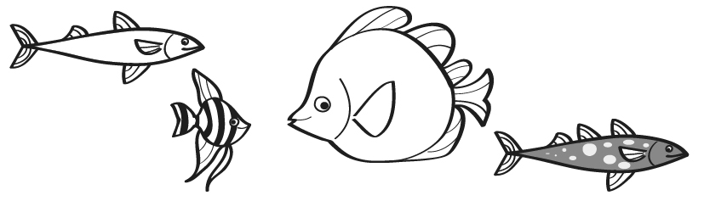 | - Student identifies two attributes, but struggles to sort the collection using both attributes.  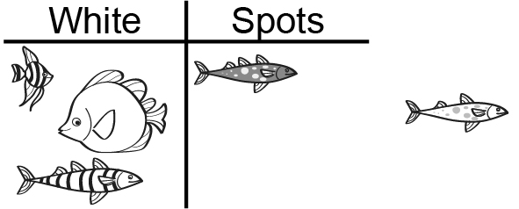  “These fish are white and this one has spots.” | - Student sorts a collection by two attributes on a Venn diagram.  “Here’s how I sorted using two attributes. The fish with both characteristics is in the overlap.”  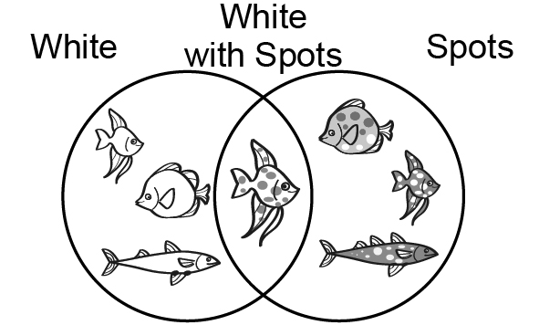
Observations/Documentation
- Student sorts data by two attributes using a two-way table.  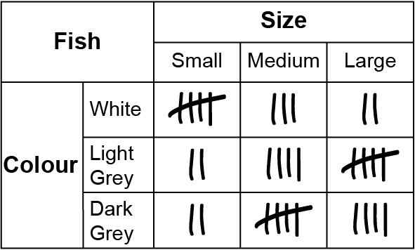  “I sorted using two attributes. My two-way table shows the data.” | - Student sorts data by two attributes using a Carroll diagram.  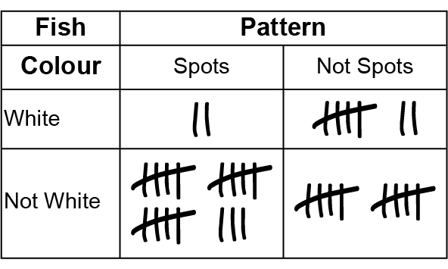  “This diagram shows the data I sorted using two attributes.” | - Student flexibly chooses an appropriate tool to sort data by two attributes and justifies choice.  .
Observations/Documentation

