Conducting Surveys Behaviours/Strategies
- Student thinks of a topic, but is unable to  formulate a question that can be addressed  through a survey.  “My favourite animal is a panda.” | - Student formulates a question that can be  addressed through a survey, but does not include sample or reasonable responses or focus on two attributes.  “Which fruit do you like best?” | - Student formulates a question that can be  addressed through a survey, but when collecting data, asks some students more than once.
Observations/Documentation
- Student formulates a question that can be  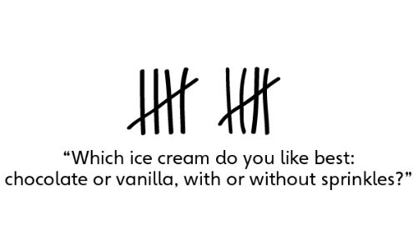  addressed through a survey, but when collecting data, struggles to record responses using simple records. | - Student formulates a question that can be  addressed through a survey and collects data  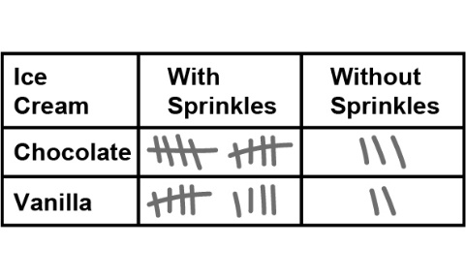  in a two-way tally table, but struggles to use data to draw conclusions. | - Student successfully formulates a question that  can be addressed through a survey, collects data in a two-way tally table, and uses data to draw conclusions.
Observations/Documentation

