Making Line Plots and Bar Graphs Behaviours/Strategies
- Student chooses a template and  attempts to create a one-to-one  display (e.g., line plot, bar graph),  but does not include labels. | - Student creates a one-to-one  display, but struggles to translate  information from tally chart to  graph (i.e., numbers in tally chart  and graph do not match). | - Student creates a one-to-one  display, but bunches Xs together  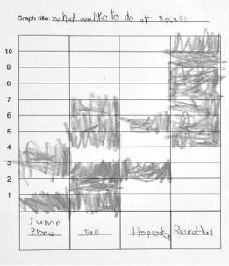  or does not space Xs or shaded  rectangles  equally. |  | 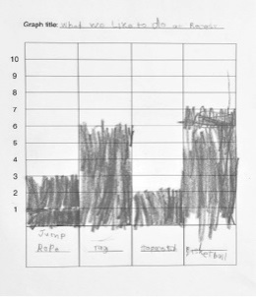  - Student successfully creates one-to-one displays (e.g., line plot, bar graph).
Observations/Documentation
Reading and Interpreting Graphs Behaviours/Strategies
- Student reads displays, but counts Xs or coloured rectangles twice or mixes up the number word sequence.  “1, 2, 3, 5, 6” | - Student reads displays, but  struggles to interpret data to  answer “how many” questions. | - Student reads displays, but  struggles to interpret data to  answer comparison questions  (e.g., how many more/less). | - Student successfully interprets  displays by noting how many  more/less than other categories.
Observations/Documentation

