Probability Cards
Master 34

Note: Cards for bags of counters are for Part A of activity.
Cards for spinners are for Part B of activity.
Bag with  • 5 red counters  • 5 yellow counters | Bag with  • 2 blue counters  • 8 green counters
Bag with  • 3 yellow counters  • 1 blue counter  • 6 green counters | 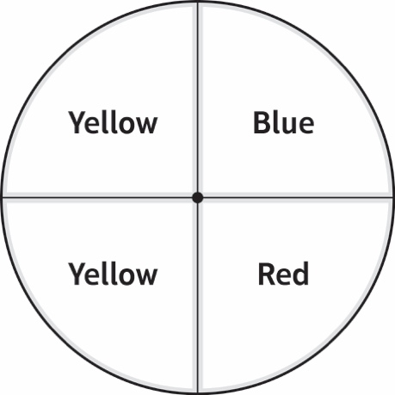
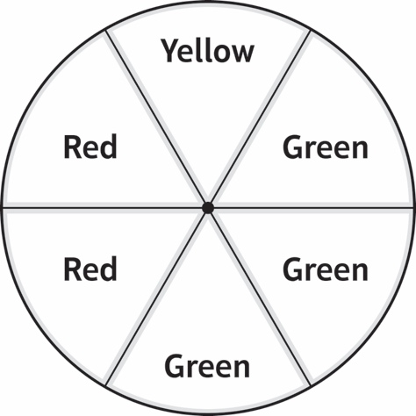 | 