**Shape Cards**

**Master 6a**

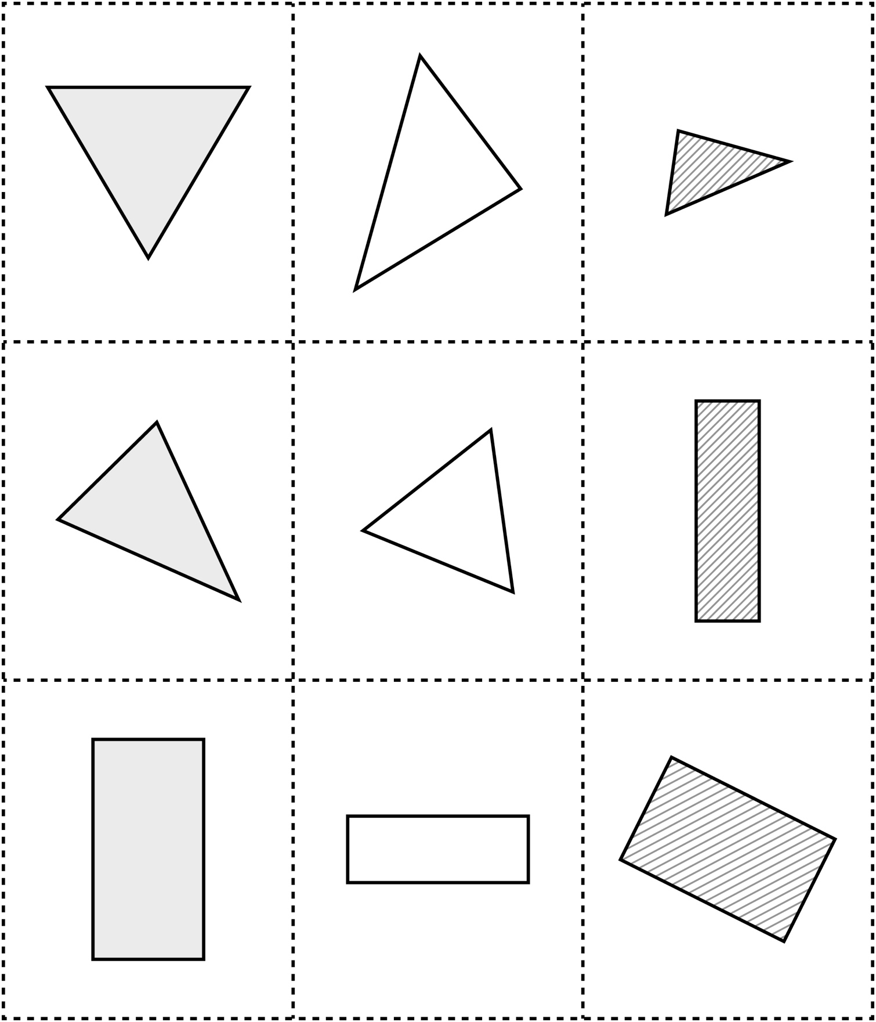

**Shape Cards**

**Master 6b**

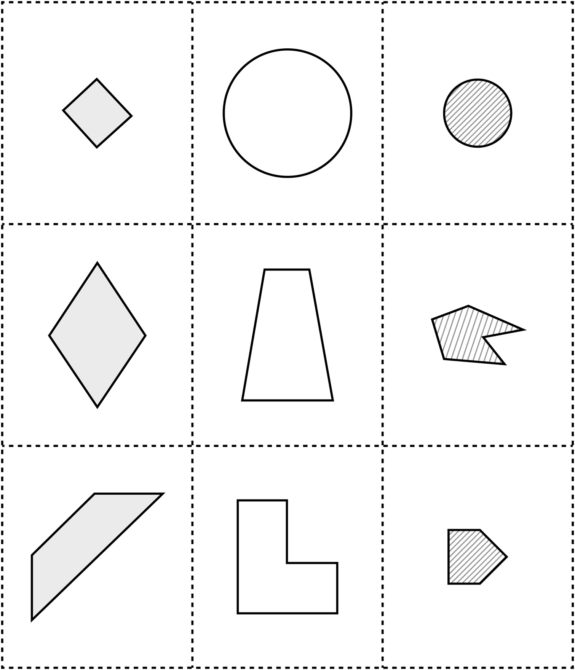

**Shape Cards**

**Master 6c**

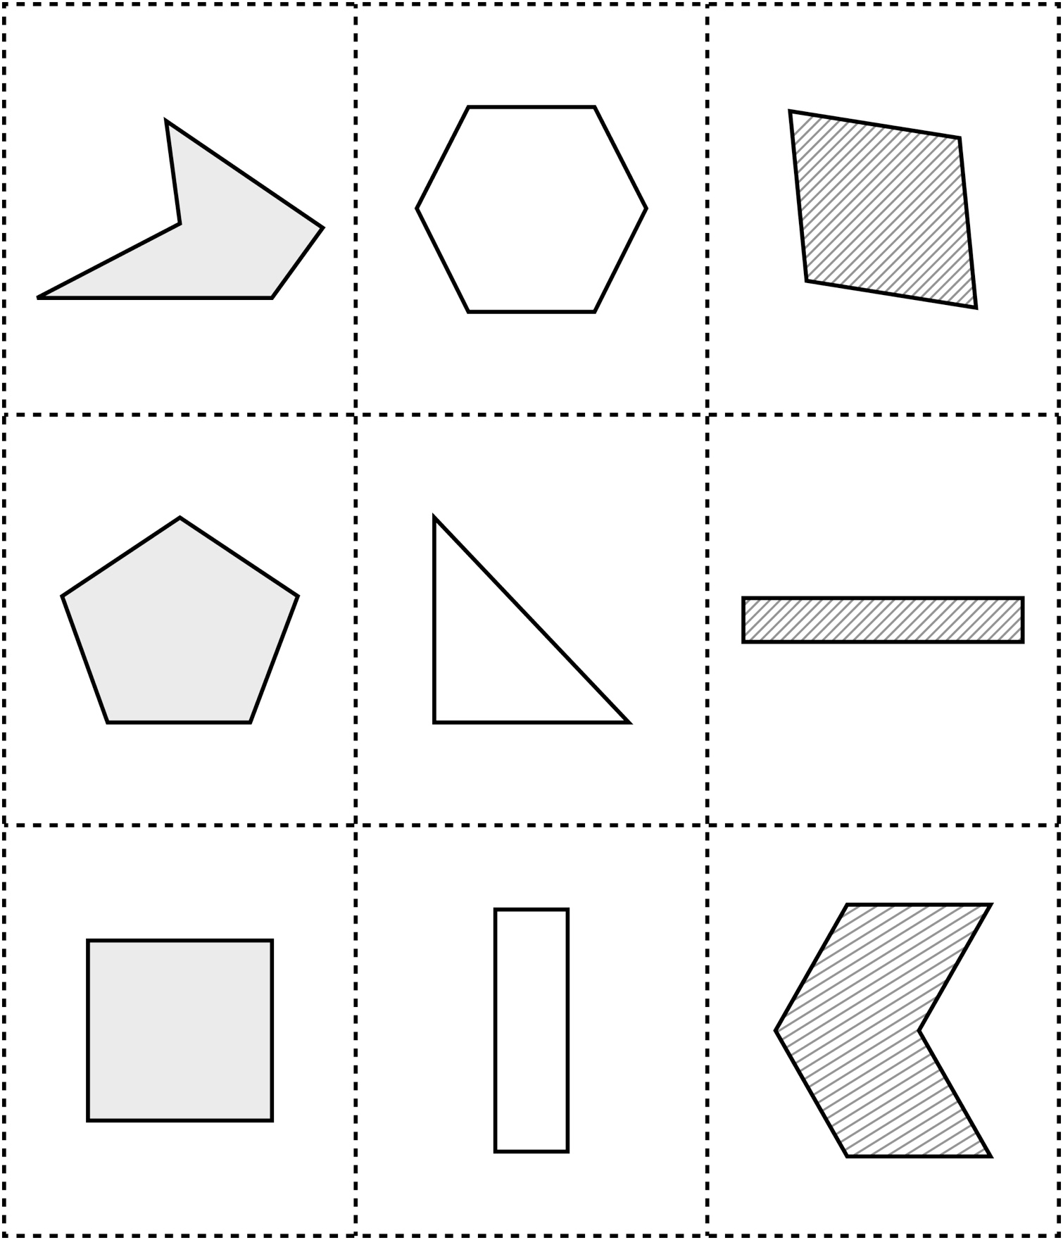

**Shape Cards**

**Master 6d**

