**Large Shapes (for Before)**

**Master 8a**

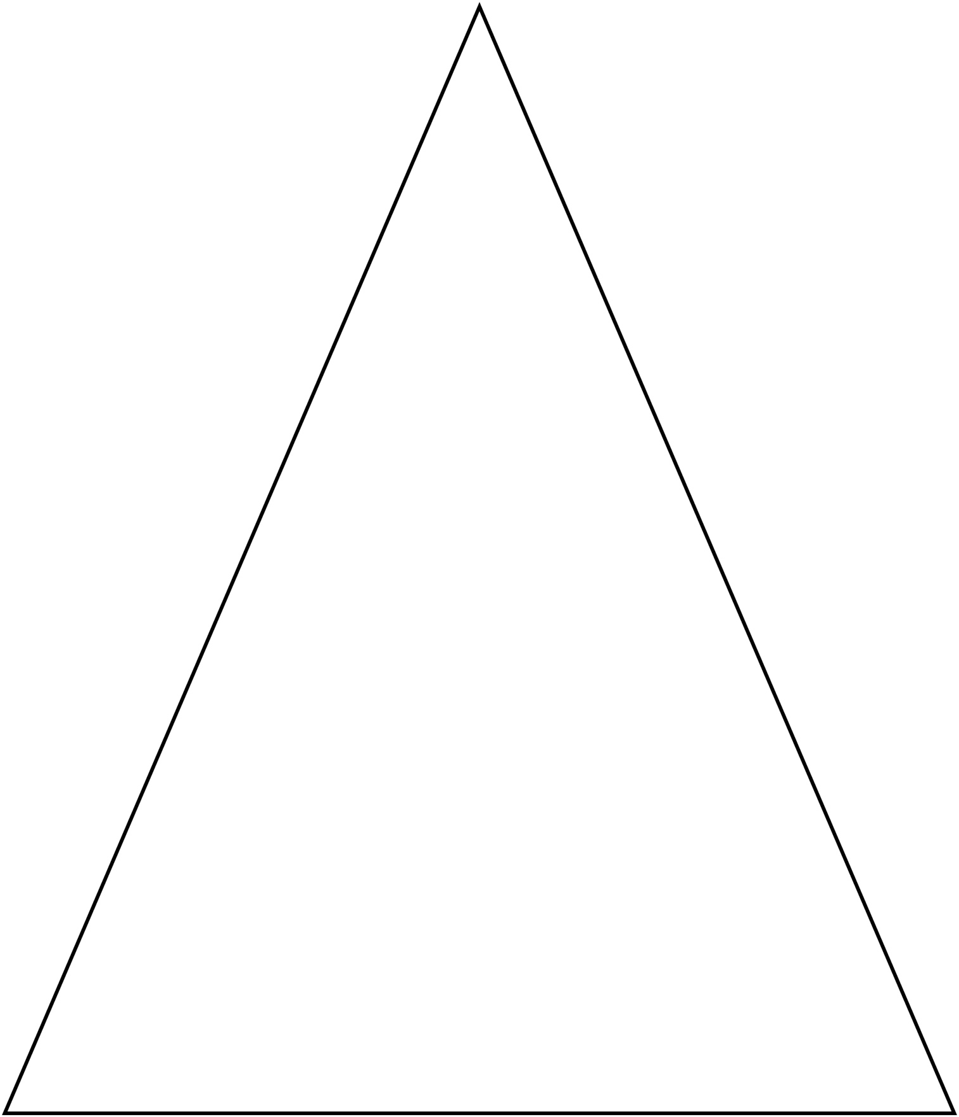

**Large Shapes (for Before)**

**Master 8b**

