Consolidation Attribute Cards
Master 12a

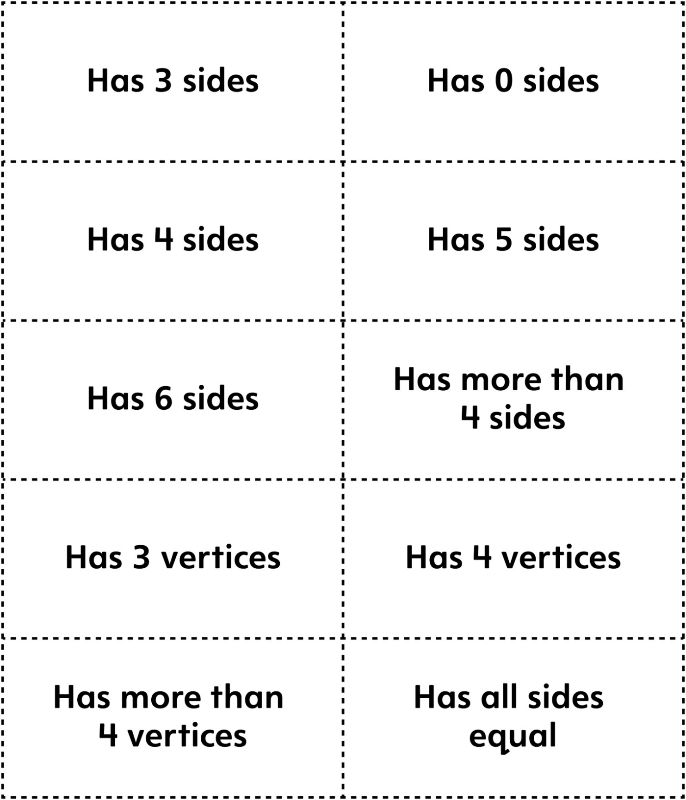

Consolidation Attribute Cards
Master 12b

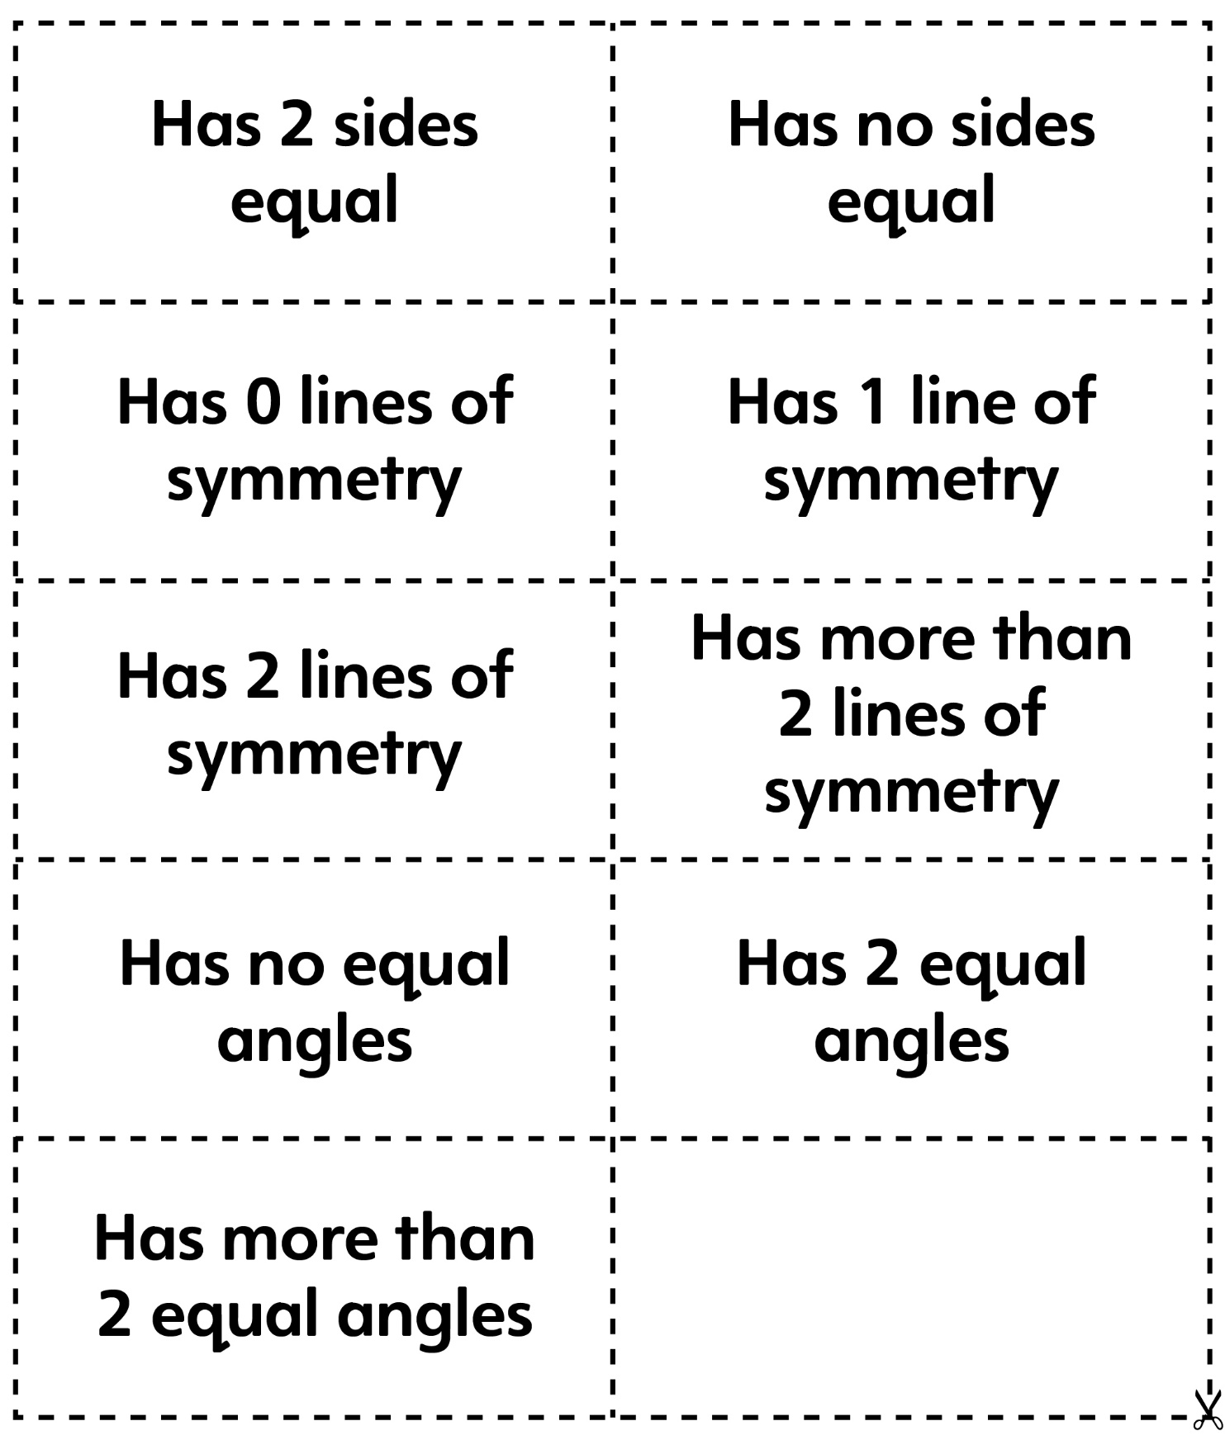
Consolidation Attribute Cards
(for Combined Grades Extension)
Master 12c

