Task Cards
Master 27a

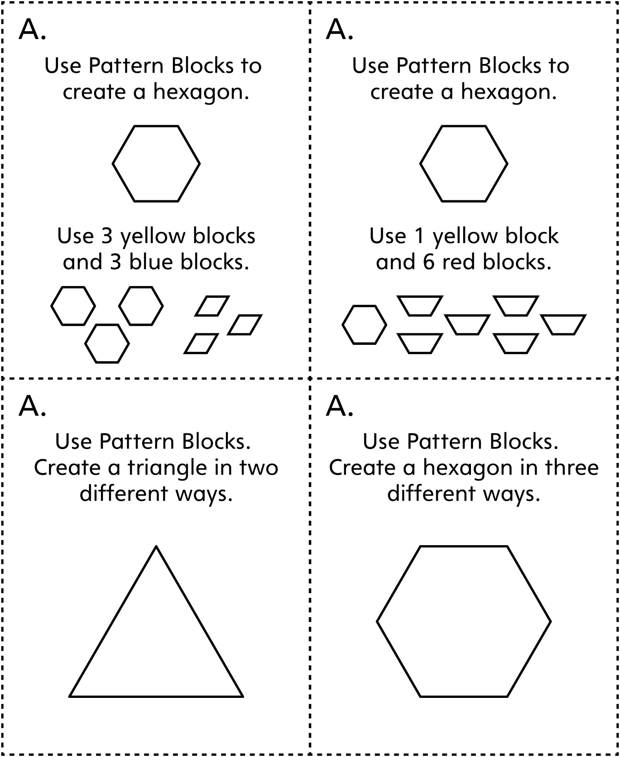
Note: Task cards are grouped by type. For example, all cards labelled A focus on using shapes to create other shapes.

Task Cards
Master 27b

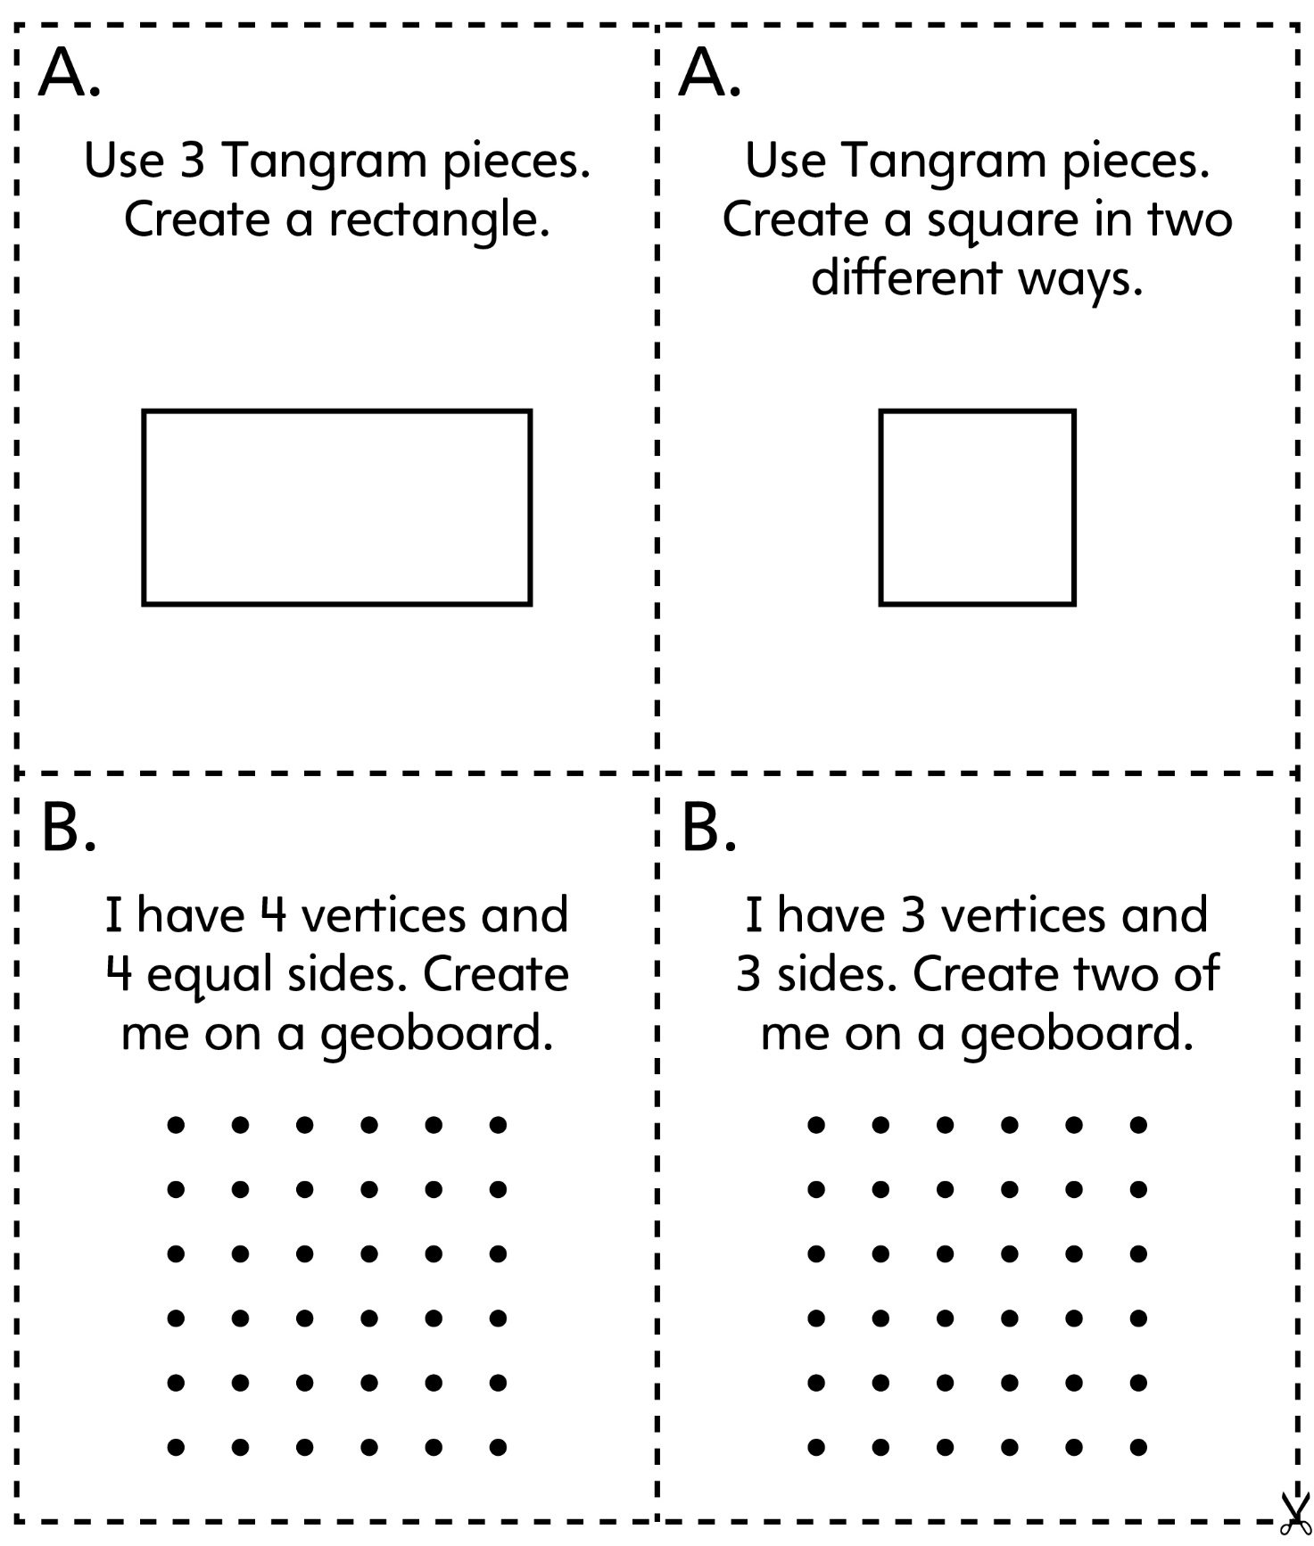

Task Cards
Master 27c

