Describing Attributes of Shapes Behaviours/Strategies
- Student chooses a shape,  but has difficulty analyzing it and  describing its attributes. | - Student analyzes geometric  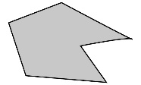  attributes of a shape, but uses non-math language to describe it.  “It looks like a bird’s  beak.” | - Student analyzes geometric  attributes of a shape, but  gives a general description.  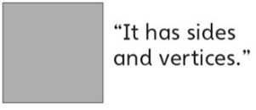 | - Student successfully analyzes  geometric attributes of 2-D shapes and uses math language to describe them.
Observations/Documentation
Visualizing and Creating Shapes Behaviours/Strategies
- Student creates a shape,  but guesses and ignores partner’s description. | - Student creates a shape,  but focuses on only part of the  description and creates incorrect  shape. | - Student creates shapes from description and visualization, but struggles to identify them.  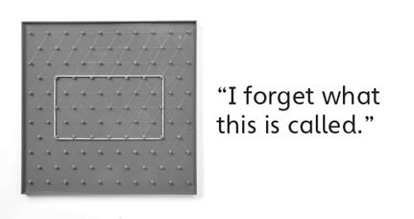 | - Student successfully creates and  identifies shapes from description and visualization.  “I made a  pentagon.”
Observations/Documentation

