**Number Cards (1–10)**

**Master 51a**

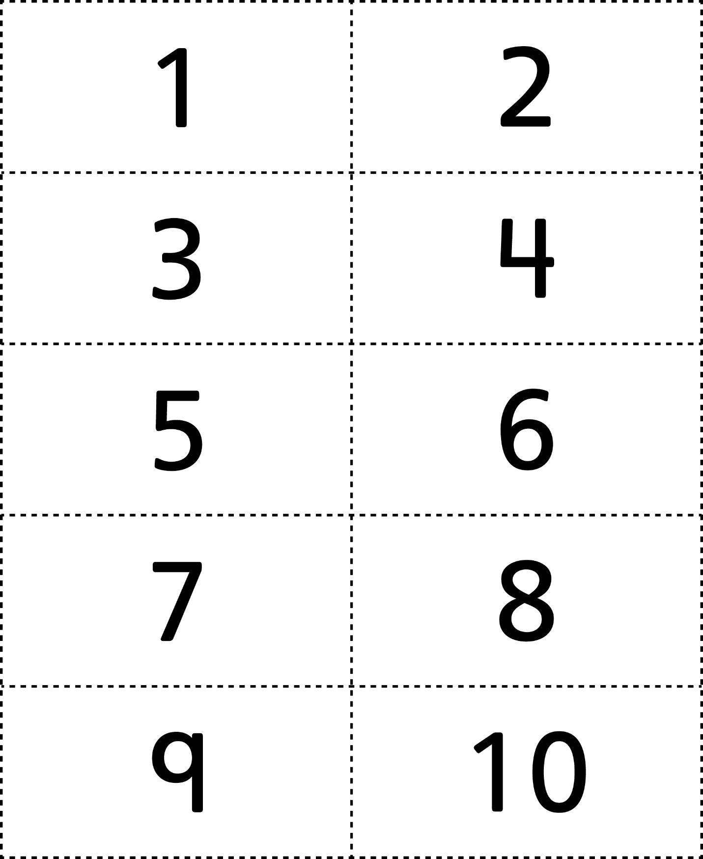



**Number Cards (11–20)**

**Master 51b**

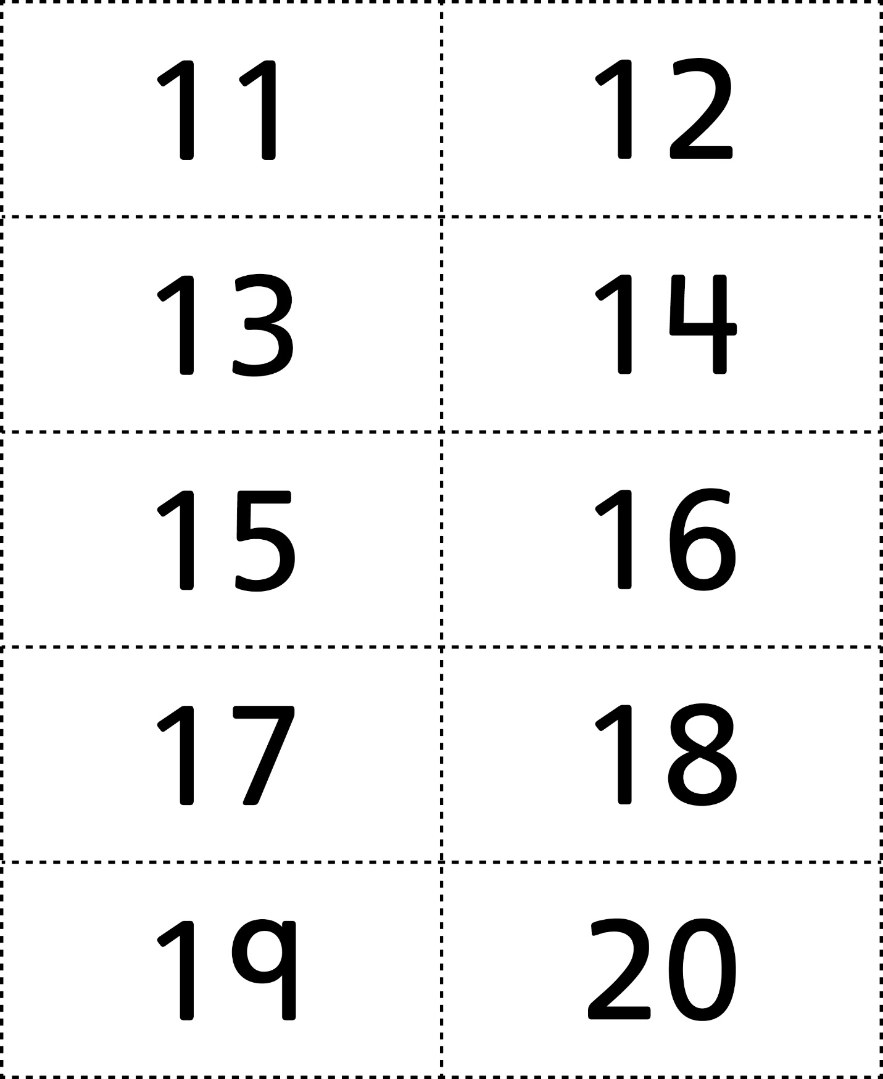



**Number Cards (21–30)**

**Master 51c**

