How Big Around? Recording Sheet
Master 6

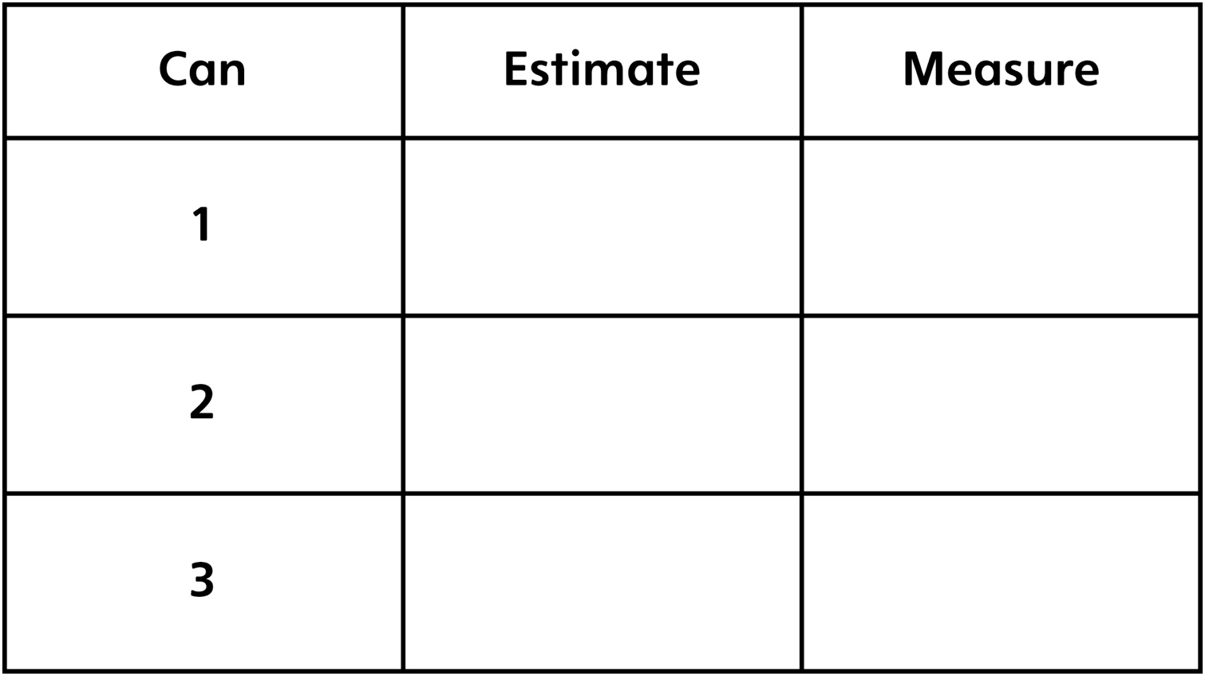

Order cans from least to greatest distance around:

__________ __________ __________

