How Many Metres? (Part 1)
Master 13a

Height of Classroom Door  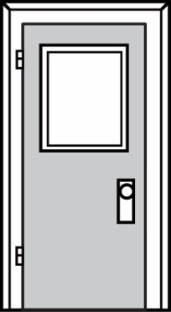  Our estimate is  ____________________________  Our measure is  ____________________________ | Length of Teacher’s Desk  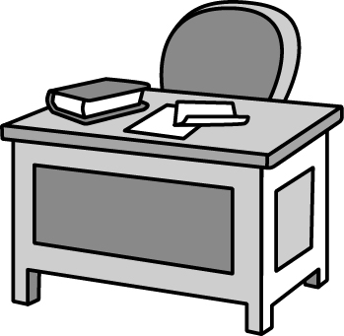  Our estimate is  ____________________________  Our measure is  ____________________________
Width of Window  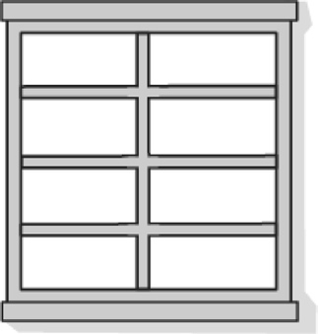  Our estimate is  ____________________________  Our measure is  ____________________________ | Length of Blackboard  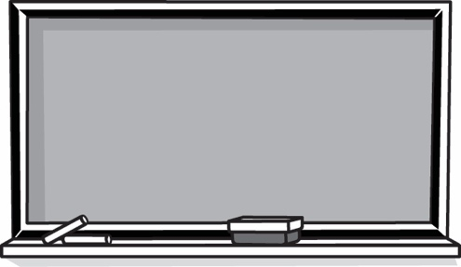  Our estimate is  ____________________________  Our measure is  ____________________________

How Many Metres? (Part 2)
Master 13b

Width of Hallway  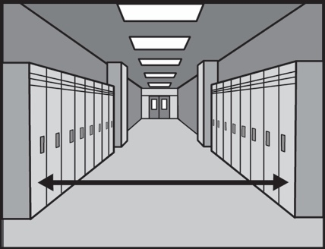  Our estimate is  ____________________________  Our measure is  ____________________________ | Length of Whiteboard  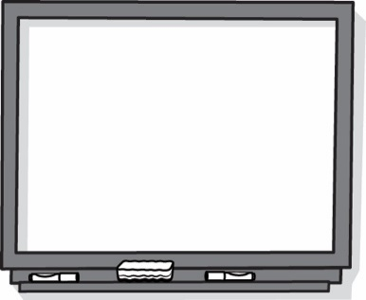  Our estimate is  ____________________________  Our measure is  ____________________________
Length of Classroom  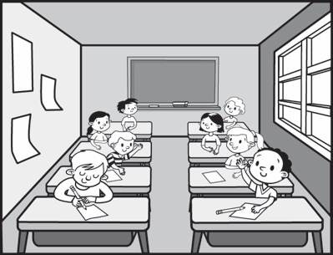  Our estimate is  ____________________________  Our measure is  ____________________________ | Length of Bookshelf  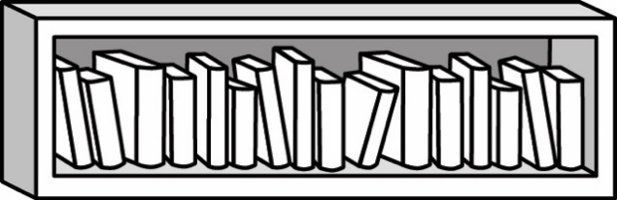  Our estimate is  ____________________________  Our measure is  ____________________________

