Choosing an Appropriate Standard Unit Behaviours/Strategies
- Student chooses an object, but  struggles to select an appropriate  standard unit to measure length.  “I’ll use metres for the glue stick.” | - Student selects an appropriate  standard unit to measure length,  but chooses the wrong tool.  “I chose metres, so I will  use the ruler.” | - Student selects an appropriate  standard unit and tool to measure length, but cannot justify choice.  “I just know metres is what  I should use.” |  | - Student successfully selects an  appropriate standard unit to  measure length and justifies choice.  “I will use metres because the  object is long.”
Observations/Documentation
Measuring Length in Standard Units Behaviours/Strategies
- Student measures length using  standard units, but does not line  up the object with the baseline of  the measuring tool.  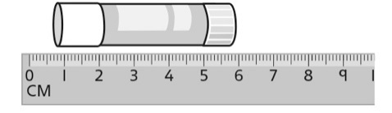 | 2. Student measures length using  standard units, but struggles to  iterate the measuring tool. | 3. Student measures length using  standard units, but forgets to  include the unit when stating the  measure or ignores leftover.  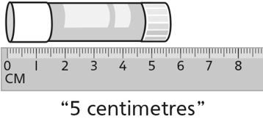 | 4. Student successfully measures  length using standard units and  includes units with measures.
Observations/Documentation

