Time Game Board
Master 28a

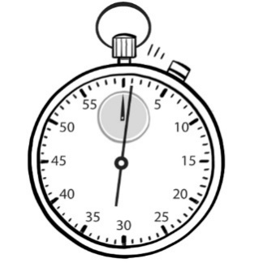 | 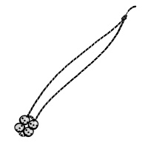  less than 1 swing | 1 second | 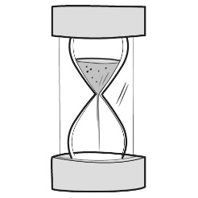  10 flips
1 and one half minutes | 2 hours | 15 minutes | 7 days
3 swings | 3 hours | 1 day | 90 flips  <Catch: replace art with art of sand timer; top is full of sand timer>  90 flips
1 minute | 60 flips | 1 hour | 2 days
10 seconds | 1 swing | 30 minutes  <Catch: replace art with art of sand timer; top is full of sand timer>  1 flip | 2 minutes

Time Game Board
Master 28b
(for Accommodations)

 | 1 hour | 1 second | 10 flips
10 seconds | 2 hours | 1 hour | 2 days
1 minute | 1 swing | 1 day | 2 minutes

Time Game Board
(for Combined Grades Extension)
Master 28c

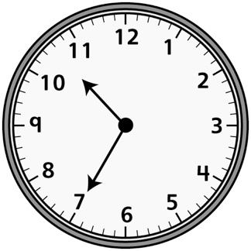 |  |  | 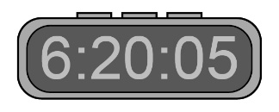
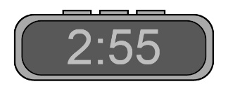
 |  | 