**Hundred Charts (101–200)**

**Master 3a**

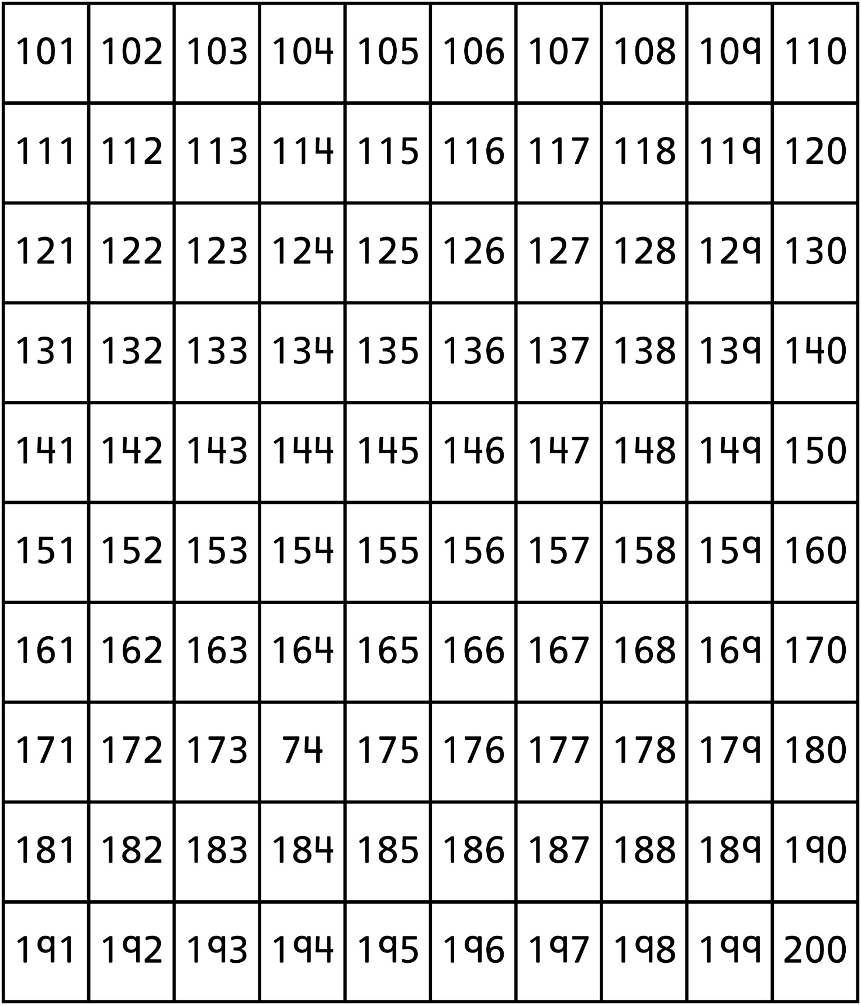

**Hundred Charts (201–300)**

**Master 3b**

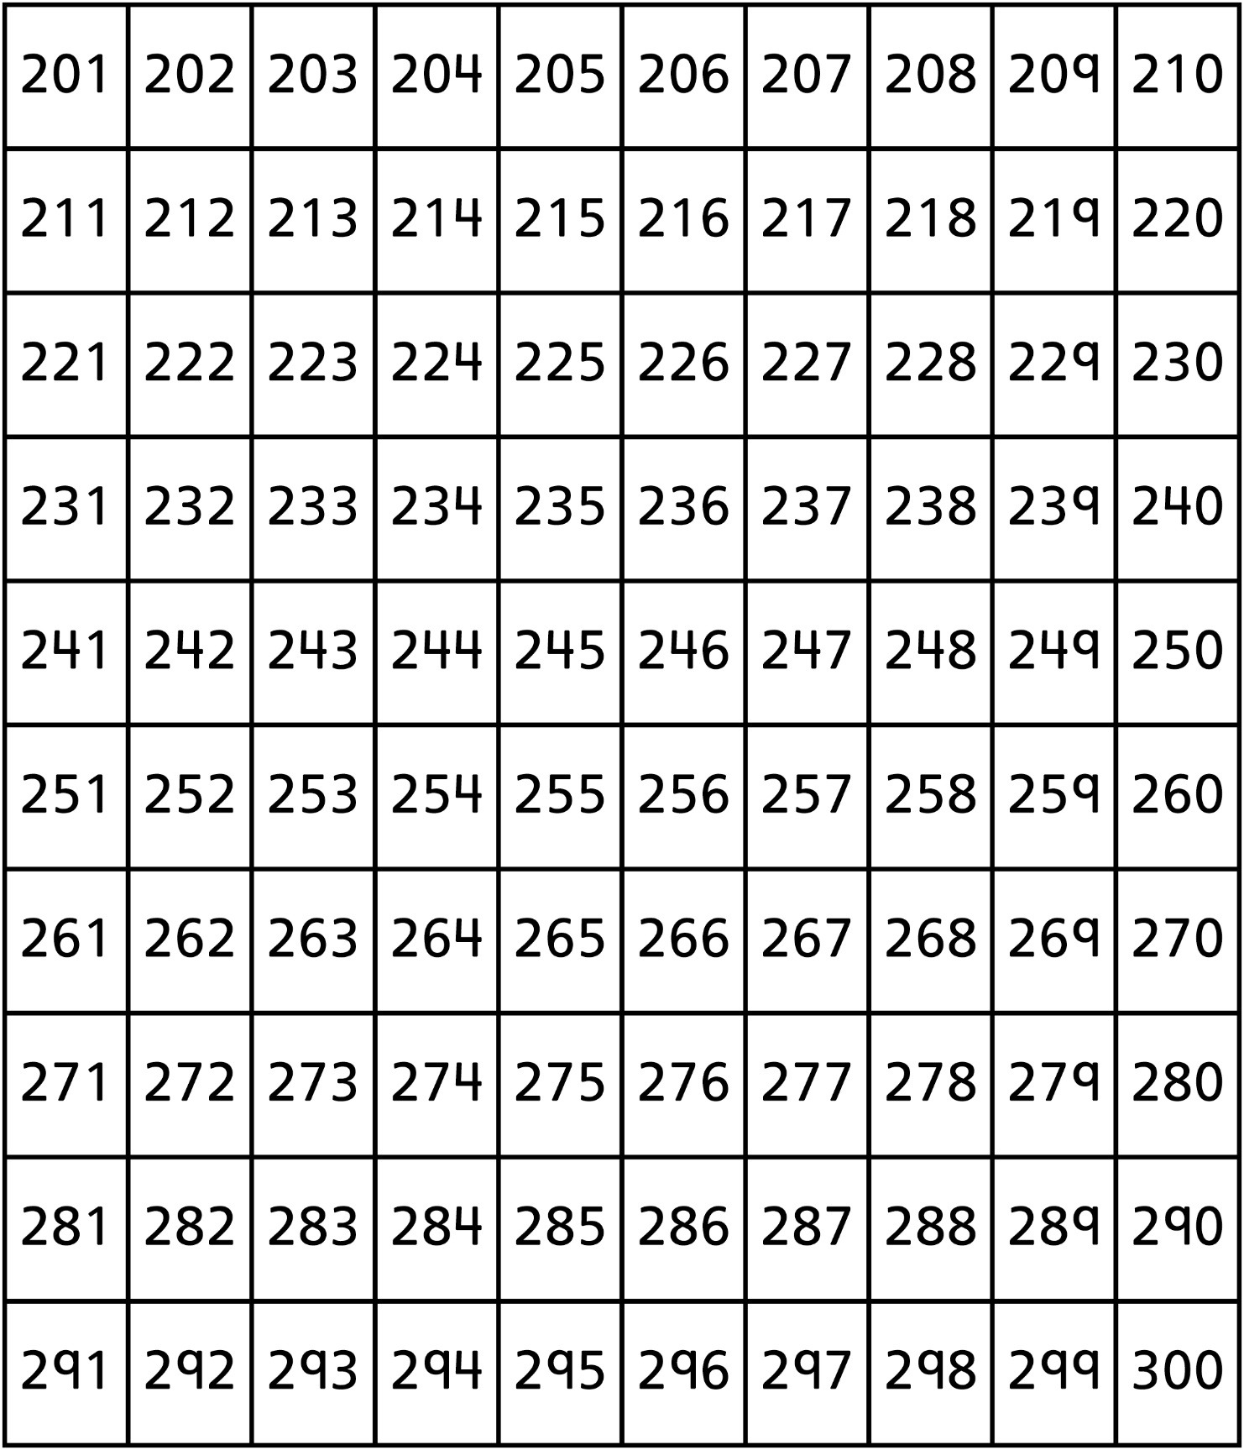

**Hundred Charts (301–400)**

**Master 3c**

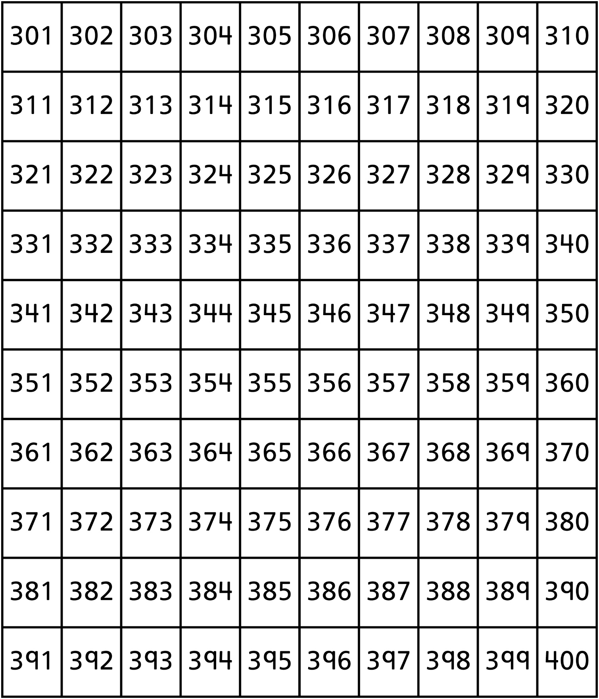

**Hundred Charts (401–500)**

**Master 3d**

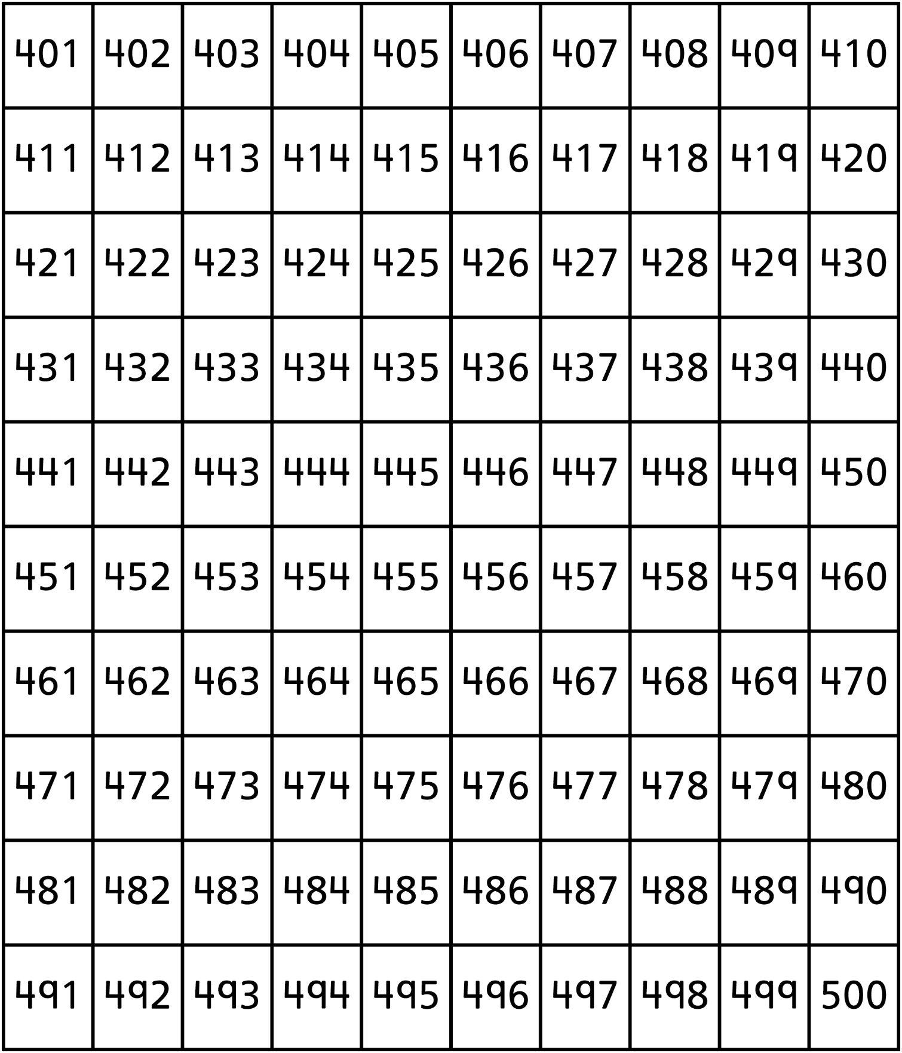

**Hundred Charts (501–600)**

**Master 3e**

**Hundred Charts (601–700)**

**Master 3f**

**Hundred Charts (701–800)**

**Master 3g**

**Hundred Charts (801–900)**

**Master 3h**

**Hundred Charts (901–1000)**

**Master 3h**

