Skip-Counting by 10s Spider Webs
Master 8a

Start at 0. Skip-count by 10s.

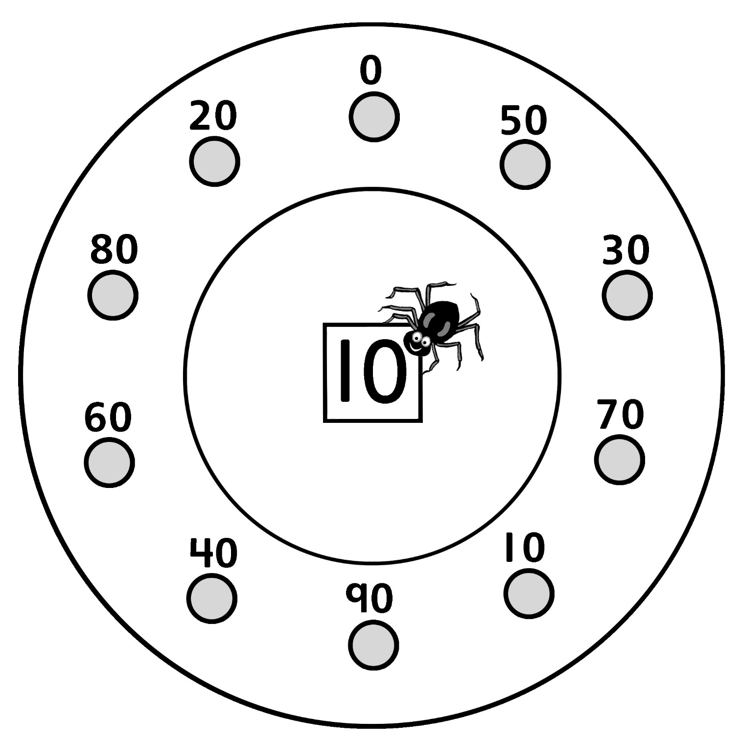

Skip-Counting by 10s Spider Webs
Master 8b

Start at 10. Skip-count by 10s.

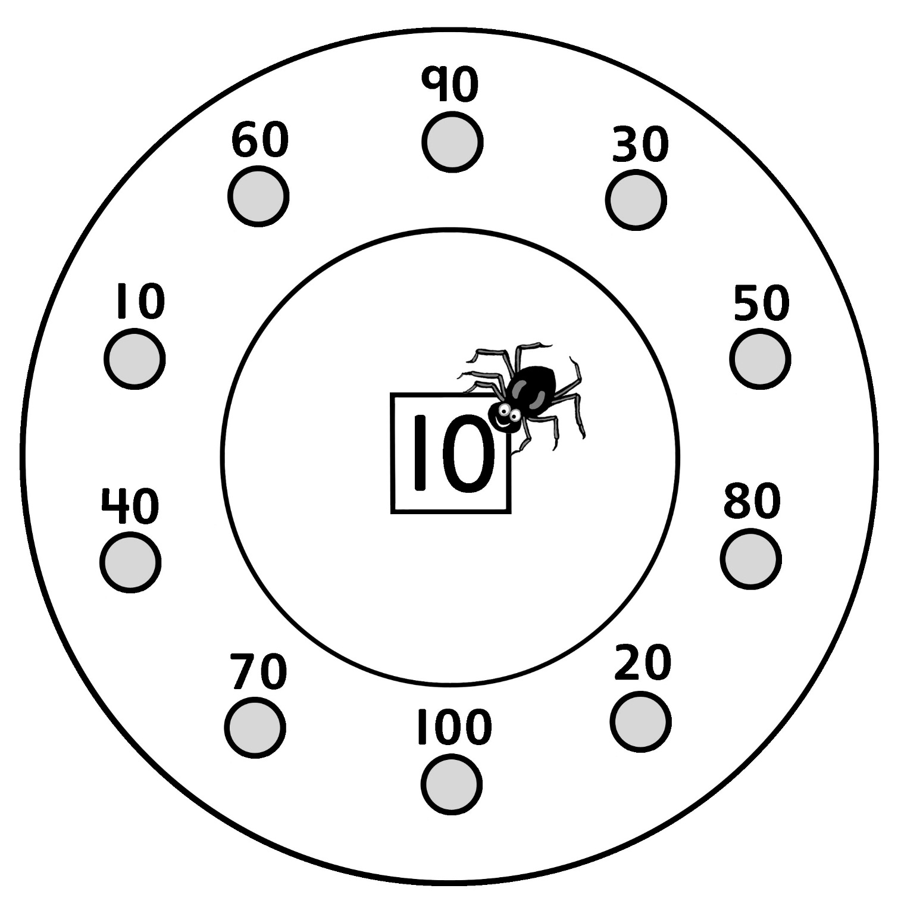

Skip-Counting by 10s Spider Webs
Master 8c

Start at 100. Skip-count by 10s.

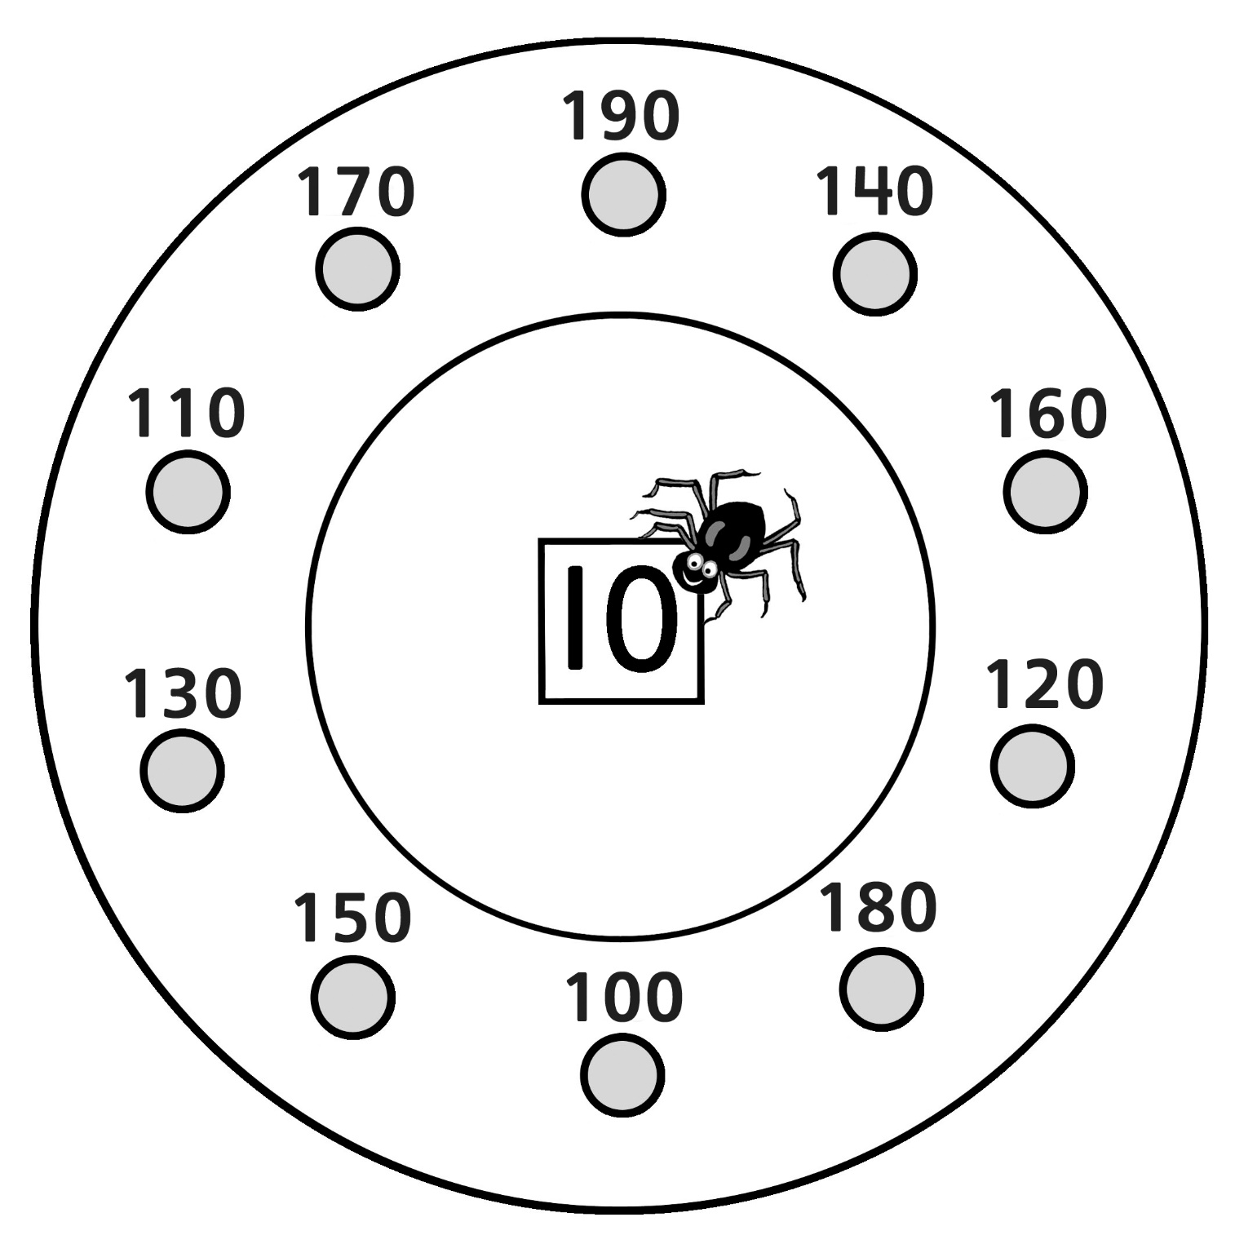

Skip-Counting by 10s Spider Webs
Master 8d

Start at 110. Skip-count by 10s.

