Skip-Counting by 20s Spider Webs
Master 10a

Start at 0. Skip-count by 20s.

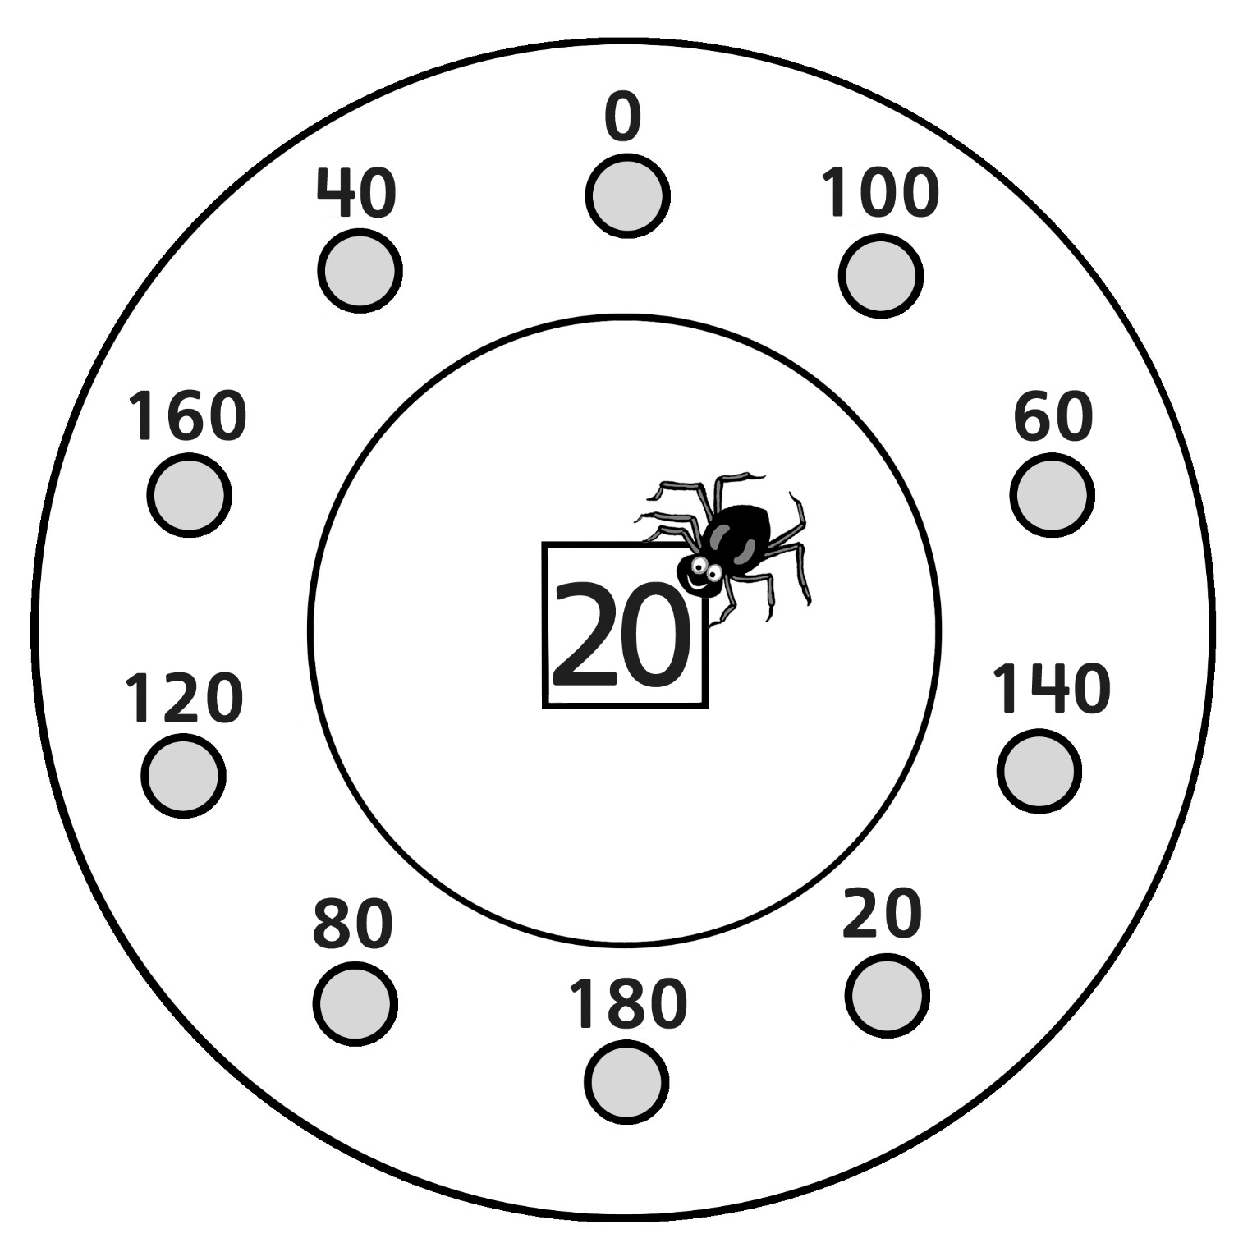

Skip-Counting by 20s Spider Webs
Master 10b

Start at 20. Skip-count by 20s.

