How Many in the Sky?
Master 30a

Ten birds are circled in this photo. Use this as a benchmark to estimate how many birds are in the sky. Count the birds to check your estimate.

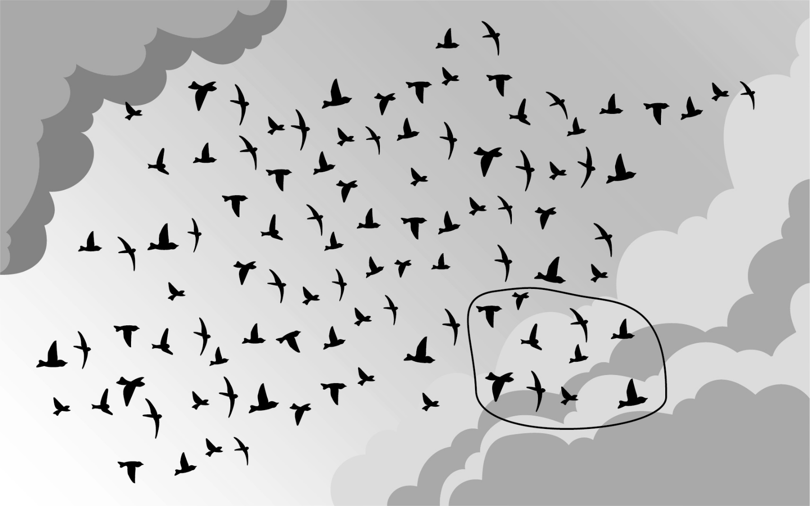

How Many in the Sky?
Master 30b

Twenty-five butterflies are circled in this photo. Use this as a benchmark to estimate how many butterflies are in the sky. Count the butterflies to check your estimate.

