Estimating Using Benchmarks Behaviours/Strategies
- Student guesses instead of using a benchmark of 10 to estimate.  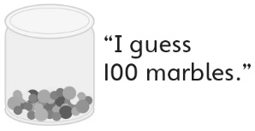 | - Student counts instead of using a  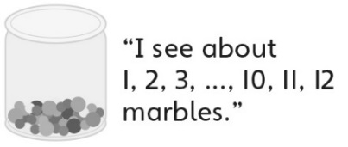  benchmark of 10 to estimate. | - Student tries to use a benchmark  of 10 to estimate, but struggles to  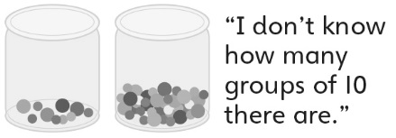  visualize groups of 10 in the jar. | - Student uses a benchmark of 10  to estimate, but does not use  previous estimates to help.
Observations/Documentation
- Student uses a benchmark of 10  to successfully estimate quantities of one size of object, but struggles when the size of the object changes.  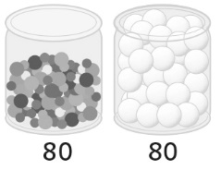 | - Student uses a benchmark of 10 to successfully estimate quantities, but struggles to explain the strategies used. | - Student uses benchmarks of 10, 20, and 25 to successfully estimate quantities, but is unable to explain how the estimates compare to the actual amounts. | - Student uses benchmarks of 10, 20, and 25 to successfully compare and estimate quantities and explains strategies used.
Observations/Documentation

